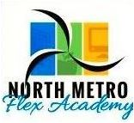

North Metro Flex Academy
2350 Helen St.
North St. Paul, MN 55109
612.900.4435

2019-2020
Annual Report
World’s Best Workforce Summary and Plan

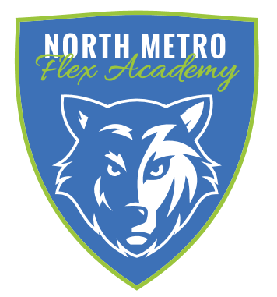

2019– 2020 Annual Report

- School Enrollment and Student Attrition Page 4
- Governance, Management, Authorizer Page 7
- Staffing Page 10
- Finances Page 11
- Academic Performance Page 13
- World’s Best Work Force Summary Page 19
- Innovative Practices Page 27
- Future Plans Page 28
- Administrator Professional Development Plan Page 28
- Community Partnerships Page 29
- World’s Best Workforce Plan
https://northmetroflex.com/resources/

Our Mission
Our mission is to prepare a diverse community of elementary and middle school students to be successful in high school, college and in their chosen vocation through a flexible, individualized learning experience that develops analytical, compassionate, disciplined and self-directed learners.
Our Vision
North Metro Flex Academy’s vision is to be a high-performing and innovative school that produces students capable of exemplary levels of higher order thinking and achievement, as well as students prepared for high school and any post-secondary opportunity they pursue. Our students have access to exceptional curriculum, tools, and teaching to maximize their success in life.
Our History
North Metro Flex Academy opened in the Fall of 2016 as a K-4 school with 170 students in attendance. The school has since expanded to include fifth grade in 2017, sixth grade in 2018, and seventh grade in 2019-20. Our school is very diverse, including a rich blend of students from different cultures, ethnicities, and socio-economic backgrounds. Our staff reflects the makeup of our student population, and includes members of the Latino, East African, African American, and Asian communities. We are now in the process of forming committees, engaging stakeholders, and enriching our academic and extra-curricular activities to better serve our community of learners.
Our Year
The 2019-2020 school year was full of challenges, as COVID-19 came upon us with full force and instigated changes in the delivery of academics as we knew it. We went from full shutdown and distance learning to hybrid learning for some and distance for others, then back to distance learning for all. NMFA staff, students and families rose to the challenge by being flexible, patient, creative, and resilient. Academic data is difficult to provide, since the majority of our goals measure fall-spring progress, and there was no academic testing in the spring of 2020 to be used to show growth and comparisons to area school districts.

- School Enrollment and Student Attrition

Student Enrollment – October 1, 2019: 235
Student Enrollment – June 6, 2020: 233

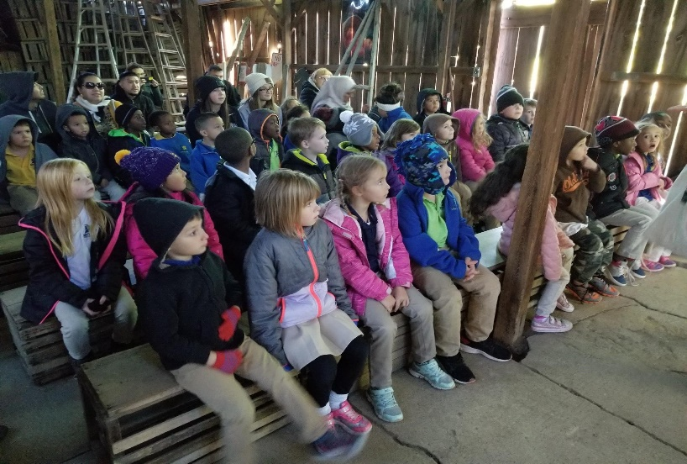

Student Demographics – October 1, 2019
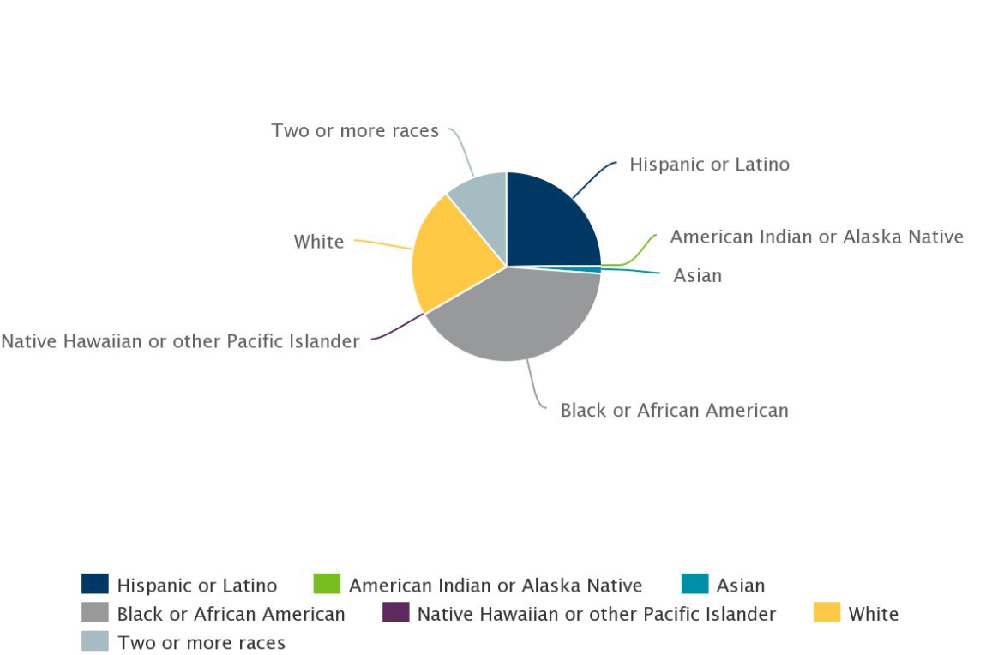

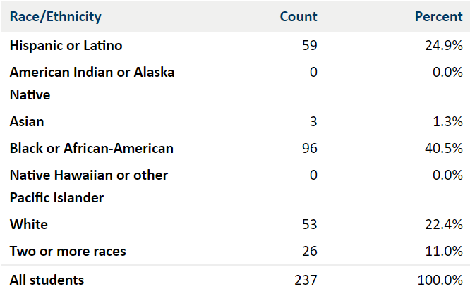

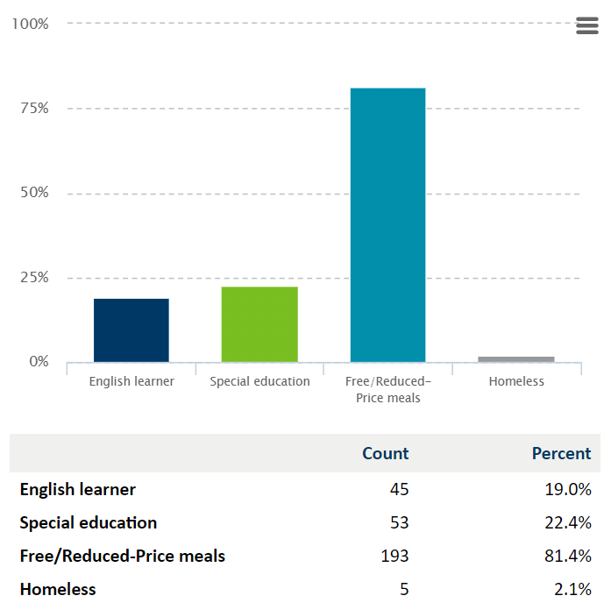

Student Attrition: Fall 2019 – Spring 2020

Day 1 Cohort Retention
 | Started | Ended | Retention
0 | 35 | 25 | 71%
1 | 40 | 32 | 80%
2 | 32 | 28 | 88%
3 | 49 | 35 | 71%
4 | 30 | 27 | 90%
5 | 20 | 16 | 80%
6 | 19 | 13 | 68%
7 | 10 | 8 | 80%
Total Population | 235 | 184 | 78%

In Year Addition Retention
 | In-Year Added | Ended | Retention
0 | 10 | 7 | 70%
1 | 8 | 5 | 63%
2 | 13 | 10 | 77%
3 | 11 | 8 | 73%
4 | 7 | 4 | 57%
5 | 4 | 4 | 100%
6 | 7 | 7 | 100%
7 | 4 | 4 | 100%
Total Population | 64 | 49 | 77%

- Governance, Management and Authorizer

2019-2020 NMFA Board of Directors

The NMFA Board is comprised of parents, teachers, and community members, and meets on the third Wednesday of each month. Meeting dates and times are posted on the school door as well as on our website (www.northmetroflex.com.) Our first Board election was held in May 2019.

NAME | BOARD POSITION | BOARD SEAT | TERM
Pam Albrecht | Board Chair | Community Member | 7/1/19 – 6/30/21
Mike Leary | Treasurer | Community Member | 7/1/19 – 6/30/21
David Isaacson | Board Member | Teacher | 10/12/18 - 6/30/21
Ember Russell | Secretary | Teacher | 7/1/19 – 6/30/21

Management

North Metro Flex Academy is managed by ACCEL Schools, which manages an established network of more than 40 charter and community schools located throughout the U.S. ACCEL serves more than 12,000 students nationwide.
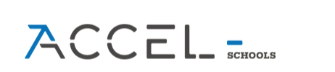
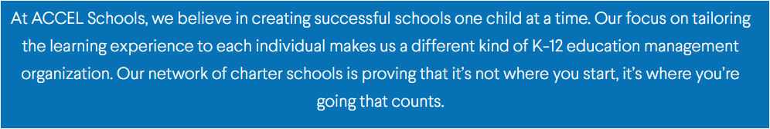

Contact Information:

ACCEL Schools
1650 Tysons Blvd
Suite 630
McLean, VA 22102
https://accelschools.com/

Authorizer

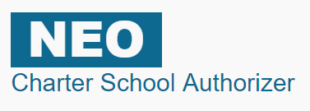
North Metro Flex Academy is authorized by Novation Education Opportunities.

Novation Education Opportunities (NEO) is a single purpose Charter School Authorizer

in the State of Minnesota.

The Mission of NEO is to authorize and oversee charter schools through consistent, ongoing and robust evaluation to achieve

significant and measurable student growth.

The Vision of NEO is to be a leading Minnesota Authorizer of

innovative, diverse, and effective Charter Schools.
NEO is organized under the Minnesota Nonprofit Corporation Act exclusively for a charitable and educational purpose, more specifically to oversee innovative charter schools through consistent, ongoing and robust evaluation to achieve significant and measurable student growth through the authorizing of public charter schools as defined in Minnesota Statutes 124E. To this end, NEO shall always be operated exclusively for charitable purposes within the meaning of Section 501(c)(3) of the Internal Revenue Code. All funds, whether income or principal, and whether acquired by gift or contribution or otherwise, shall be devoted to said purposes.

Contact Information:

Novation Education Opportunities

3432 Denmark Ave, Ste. 130
​ Eagan, MN 55123

612-889-2103
executive.director.neo@gmail.com

- Staffing
PRINCIPAL: Therese L. Privette M.A.Ed.
ASSISTANT PRINCIPAL: Debra Kranz M.Ed.
OFFICE and OPERATIONS MANAGER: Jay Caballero
SPECIAL EDUCATION TEACHER/COORDINATOR: David Isaacson

Last Name | First Name | Assignment | File Folder
Alfonso | Christine | Art All Grades 5-7 | 459188
Anderson | Madeline | Music All Grades K-7 | 481661
Bartholomew | Aaron | Math 5th - 7th Grade | 504756
Bercaw | Elizabeth | ELL | 325575
Cayou-Konkler | Heidi | Title 1 | 323394
Emery | Liana | 1st Grade | 375720
Erickson | Nancy | 2nd Grade | 313884
Hart | Victoria | Kindergarten | 506097
Hofstad | Chloe | Special Education | 512904
Isaacson | David | Special Education | 369551
Johnson | Kyle | Social Studies/Science 5-7 | 486413
Karg | Jessaca | 2nd Grade | 509076
Karnitz | Helen | Special Education | 319983
Listerud | Tina | ELA 5th - 7th Grade | 460484
Livdahl | Jill | Special Education/Title 1 | 319680
Russell | Ember | Kindergarten | 491609
Saline | Sandy | Special Education | 449692
Sauerwein | Polly | 1st Grade | 505024
Sewich | Allyson | 3rd Grade | 1000990
Strasser | Kelly | Special Education | 442684
Venne | Ann | 3rd/4th Crade | 407392
Wiatros | Anna | 4th Grade | 334676

NORTH METRO FLEX ACADEMY 2019-2020 SUPPORT STAFF
Armstrong | Amy Jo | PARAPROFESSIONAL
Arredondo | Elizabeth | PARAPROFESSIONAL
Fadlalla | Amina | PARAPROFESSIONAL/FOOD SERVICE
Hastings | Caylin | PARAPROFESSIONAL
Hastings | Lacey | PARAPROFESSIONAL/FOOD SERVICE
Heider | Katie | PARAPROFESSIONAL
Hurlburt | Desiree | PARAPROFESSIONAL
Liyew | Tigist | PARAPROFESSIONAL
Lynch | Michael | BEHAVIOR INTERVENTION ASSISTANT
Johnson | Sara | PARAPROFESSIONAL
Skalbeck | Paul | PARAPROFESSIONAL
Smieja | Chelsea | SPECIAL EDUCATION DUE PROCESS
Olson | Carolina | PARAPROFESSIONAL/CULTURAL LIAISON
Wambui | Pauline | PARAPROFESSIONAL
Tyler | Rachelle | PARAPROFESSIONAL

- Finances
The school’s financial documents are closely reviewed monthly by the Finance Committee. Committee members review and inspect the financials and challenge items that may be inconsistent with the budget. The Board Treasurer and Finance Manager provide a monthly update at each regularly scheduled board meeting providing full transparency to the board, staff and community.
Financial Data Points:
- The school completed the year with a fund balance of $31,373.

- The school obtained an unqualified audit for FY20.

- The 2020 audit contained no material weaknesses or deficiencies.

- North Metro Flex Academy is indebted to ACCEL/Pansophic set to be repaid over a 10-year period (2028)

- The school’s governmental funds reported a total ending fund balance of $38,966
Continuing on the growth from the past year, North Metro Flex Academy continues to benefit from the full-day funding for kindergartners. Furthermore, the school’s student retention continues to maintain the growth of the student body. Conservative budget creation, strict adherence to that budget and responsible execution will mean an increase to the fund balance. The school will pragmatically work to increase enrollment while controlling expenses to build a strong fund balance over the coming years.

Presented below is the balance sheet as of 6/30/2020 (audited):
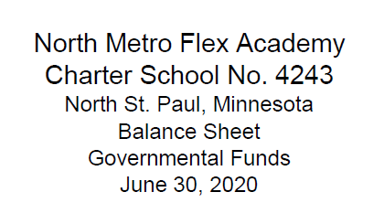
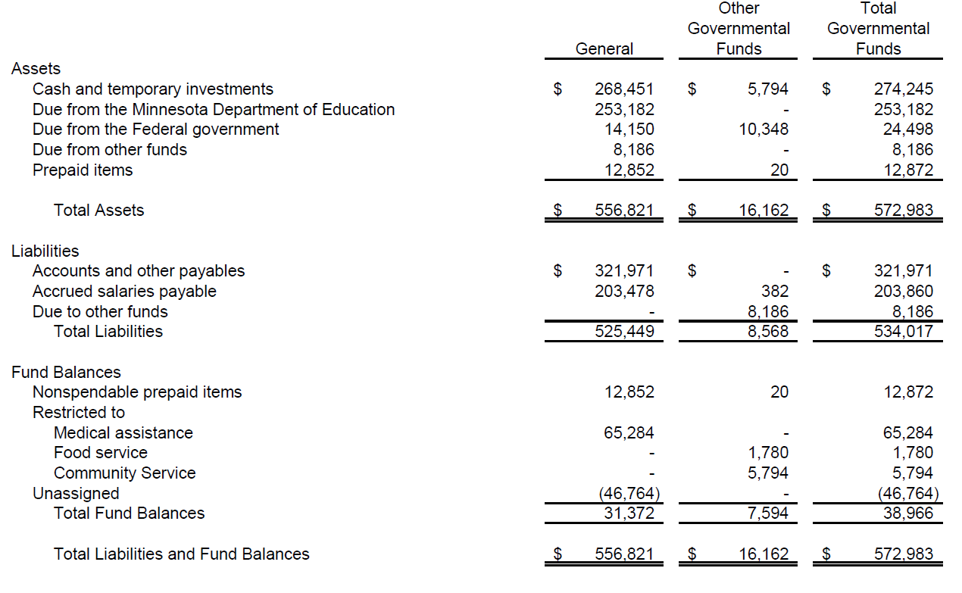

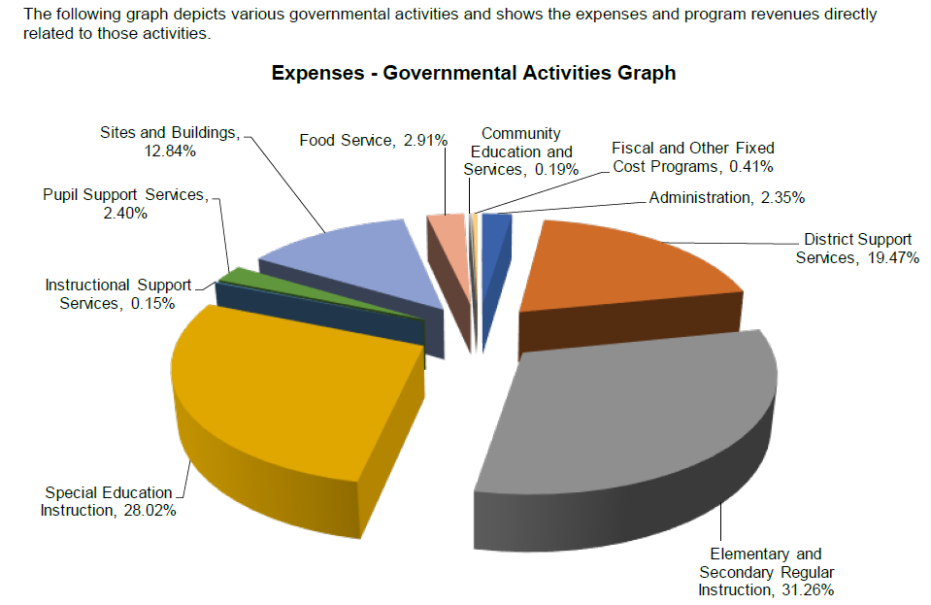

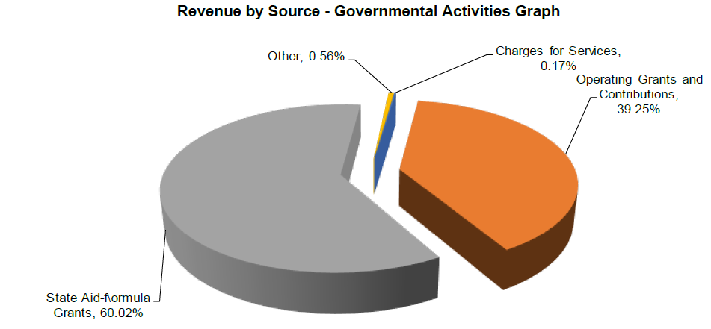

- Academic Performance
Due to COVID-19 school closures, we were not able to assess students in Spring 2020.
These scores reflect the number of students at or above grade level in Winter 2020.

NWEA Winter 2019-2020
Kindergarten Math
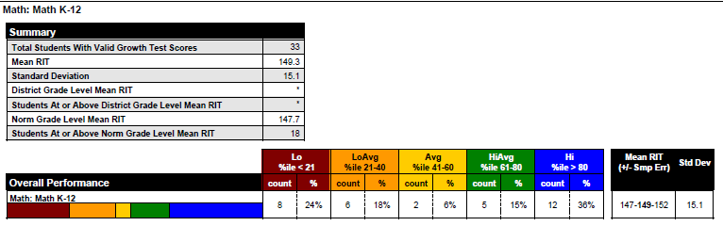

Kindergarten Reading
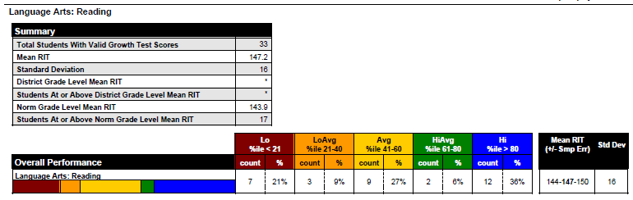

First Grade Math
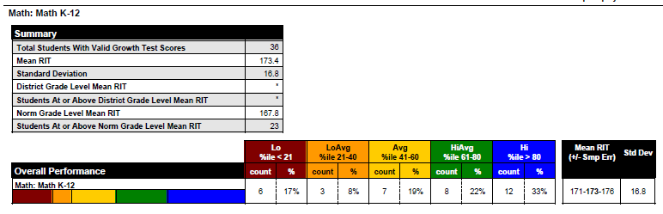
First Grade Reading
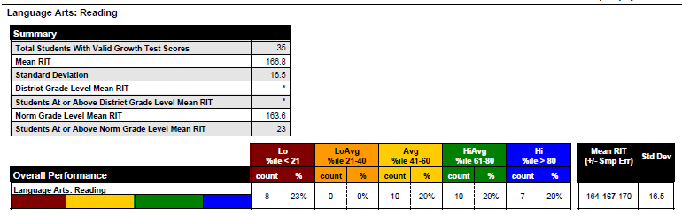

Second Grade Math
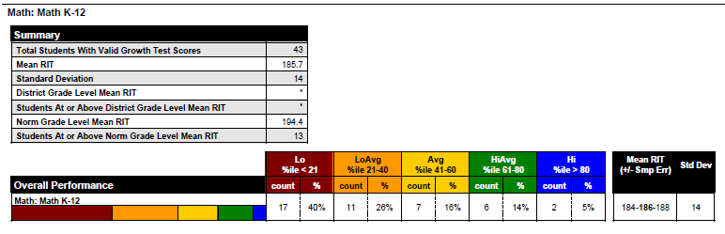

Second Grade Reading
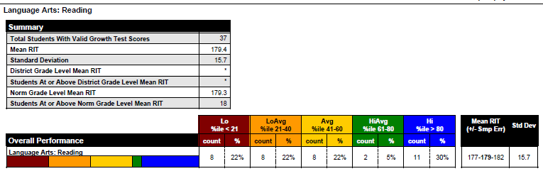

Third Grade Math
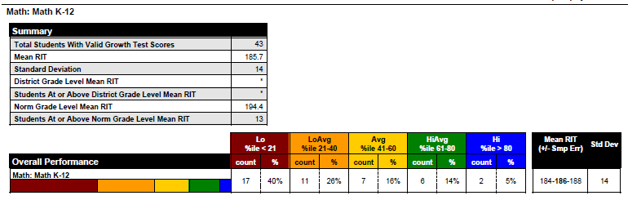

Third Grade Reading
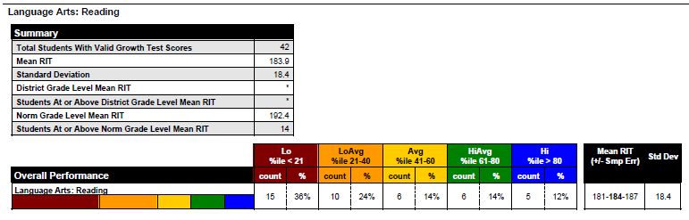

Fourth Grade Math
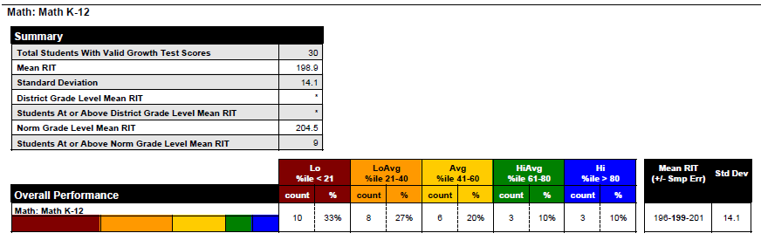

Fourth Grade Reading
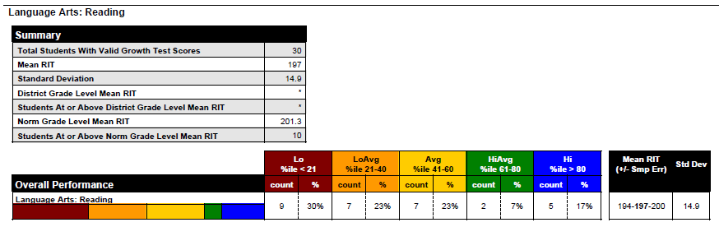

Fifth Grade Math
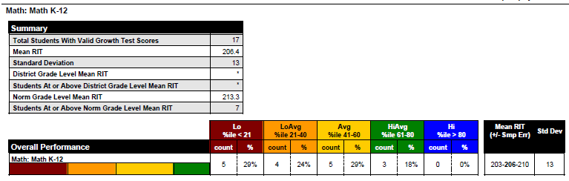

Fifth Grade Reading
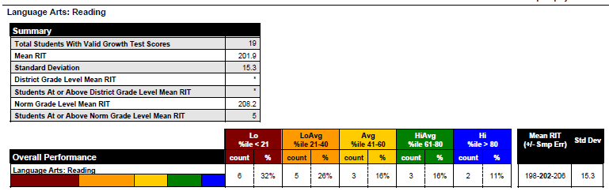

Sixth Grade Math
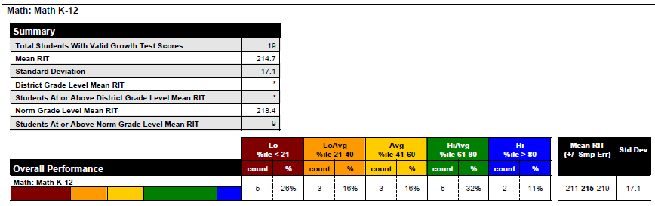

Sixth Grade Reading
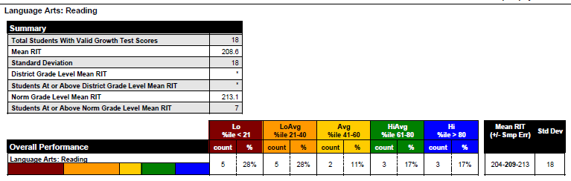

Seventh Grade Math
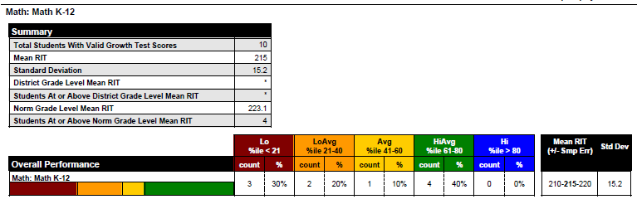

Seventh Grade Reading
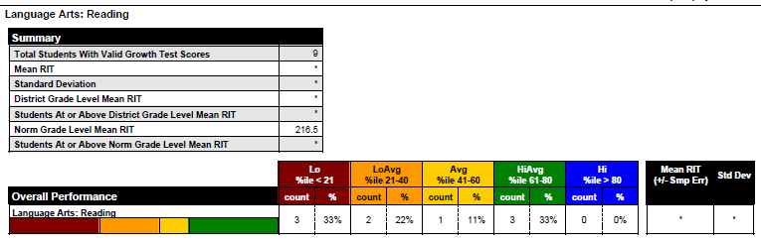

- World’s Best Work Force Summary

District or Charter Name
4243-07 North Metro Flex Academy

Grades Served

Kindergarten
First grade
Second grade
Third grade
Fourth grade
Fifth grade
Sixth grade
Seventh grade
Eighth grade

WBWF Contact Name
Therese Privette
WBWF Contact Title
Principal
WBWF Contact Phone Number
612.900.4435 WBWF Contact Email
tprivette@northmetroflex.com

MDE understands this past school year (2019-2020) ended under unique circumstances due to the COVID-19 pandemic. Therefore, we are providing reporting options that reflect this disruption in your ability to appropriately report annual progress.

WBWF Requirement: For each school year, the school board must publish a report in the local newspaper, by mail or by electronic means on the district website.

Provide the direct website link to the district's WBWF annual report. If a link is not available, describe how the district disseminates the report to stakeholders.

www.northmetroflex.com

Annual Public Meeting

These annual public meetings were to be held in the fall of each school year. Report on this measure for the 2019-2020 school year.

WBWF Requirement: School boards are to hold an annual public meeting to communicate plans for the upcoming school year based on a review of goals, outcomes and strategies from the previous year. Stakeholders should be meaningfully involved, and this meeting is to occur separately from a regularly scheduled school board meeting.

Provide the date of the school board annual public meeting to review progress on the WBWF plan and Achievement and Integration plan for the 2019-20 school year.

District Advisory Committee

WBWF Requirement: The district advisory committee must reflect the diversity of the district and its school sites. It must include teachers, parents, support staff, students, and other community residents. Parents and other community residents are to comprise at least two-thirds of advisory committee members, when possible.

The district advisory committee makes recommendations to the school board.

District Advisory Committee Members

First and Last Name
Terri Privette
Role in District
Principal

First and Last Name
Cassie Albrecht
Role in District
Parent

First and Last Name
Maureen Alexander
Role in District
Parent

First and Last Name
Debra Kranz
Role in District
Instructional Leader/Asst. Principal

First and Last Name
Jessica Mikel
Role in District
Parent

First and Last Name
Mike Leary
Role in District
Board member – Community

Equitable Access to Effective and Diverse Teachers

WBWF Requirement: WBWF requires districts and charters to have a process in place to ensure students from low income families, students of color, and American Indian students are not taught at disproportionate rates by inexperienced, out of field, and ineffective teachers. The legislation also requires that districts have strategies to increase access to teachers who reflect the racial and ethnic diversity of students. While districts/charters may have their own local definitions, please note the definitions developed by Minnesota stakeholders during the Every Student Succeeds Act (ESSA) state plan development process:

An ineffective teacher is defined as a teacher who is not meeting professional teaching standards as defined in local teacher development and evaluation (TDE) systems.
An inexperienced teacher is defined as a licensed teacher who has taught for three or fewer years.
An out-of-field teacher is defined as a licensed teacher who is providing instruction in an area which he or she is not licensed.
The term “equitable access gap” refers to the difference between the rate(s) at which students from low income families, students of color, and American Indian students are taught by inexperienced, out-of-field, or ineffective teachers and the rate at which other students are taught by the same teacher types. This is not to be confused with the “achievement gap” (how groups of students perform academically); rather, “equitable access gap” is about which student groups have privileged or limited access to experienced, in-field, and effective teachers. Districts/charters are encouraged to monitor the distribution of teachers and identify equitable access gaps between and within schools, but they may also make comparisons to the state averages or to similar schools. It is important to note that some of the most significant equitable access gaps occur at the school and classroom level.
Districts/charters may also use other indicators of “effectiveness” such as teachers receiving stronger evaluations overall, teachers with strengths in particular dimensions of practice (e.g., culturally responsive practices), teachers certified by the National Board for Professional Teaching Standards, or teachers with demonstrated student growth and achievement results.

Describe your process for ensuring students of color, American Indian students and students from low income families have equitable access to experienced, infield, and effective teachers.

Each summer as we recruit new teachers, we consistently try to hire staff representing our current student demographic. Our STAR data is reviewed twice per year, giving us information used for future hiring. Since we are not able to afford the higher salaries offered by local districts, we look for staff willing to accept lower pay for better working conditions. All teachers are licensed and highly qualified. Our support staff is representative of our student and family demographic. The NMFA Board of Directors reviews data yearly.

What goal(s) do you have to reduce and eventually eliminate equitable access gaps?

We have advertised on nationwide website Indeed, as well as Minnesota website St. Cloud EdPost and K-12 Jobspot. We have interviewed qualified applicants who have turned us down due to salary limitations. As our enrollment increases, we hope to be able to attract and hire diverse, experienced, effective teachers with an increased budget for teaching staff.

WBWF Requirement: WBWF requires districts and charters to examine student access to licensed teachers who reflect the racial and ethnic diversity of students. A growing body of research has demonstrated that all students benefit when they are taught by racially and ethnically diverse staff throughout their career, and students of color and indigenous students benefit even more. Consequently, working to increase teacher racial diversity is beneficial to all schools.

Describe your efforts to increase the racial and ethnic diversity of teachers in your district. Which racial and ethnic student groups are present in your district that are not yet represented in your licensed teacher staff? How many additional teachers of color and American Indian teachers would you need in order to reflect your student population?

During the 2019-2020 school year, the student demographic of NMFA was:

24.9 % Latino
22.4 % White
40.5 % Black
1.3 % Asian

100% of our classroom teachers are Caucasian. To reflect our student population, our goal is to employ three Latino teachers, four Black teachers, and five Caucasian teachers. We do employ the following POC at NMFA: African American -Behavior
Intervention Assistant and Special Ed. Paraprofessionals; East African -
Kitchen/Paraprofessional; Latino - Liaison/Paraprofessional; Pacific Islander - Office
and Operations Manager. Based on our student demographic, we should employ at least two African American teachers.

What strategies has the district initiated to increase and retain teachers of color and American Indian teachers in the district? What goal(s) are you pursuing?

We regularly advertise for teachers on three websites:
EdPost, K-12 JobSpot, and Indeed. We have not been successful in recruiting teachers of color in our district. Our goal is to employ at least two African American and one Latino teacher for the 2020-2021 school year.

Local Reporting of Teacher Equitable Access to Effective and Diverse Teachers Data

Districts are required to publicly report data on an annual basis related to student equitable access to teachers, including data on access for low income students, students of color, and American Indian students to experienced, in-field, and effective teachers and data on all student access to racially and ethnically diverse teachers.

Each year data relating to Teacher Equitable Access is published in our World’s Best Workforce Summary and posted on our school website. Data is annually reported to MDE on the STAR Report.

Goals and Results

SMART goals are: specific and strategic, measurable, attainable (yet rigorous), results-based and time-based. Districts may choose to use the data profiles provided by MDE in reporting goals and results or other locally determined measures.

All Students Ready for School

Does your district/charter enroll students in kindergarten? Yes

Goal

Provide the established SMART goal for the 2019-20 school year.

60-69 percent of kindergarten students will meet or exceed the first grade RIT target score of 159 for math in the combined FY 2017-FY 2021.

Result

Provide the result for the 2019-20 school year that directly ties back to the established goal. If unable to report a result because of disruptions due to COVID-19, please respond, “Unable to report.”

Unable to report spring data due to COVID-19. In Winter 2020, 36% of Kindergarteners scored at least 159 on NWEA Math Testing.

Goal Status
Check one of the following: On Track (multi-year goal)

Narrative

What data have you used to identify needs for all students in this goal area? How is this data disaggregated by student groups and inclusive of all students? What strategies are in place to support this goal area?

We have used all possible NWEA data up until March 2020. This data was inclusive of all tested students. We are continuing to instruct all students through a Hybrid and Distance Learning Model, and we are hoping to be able to test in person in the spring of 2021.

All Students in Third Grade Achieving Grade-Level Literacy

Does your district/charter enroll students in grade 3?
Yes

Goal:
Provide the established SMART goal for the 2019-20 school year.

The school's third grade proficiency rate is greater than the resident district (St. Paul Public Schools) average on SY 2019-2020 Reading MCAs.

Result

Provide the result for the 2019-20 school year that directly ties back to the established goal. If unable to report a result because of disruptions due to COVID-19, please respond, “Unable to report.”

Unable to report

Goal Status

Check one of the following:
Unable to report

Narrative
What data have you used to identify needs for all students in this goal area? How is this data disaggregated by student groups and inclusive of all students? What strategies are in place to support this goal area?

We are continuing to monitor these students using classroom assessments, NWEA scores when possible, work completion, and teacher running records.

Close the Achievement Gap(s) Between Student Groups

Goal
Provide the established SMART goal for the 2019-20 school year.

MCA Math: The school's combined FY 2017-FY 2021 F & R proficiency rate exceeds the resident district average by up to 10 percentage points.

Result

Provide the result for the 2019-20 school year that directly ties back to the established goal. If unable to report a result because of disruptions due to COVID-19, please respond, “Unable to report.”

Unable to report

Goal Status

Unable to report

Narrative

What data have you used to identify needs for all students in this goal area? How is this data disaggregated by student groups and inclusive of all students? What strategies are in place to support this goal area?

We are continuing to monitor these students using classroom assessments, NWEA scores when possible, work completion, and teacher running records.

All Students Career- and College-Ready by Graduation

Goal

Provide the established SMART goal for the 2019-20 school year.

MCA Math: The school's combined FY 2017-FY 2021 proficiency rate exceeds the state combined FY 2017-FY 2021 proficiency rate AND/OR the school improves its proficiency rate from the baseline year of FY 2017 (38.10%) by at least 10 percentage points by FY 2021.

Result

Unable to report. Same as 2018-2019.

Provide the result for the 2019-20 school year that directly ties back to the established goal. If unable to report a result because of disruptions due to COVID-19, please respond, “Unable to report.”

Unable to report

Goal Status

Unable to report

Narrative

What data have you used to identify needs for all students in this goal area? How is this data disaggregated by student groups and inclusive of all students? What strategies are in place to support this goal area?

Typically, we use MCA data to identify needs for all students in this goal area. Data is disaggregated by F&R and ELL groups. During distance learning, students receive at least 60 minutes per day of math online instruction and support, with more support provided for Special Education and Title 1 students.

Does your district/charter enroll students in grade 12? No

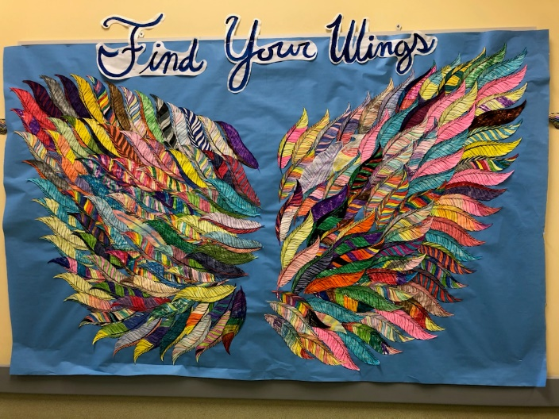
- Innovative Practices and Implementation
As in all schools around the world, during the COVID-19 Pandemic of 2020, NMFA implemented a wide variety of new, innovative practices.
Google Classroom:
Our entire online Student Learning System was based on Google Classroom. Google Classroom integrates ClassTag, our parent communication app, with daily student responsibilities and messages. Students log in to Google Classroom every morning to meet with teachers, find daily assignments, Zoom invitations, and other notifications. Work is completed and uploaded to be reviewed by classroom teachers.
Programs utilized within Google Classroom include:
- Lexia Reading Program
- Reflex and Freckle Math
- IXL – All subject areas
- Generation Genius Science
- HMH Digital Curriculum including:
  - Go Math
  - Science Fusion
  - Journeys Literacy Curriculum
  - Social Studies
Pearson/SAVVAS Curriculum including:
- MyPerspective ELA
- MyWorld Interactive History and Geography
- The Future
Additional Grade Added: In September of 2020 we expanded to become a complete K-8 school with the opening of our new middle school wing. Construction to add three classrooms, a science lab, and two bathrooms has been completed. We were excited to welcome new middle school students and additional K-4 students to fill up our space.

Other plans for the future include:

- Continuing to increase our after school clubs and activities.
- Offering more access to our coding, robotics, and engineering activities.
- Improve our science program, including adding a new instructor, new equipment, and more hands-on activities.
- Increasing partnerships with our communities of Oakdale, North St. Paul, and Maplewood, and East St. Paul.
- Committing to more community service projects with our North St. Paul neighbors.
- Connecting with local colleges to enrich our academic programs.

- Administrator Professional Development Plan
Strategies | Time Line | Resources
Read professional books and articles and viewing webinars featuring strategies for continuing instruction and engaging students in Distant/Remote Learning | September 1, 2020 - August 1, 2021 | An abundance of articles from:  - Education Week  - Edutopia  - The Institute of Educational Services  - Scholastic  - American Psychological Association  - ASCD  Webinars through:  - EdWeb  - EdSource  - Pearson  - EdWeek
Regional Centers of Excellence: Continuous Improvement Under ESSA Workshops | September 1, 2020 -August 1, 2021 | Continuing Participation in Professional Development with RCE Staff  - Explore beliefs and dispositions that support the learning of all students  - Build understanding of how evidence and data is used in school improvement  - Explore resources that can be used in planning and conducting a Comprehensive Needs Assessment that is aligned with ESSA requirements (i.e. Resource Inequities)  - Build understanding of the Exploration stage of the active implementation framework in the context of school improvement planning, including:  - The role of the leadership team in the continuous improvement planning process  - Meaningful stakeholder engagement and communication  - Utilize work time with teams for School Improvement planning with support from Regional Centers of Excellence staff.  This support will continue throughout the 2020-2021 school year.
MDE Charter Leader Support Network Training | January 1, 2020 - August 1, 2021 | Understanding the crucial role principals play in directly and indirectly influencing student achievement, the Minnesota Department of Education (MDE) provides resources and direction to principals and their supervisors for use in growth-focused principal development and evaluation, and for use in principals’ work as instructional leaders.
Personal Leadership Coaching and Mentorship with Jean Duffy, Ed.D. | September 1, 2020 -August 1, 2021 | Understanding that it takes time and experience for new school principals to feel comfortable in their role, Dr. Duffy works with me to not only focus on the immediate demands of the role, but also asking what differences these demands will make to students’ learning. By working with Dr. Duffy, I gain insights into what works and what does not, while modeling the ongoing learning principles I expect from teachers and students.

- Community Partnerships
North St. Paul Public Library
Every week, every classroom walks to the library to borrow books for independent reading. The teachers coordinate with the librarians throughout the school year.
Hill Murray High School
Every semester 15 Junior and Seniors from Hill Murray High School tutor students in reading and math on site. Three times a week they come to our school. Twice a year a group of 6-8 students come to our school to do a service project on site for our school. Twice a year there is a food drive to supplement food for our emergency food shelf. Hill Murray also invites our students to their theater performances.

North High School
The National Honor Society has partnered with us to provide support to our students and families to support our Scholastic Book Fair and tutoring. The Show Choir and band visit our school to showcase the performing arts.
North Presbyterian Church
North Presbyterian Church has donated funds to the Sheridan Story Project to provide 50 meals each week for families. These meals are sent home in students’ backpacks. They have also helped us create an emergency food shelf for our families.
North St. Paul Fire Department and Police Department
We have an ongoing partnership with both departments to provide education and support to our students and families.
North St. Paul/Maplewood/Oakdale Local businesses
Numerous businesses throughout our community give donations to our annual carnival.

World’s Best Workforce Plan
You can find our WBWF Plan at:
https://northmetroflex.com/resources/

