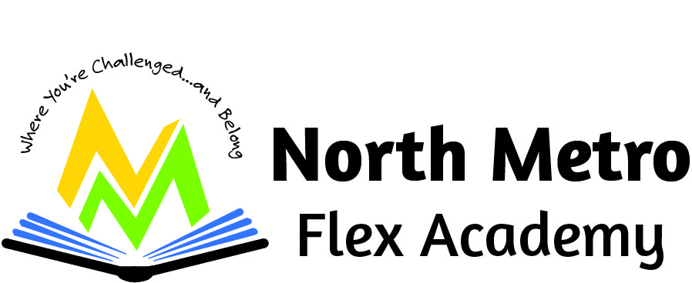

North Metro Flex Academy
2350 Helen St. North St. Paul, MN 55109
651-300-6300
2023 – 2024

Combined Report on
Comprehensive Achievement and Civic Readiness Report
And
Charter School Annual Report on Prior Year Progress

Table of Contents
- Introduction page 1

- School Enrollment page 2

- Student Attrition page 3

- Governance and Management page 4

- Result of Annual Assessment of Board Performance page 4 -10

- Training Each Board Member Attended in Previous Year page 11-13

- Training Completed by the School Director page 14

- Staffing page 15

- Finances page 16-19

- Review of Goals, Outcomes, and Strategies from the Previous Year page 20-38

- Innovative Practices and Implementation page 39-41

- Improvement plans (including improving curriculum,
instruction and cultural competency) Leading to Comprehensive
Achievement and Civic Readiness page 42
Additional Goals in Contract with Authorizer (NEO) page 46

- Efforts to Equitable Distribute Diverse, effective, and In-Field
Teachers page 47
(Documentation of dissemination of information about school’s
offering and enrollment procedures to diverse community groups.
The dissemination of information must be to families that reflect
the diversity of Minnesota’s population and targeted groups. The
targeted groups include students of
color, at risk of academic failure, and underrepresented relative to
Minnesota’s population, as well as families and communities
identified as low-income.)

- Future Plans page 49

Table of Contents
for the Strategic Plan for the Coming Year

- Introduction page 54
School mission, vision, how the school is meeting the primary and
additional purposes for which it was chartered, and name of
school authorizer.

- Goals and Benchmarks for the coming year page 55
(Aligned to the 5 Comprehensive Achievement and Civic
Readiness goals of all children are ready for school, all racial and
economic achievement gaps between students are closed, all students
are ready for career and college, all students graduate, and all students
are prepared to be lifelong learners.

- Process to Evaluate Progress Toward Standards page 69

- Process to Identify Students for Gifted/Talented Programs and
Accelerate their learning page 72

- Process to Adopt Early Admission Procedures page 76

- System to Review the Effectiveness of Instruction and Curriculum page 78

- System to Provide Student Access to Effective Teachers Who Reflect the
Diversity of Enrolled Students page 82

- Strategies for Improving the Englis Language Development of
Multilingual Learners (English Language Learners) page 86

- Practices that Integrate High Quality Instruction, Rigorous
- Curriculum,
Technology, and a Collaborative Prfessional Culture page 90

- Annual Budget for Implementing the Long-Term Strategic Plan page 93

- Introduction

Our Mission
We are a high-performing and innovative close-knit school that produces students capable of exemplary levels of critical thinking and achievement. In our school, we use exceptional curriculum, tools, and teaching to maximize student success in life.
Our Vision
We prepare a diverse community of elementary and middle school students to be successful in high school, post-secondary and in their chosen vocation through a flexible learning experience that develops analytical, compassionate, disciplined and self-directed learners.
Our History
North Metro Flex Academy opened in the Fall of 2016 as a K-4 school with 170 students in attendance. The school has since expanded to include 5th grade in 2017, sixth grade in 2018, seventh grade in 2019 and 8th grade in 2020. Our school is very diverse, including a rich blend of students from different cultures, ethnicities, and socio-economic backgrounds. Our staff reflects the makeup of our student population, and includes members of the Latino, East African, and African American communities. We are now in the process of forming committees, engaging stakeholders, and enriching our academic and extra-curricular activities to better serve our community of learners.
Novation Education Opportunities (NEO) our school’s authorizer.
Wendy Swanson Choi is the Executive Director and can be contacted at 612-889-2103 and executive.director.neo@gmail.com. NEO is organized under the Minnesota Nonprofit Corporation Act exclusively for a charitable and educational purpose, more specifically to oversee innovative charter schools through consistent, ongoing and robust evaluation to achieve significant and measurable student growth through the authorizing of public charter schools as defined in Minnesota Statutes 124E. To this end, NEO shall at all times be operated exclusively for charitable purposes within the meaning of Section 501(c)(3) of the Internal Revenue Code. All funds, whether income or principal, and whether acquired by gift or contribution or otherwise, shall be devoted to said purposes.
Contact InformationNovation Education Opportunities
3432 Denmark Ave, Ste. 130
Eagan, MN 55133
612-889-2103
Executive.director.neo@gmail.com
1
- School Enrollment
190 Students (data from February 2024)
Kindergarten – 6th Grade 7th-8th Grade
American Indian 0% 0 0% 0
Asian 6% 9 2.5% 1
Black or African American 35.3 % 53 42.5% 17
Hispanic or Latino 24% 36 27.5% 11
Native Hawaiian/Pacific Islander 0% 0 0% 0
White 24% 36 20% 8
Two or more races 10.7 % 16 7.5% 3

English Learners 23.3% 35 20% 8
Special Education 25.3% 38 30% 8
Free/Reduced 76.7% 115 80% 32
Homeless 1.3% 2 0% 0

2

- Student Attrition
Enrollment
10/1/2023 9/2024 9/1/2024 (new) 10/1/2024
Returning
K 13 7 19 19
1 20 14 6 13
2 27 24 1 15
3 23 18 4 28
4 17 14 4 22
5 27 19 4 18
6 21 13 10 29
7 21 20 8 21
8 19 3 23
188 129 59 188

3
NMFA Board of Directors
- The NMFA Board is comprised of parents, teachers, and community members, Governance and Management
and meets on the third Wednesday of each month. Meeting dates and times are posted on the school door as well as on our website (www.nmfamn.org). We held a board election in May of 2024.
Mike Leary Board Chair Community Member 7/1/23-6/30/25
Dave Isaacson Treasurer Teacher 7/1/22-6/30/25
Kyle Johnson Secretary Teacher 7/1/23-6/30/25
Joe Palkowitsch Member Parent 7/1/23-6/30/25
Barbara Smith Member Parent 8/1/24-6/30/2

- Result of Annual Assessment of Board Performance
2024-2025 Board Development Plan Minutes and Action Items.docx.pdf
NMFA 2024-2025 BOARD DEVELOPMENT PLAN This plan describes a formal process to sustain and regenerate our Board. This plan is intended to ensure that:
● We have a working knowledge of the prevailing value system as well as the talents and levels of commitment for each Board member.
● Board members understand the importance of establishing data-based methods for goal evaluation.
● Board members understand techniques for recruiting and developing new Board members as well as improving the knowledge and skills of existing Board members.
● The Board understands the difference between governance and management, guarding against intrusive micro-management.
● We have adequate strategic planning for long-term sustainability.
● Board members avoid expressing individual preference at the expense of the group.
● Board members avoid expressing the power of the Board outside the confines of a Board meeting.
4
Plan Contents A. Board Organization (based on goal of 7 Board Members): Name Board Role Representation Governance/ Personnel Committee
Finance Committee Policy Committee
Michael Leary Board Chair Community Chair Member
Dave Isaacson Treasurer Teacher Chair Secretary
Kyle Johnson Secretary Teacher Chair
Joe Palkowitsch Member Parent Member
Barbara Thomas Smith Member Parent Member
Member TBD Open TBD

Sustainable Board Model:
● The Governance/Personnel Committee duties and scope includes:
o Goals and strategy o Board involvement with principal and principal performance goals and feedback. 1
o Overall compliance assurance with education, contractual and legal requirements
o Guides the nomination process.
● The Finance Committee duties and scope includes:
o Budget development and monitoring monthly financials.
o Finance compliance assurance.
o Ensure yearly financial audit.
o Review proposed expenditures and approve actual expenditures.
o Ensuring adequate Internal control process
● The Policy Committee duties and scope includes:
o Monitoring currency and effectiveness of existing policies
5
o Identifying need for potential new policies and development for Board review/approval (in conjunction with principal and other relevant contributors)
o Creates and maintains a Policy Review Calendar (See Appendix A)
o Reviews progress towards policy goals quarterly and updates the Board as a standing quarterly agenda item.

C. Board Development and Sustainability Goals
● The board size is at least 5 and targeted at 7 members. Methods of recruitment include:
o Poll teachers for 1-2 members.
o Post on Facebook
o Ask teachers to talk to targeted parents, Newsletters
o Obtain word of mouth through contacts for community representatives
o Business and local community outreach (e.g., business associations, civic groups)
● The Board meets monthly to improve effectiveness and safeguard sustainability.
● Board and committee attendance (recorded and reported in minutes) are kept on the Google Docs site.
● Enforce a Board member attendance threshold that demonstrates the Duty of Caring (i.e., attending ¾ of Board meetings annually). See Board minutes for attendance documentation.
● Censure behavior that is counter to Board values and good governance
● The Board holds an annual retreat/workshop (July) to review and update short-term and long-range goals and monitor Board performance.
6

o Published current and long-range goals for the Board and school are maintained on a dedicated Board Google Docs site with access to all Board members.
● Keep updated key Board documents located on the Board Google Docs site and/or school website (if required to be published there), including:
o Original Application of the Charter and its Bylaws,
o Current Charter Contract with NEO
o Board Policies
o School Plans , Handbooks
o Leases
o Audits
o Calendar
o Annual Reports
o Board Agendas and Minutes, Financial Reports
● Use the Board self-evaluation system (See Appendix B)
● Maintain a skill improvement track for individuals (See Appendix C)
● Create a group development program.
o Develop systems to assure continued cohesiveness.
o Develop systems to allow for on-going training and recording of same (see plan in D below)
D. Board Short-Term Goals (during current school year)
● Recruit at least 1 Community Board member and 1-2 other Board members in upcoming school year (Parent member added before start of school year).
● Continue payment of long-term debt per settlement agreement
7
● Evaluate new academic targets proposed in NEO Performance Matrix and continue to establish goals and process for closing gaps as quickly as feasible.
● Review and approve the new school curriculum.
● Achieve renegotiation of lease and/or payment adjustments reflecting payoff of loan 3
● Identify and obtain opportune grants to support special projects or needs.
● Implement succession plan for Board Officers
● Deliver plan for updating school policies!
● Utilize available Board training resources and events, including:
o Complete NEO MN Charter Board website topics and collect certificates providing documentation of completion:
▪ All Board members have completed all 3 Initial Board Training Learning and the 6 Charter Board Training mini courses.
▪ All Board members will complete added courses within 6 months after publication. One mini course will be discussed at the Board meeting each month as part of the standing agenda item.
▪ Determine best use of MACS resources with new membership.
o Utilize internal Board training resources consistent as appropriate and available along with review of MN Charter Board mini courses timing, such as (TBD during monthly Board agenda planning):
▪ Finance/Avoiding Audit pitfalls – Kyle Knudson
▪ Legal Matters – Our Attorney
▪ Academics/Curriculum – Debbie Kranz
▪ Special Education methods – Dave Isaacson
8
▪ New Charter School requirements / Achieving NEO recognition certificates – Wendy Swanson-Choi, NEO E. Board Long-Term Goals
● Achieve academic and financial targets included in NEO Performance Matrix and obtain renewal after the current 5 years.
● Achieve student recruitment and retention targets.
● Retain staff and achieve needed professional development and certifications.
● Achieve 20% Fund Balance within 5-year renewal time and maintain it during the next 5 year NEO renewal cycle.
● Integrate any NEO Board areas of concerns included in Charter School Contract into additional goals [completed?]
● Make Use of Board Development Plan to achieve Board Goals (i.e., action plans based on annual evaluations)
● Annual Board Retreat includes review and self-evaluation of progress against Board Development Plan (July 2024).
● New member orientation program (to be completed within first month of new Board member approval) 4
● Direct new members to the Board Google site and school website to find: ▪ Bylaws
▪ NEO Charter Contract, Policies
▪ Calendar
▪ Handbooks
▪ Web directions
▪ Board expectations including hours per month and attendance.
▪ Committees and assignments
o Develop a calendar of events for new members (to be created along with new Board member approval):
9

▪ Attend at least two meetings before being seated.
▪ Complete all 6 Charter Board mini courses in the first year of election (all 3 Initial Board Training Learning Plans within first 3 months)
5. APPENDIX A POLICY REVIEW CALENDAR (TO BE UPDATED QUARTERLY AND STANDING AGENDA ITEM) https://drive.google.com/drive/folders/1H0yFIj73ajyvurvXG8qEocy4b9Dm4GKK POLICY TARGET YEAR FOR REVIEW CHANGES NEEDED?
BOARD REVISION DATE
5.5.10 Face Covering Protocol
8.3 Crisis Management
7.1 Segregation of Duties
4.1.2 At-Will Employment Procurement Policy
3.2 Administration of the MN Gov Data Practices Act
5.4.2 Bullying Prevention
7.2.1 Board Approval of Vendor Contracts
6.2 Length of School Year and School Calendar
6 5.4 Student Uniforms
5.9.2 NMFA English Learners was removed and replaced with the LIEP plan

10
- Training Each Board Member Attended in Previous Year
Title | Mike | Dave | Kyle | Joe | Smith (New Board Member)
Abide by the Bylaws | 11/19/2019 | 11/18/2019 | 6/10/2022 | 03/27/2022
Adopt a Budget | 12/18/2019 | 11/24/2019 | 3/20/2022 | 01/18/2023
Adopt a World's Best Workforce Strategic Plan | 12/18/2019 | 11/24/2019 | 6/27/2022 | 12/13/2021
Adopt Required Reports #2 WBWF Summary Report | 12/18/2019 | 11/30/2019 | 6/27/2022
Approve a World's Best Workforce and Annual Report | 1/15/2020 | 12/15/2019 | 6/15/2022 | 12/15/2021
Close a Board Meeting | 1/15/2020 | 1/13/2020 | 2/20/2023 | 01/17/2023
Comply with Admissions and Lottery Requirements | 1/15/2020 | 1/13/2020 | Um
Comply with Nondiscrimination Statutes | 1/15/2020 | 1/13/2020 | Um
Conduct A Board Election | 2/2/2020 | 3/15/2020 | 6/10/2022 | 03/24/2022
Conduct Financial Oversight of Cash Flow | 2/2/2020 | 4/15/2020 | 3/27/2022
Conduct Financial Oversight of Fund Balance | 2/17/2020 | 5/1/2020 | 6/15/2022
Conduct Financial Oversight of Pupil Units | 2/17/2020 | 5/1/2020 | 6/14/2022 | 2/22/2023
Conduct Open Meetings | 2/17/2020 | 6/15/2020 | 2/19/2023 | 07/29/2022
Create a Board Development Plan | 2/17/2020 | 7/21/2020 | 6/14/2022 | 01/17/2023
Develop and Use Policies | 2/17/2020 | 8/24/2020 | 2/19/2023 |  | Page 11
Earn The MDE School Finance Award | 2/17/2020 | 9/15/2020 | 6/27/2022
Evaluate Progress Towards Contract Goals | 2/16/2021 | 9/15/2020 | 2/19/2023
Evaluate the Leaders | 2/16/2021 | 11/14/2020 | 6/10/2022 | 2/22/2023
Hold a Public World's Best Workforce Meeting | 2/16/2021 | 11/14/2020 | 2/23/2023 | 2/22/2023
Look Out for Conflicts of Interest | 5/15/2021 | 3/22/2021 | 3/27/2022 | 03/25/2022
Maintain Authorizer Relations | 5/15/2021 | 3/22/2021 | 2/19/2023 | 2/22/2023
Maximize Revenue with Reimbursements | 5/17/2021 | 4/15/2021 | 2/20/2023
Meet Accessibility Requirements | 5/17/2021 | 4/15/2021
Meet Early Learning Program Requirements | 5/17/2021 | 7/1/2021 | 7/3/2022
Meet Requirements for Serving Multilingual Learners | 7/9/2021 | 7/1/2021 | 8/17/2022
Meet School Nutrition Program Requirements | 7/9/2021 | 7/1/2021 | 2/19/2023
Negotiate a Building Lease | 7/9/2021 | 8/13/2021 | 2/19/2023
Negotiate the Charter Contract | 7/9/2021 | 8/13/2021 | 2/19/2023
Oversee Proper Use of Public Funds | 7/9/2021 | 8/13/2021 | 8/17/2022
Participate in Meetings Remotely | 7/20/2021 | 9/12/2021 | 2/23/2023 | 2/22/2023
Prevent Audit Findings for Misstatements | 3/7/2022 | 9/11/2021 | 6/27/2022
Prevent Audit Findings in Internal Controls |  | 9/11/2022 | 3/27/2022 |  | Page 12
Prevent Audit Findings in Legal Compliance |  | 9/11/2022 | 12/5/2022
Respond to Complaints |  | um | um
Respond to Data Requests |  | 7/5/2022 | 12/5/2022
Retain and Maintain Records |  | 7/5/2022 | 12/5/2022
Run an Orderly Board Meeting |  | um | um
Safeguard Personnel Data |  | 6/12/2022 | 2/20/2023 | 01/17/2023
Safeguard Student Data |  | 6/12/2022 | 2/20/2023 | 03/25/2022
Take Minutes |  | 6/8/2022 | 3/27/2022 | 4/19/2023

13

- Training Completed by the School Director
Tier 4 License Elementary Education 1-6 Expiration 6/30/2027
125 clock hours
Professional Administration Principal K-12, Expiration 6/30/2027
125 clock hours
MESPA Conference Trainings February 2024
BARR Training Trauma Informed Practices and Meetings August 2024
Staff Annual Health and Safety Training 2024
Cultural Competency Training 2024
Mandated Reporter Training 2024
Civil Rights Training 2024
Suicide Prevention Training 2024
American Indian Training 2024
Food Service Training 2024
Literacy Learning for Leaders February 2023Charter Leader Support Network Leading with a Learner –Centered Equity Lens June 2023
Charter Leader Support Network Summer Retreat July 2023
Envoy Training August 2023
Innocent Classroom Training August 2023
Suicide Prevention August 2023
Mental Health August 2023
LETRS Training November 2022
LETRS Training Principal Primer Units 1-4 November 2022
NEO Celebration of Leading and Learning May 2023
NEO Celebration of Leading and Learning November 2022

14
- Staffing
Principal: Debra Kranz
Operations: Chelsea Smieja
Special Education Lead Teacher and Coordinator
Licensed Staff
Last Name First Name Position
Kranz Debra Principal
Smieja Chelsea Operations
Isaacson Dave SPED Coordinator
Russell Ember Kindergarten
Nash Kaylee First Grade
O’Rourke Colleen Second Grade
Skalbeck Paul Third Grade
McKee Chris Fourth Grade
Johnson Kyle MS Social Studies/Science
Winter Kelly MS Math
Listerud Tina MS ELA
Matsen Megan Science
Anderson Madeline Music and Art
Engstrom Caesare PhysEducation/Health/DAPE
Hastings Lacey Special Education
Peterson Julie Special Education
Dobbelmann Amanda Special Education
Marchetti Barbara Special Education
Bercaw Elizabeth ELL
Support Staff
Last Name First Name Position
Smieja Chelsea Operations
Wheeler Lisa Paraprofessional
Mogren Amy Paraprofessional
Round Karissa Sped Para/Food Service
Gonzaga Anna Sped Para
Jagerson Madeline Sped Para and Student Teacher
Matsen Megan Sped Para
Carey Garius Cultural Liasion
Kaeder Pam Sped Para
Olson Carolina Sped Para/Cultural Liasion
Hernandez Gerardo Sped Para/Cultural Liasion
Johnson Sara ADSIS Para
Cowan Chris Title 1/Sped Para
Walton Nichole Sped Para (page 14)

Fadlalla Amina Sped Para
Crowley Ceil DAC/Destination Imagination
Robinson Mark BIS/Cultural Liasion

15

- Finances
The school’s financial packet and supplemental transaction data are reviewed monthly at the Board’s Finance Committee. At this committee, members review and inspect the financials, receiving clarifications and answers to questions on line items that may be outside the expected numbers as compared to the budget. The Board Treasurer and Finance Manager provide a monthly update at each regularly scheduled board meeting providing full transparency to the board, staff and community.

Schools typically receive most of their funding through state sources, derived from legislation passed by the Minnesota legislature. In FY2024, North Metro Flex received funds from local sources, federal and state funding. The breakdown is represented in the graph below:
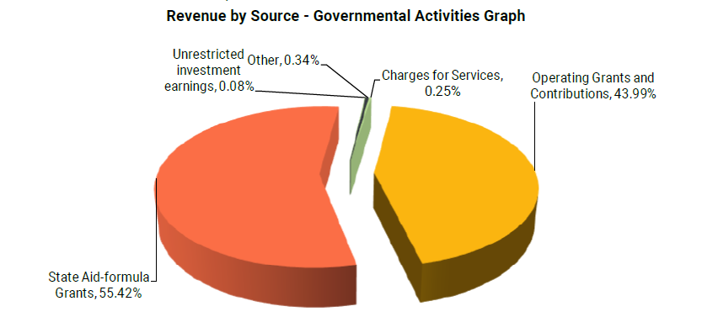

North Metro Flex Academy continues to focus on investing most of its dollars directly into instructional activities to keep the funds as close to the students as possible. Spending funds in the classroom helps to ensure that our money is where our focus is, with our students. Instructional expenses make up over 70% of all spending at North Metro Flex Academy as represented below.

16
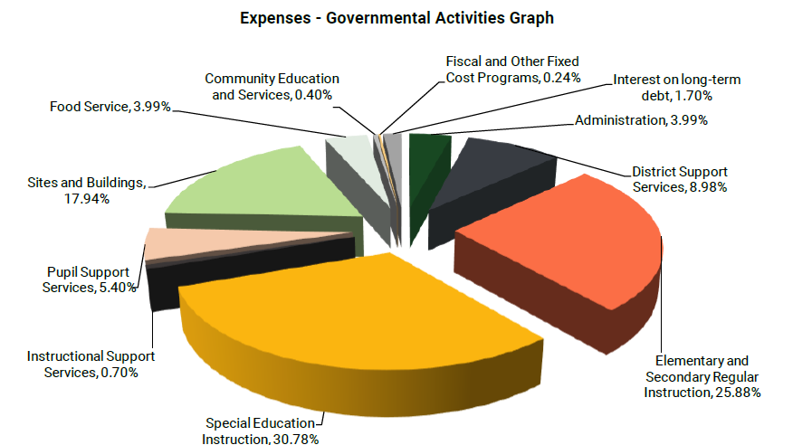

Audited financial statements for North Metro Flex Academy showed a loss of $77,896 for FY2024. This results in a fund balance of 673,760 or 17.5% when considering all fund balances. When considering only unrestricted fund balances, the school finished the year at 15.47%. This is represented in the balance sheet and income statements provided below.

17
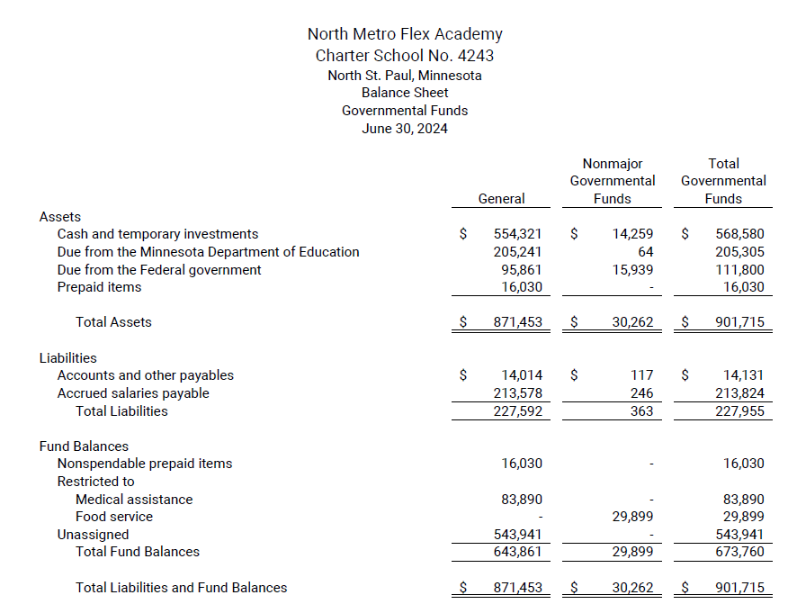

18
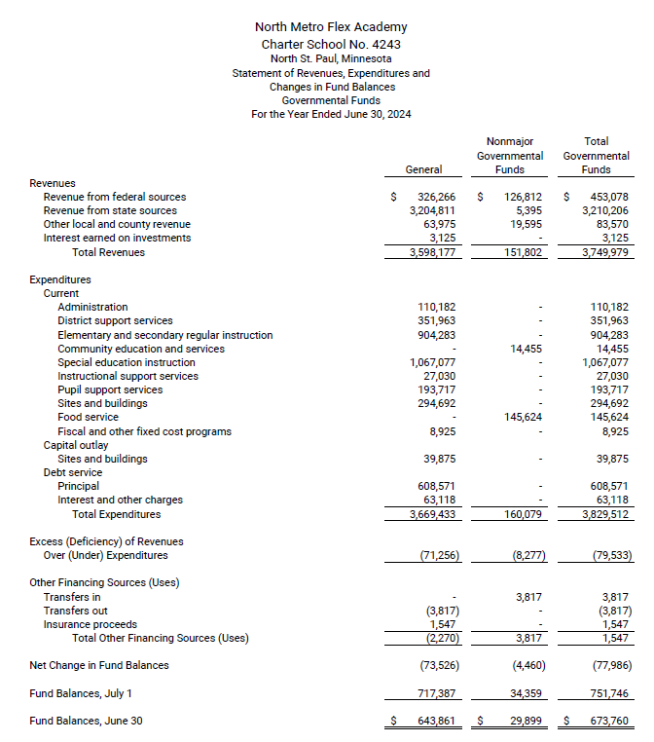

19

- Review of Goals, Outcomes, and Strategies from the Previous Year
Review of Goals, Outcomes, and Strategies (2023-2024)
How was this calculated?
FastBridge: Reporting: Group Growth Report: (aReading, earlyReading, aMath, or earlyMath)
- Set the Start and End dates to fall and spring of the same school year.
- Click the + to expand the data where the students names are.
- Set the data to sort by fall score.
- Use the Norms guide to find the 50th %ile for fall (this is the grade level line)
- Draw a line between 0-49%ile and 50th%ile and above
- Count how many students are below the 50th%ile in the fall
- Move over to the “Monthly Observed Growth %ile)
- Count the number of students who started below the 50th%ile in the fall who made 50% or more growth.

**Repeat for students at and above the 50th %ile in the fall
The calculation for below grade level in the fall is:
- # of kids at or above 50th%ile in growth over # of kids who scored below grade level in the fall
The calculation for above grade level in the fall is:
- # of kids at or above 50th%ile in growth over # of kids who scored at or above grade level in the fall

The 50th%ile in the fall is the on grade level line.
The 50th%ile or above in growth shows making at least a year’s growth.

20
Grades K-1 earlyMath (at or above 50th%ile)
Exemplary | 30% of students in grades K-1 who test at or above the 50th percentile in the fall in earlyMath will have fall to spring growth at or above the 50th percentile. | 8
Satisfactory | 24% of students in grades K-1 who test at or above the 50th percentile in the fall in earlyMath will have fall to spring growth at or above the 50th percentile. (Actual: 2/7= 28%) | 4 | 4
Not Satisfactory | Less than 24% of students in grades K-1 who test at or above the 50th percentile in the fall in earlyMath will have fall to spring growth at or above the 50th percentile. | 0
Grades K-1 earlyMath (below 50th%ile)
Exemplary | 40% of students in grades K-1 who test below the 50th percentile in the fall in earlyMath will have fall to spring growth at or above the 50th percentile. (Actual: 8/18= 44%) | 8 | 8
Satisfactory | 34% of students in grades K-1 who test below the 50th percentile in the fall in earlyMath will have fall to spring growth at or above the 50th percentile. | 4
Not Satisfactory | Less than 34% of students in grades K-1 who test below the 50th percentile in the fall in earlyMath will have fall to spring growth at or above the 50th percentile. | 0

Results | Year | Fall earlyMath Scores At or Above 50th Percentile | Fall to Spring Growth At or Above the 50th Percentile | Fall earlyMath Scores Below 50th Percentile | Fall to Spring Growth At or Above the 50th Percentile
Results | 2021-2022 | NWEA | NWEA | NWEA | NWEA
Results | 2022-2023 | NWEA | NWEA | NWEA | Page 21
Results | 2023-2024 | 7 | 2 | 18 | 8
Results | 2024-2025
Results | 2025-2026
Results | 2021-2026
Analysis | The school's combined average 2023-2024 Fall-Spring growth rate is 40%.

Grades K-1 earlyReading (at or above 50th%ile)
Exemplary | 40% of students in grades K-1 who test at or above the 50th percentile in the fall in earlyReading will have fall to spring growth at or above the 50th percentile. (Actual: 3/3= 100%) | 8 | 8
Satisfactory | 34% of students in grades K-1 who test at or above the 50th percentile in the fall in earlyReading will have fall to spring growth at or above the 50th percentile. | 4
Not Satisfactory | Less than 34% of students in grades K-1 who test at or above the 50th percentile in the fall in earlyReading will have fall to spring growth at or above the 50th percentile. | 0
Grades K-1 earlyReading (below 50th%ile)
Exemplary | 40% of students in grades K-1 who test below the 50th percentile in the fall in earlyReading will have fall to spring growth at or above the 50th percentile. | 8
Satisfactory | 34% of students in grades K-1 who test below the 50th percentile in the fall in earlyReading will have fall to spring growth at or above the 50th percentile. Page 22 | 4
Not Satisfactory | Less than 34% of students in grades K-1 who test below the 50th percentile in the fall in earlyReading will have fall to spring growth at or above the 50th percentile. (Actual: 0/22= 0%) | 0 | 0

Results | Year | Fall earlyReading Scores At or Above 50th Percentile | Fall to Spring Growth At or Above the 50th Percentile | Fall earlyReading Scores Below 50th Percentile | Fall to Spring Growth At or Above the 50th Percentile
Results | 2021-2022 | NWEA | NWEA | NWEA | NWEA
Results | 2022-2023 | NWEA | NWEA | NWEA | NWEA
Results | 2023-2024 | 3 | 3 | 22 | 0
Results | 2024-2025
Results | 2025-2026
Results | 2021-2026
Analysis | The school's combined average 2023-2024 Fall-Spring growth rate is 12%.

23
Grades 2-5 aReading (at or above 50th%ile)
Exemplary | 30% of students in grades 2-5 who test at or above the 50th percentile in the fall in aReading will have fall to spring growth at or above the 50th percentile. (Actual: 8/25= 32%) | 8 | 8
Satisfactory | 24% of students in grades 2-5 who test at or above the 50th percentile in the fall in aReading will have fall to spring growth at or above the 50th percentile. | 4
Not Satisfactory | Less than 24% of students in grades 2-5 who test at or above the 50th percentile in the fall in aReading will have fall to spring growth at or above the 50th percentile. | 0
Grades 2-5 aReading (below 50th%ile)
Exemplary | 40% of students in grades 2-5 who test below the 50th percentile in the fall in aReading will have fall to spring growth at or above the 50th percentile. (Actual: 32/52= 61%) | 8 | 8
Satisfactory | 34% of students in grades 2-5 who test below the 50th percentile in the fall in aReading will have fall to spring growth at or above the 50th percentile. | 4
Not Satisfactory | Less than 34% of students in grades 2-5 who test below the 50th percentile in the fall in aReading will have fall to spring growth at or above the 50th percentile. | 0

Results | Year | Fall aReading Scores At or Above 50th Percentile | Fall to Spring Growth At or Above the 50th Percentile | Fall aReading Scores Below 50th Percentile | Fall to Spring Growth At or Above the 50th Percentile
Results | 2021-2022 | NWEA | NWEA | NWEA | NWEA
Results | 2022-2023 | NWEA | NWEA | NWEA | NWEA Page 24
Results | 2023-2024 | 25 | 8 | 52 | 32
Results | 2024-2025
Results | 2025-2026
Results | 2021-2026
Analysis | The school's combined average 2023-2024 Fall-Spring growth rate is 52%.

25
Grades 2-5 aMath (at or above 50th%ile)
Exemplary | 30% of students in grades 2-5 who test at or above the 50th percentile in the fall in aMath will have fall to spring growth at or above the 50th percentile. | 8
Satisfactory | 24% of students in grades 2-5 who test at or above the 50th percentile in the fall in aMath will have fall to spring growth at or above the 50th percentile. (Actual: 2/7= 28%) | 4 | 4
Not Satisfactory | Less than 24% of students in grades 2-5 who test at or above the 50th percentile in the fall in aMath will have fall to spring growth at or above the 50th percentile. | 0
Grades 2-5 aMath (below 50th%ile)
Exemplary | 40% of students in grades 2-5 who test below the 50th percentile in the fall in aMath will have fall to spring growth at or above the 50th percentile. (Actual: 23/53=44%) | 8 | 8
Satisfactory | 34% of students in grades 2-5 who test below the 50th percentile in the fall in aMath will have fall to spring growth at or above the 50th percentile. | 4
Not Satisfactory | Less than 34% of students in grades 2-5 who test below the 50th percentile in the fall in aMath will have fall to spring growth at or above the 50th percentile. | 0
Results | Year | Fall aMath Scores At or Above 50th Percentile | Fall to Spring Growth At or Above the 50th Percentile | Fall aMath Scores Below 50th Percentile | Fall to Spring Growth At or Above the 50th Percentile
Results | 2021-2022 | NWEA | NWEA | NWEA | NWEA
Results | 2022-2023 | NWEA | NWEA | NWEA | Page 26
Results | 2023-2024 | 7 | 2 | 53 | 23
Results | 2024-2025
Results | 2025-2026
Results | 2021-2026
Analysis | The school's combined average 2023-2024 Fall-Spring growth rate is 41%.

Page 27
Grades 6-8 baseline: ‘24-’25 school year aMath (at or above 50th%ile)
Exemplary | 30% of students in grades 6-8 who test at or above the 50th percentile in the fall in aMath will have fall to spring growth at or above the 50th percentile. | 8
Satisfactory | 24% of students in grades 6-8 who test at or above the 50th percentile in the fall in aMath will have fall to spring growth at or above the 50th percentile. | 4
Not Satisfactory | Less than 24% of students in grades 6-8 who test at or above the 50th percentile in the fall in aMath will have fall to spring growth at or above the 50th percentile. | 0
Grades 6-8 baseline: ‘24-’25 school year aMath (below 50th%ile)
Exemplary | 40% of students in grades 6-8 who test below the 50th percentile in the fall in aMath will have fall to spring growth at or above the 50th percentile. | 8
Satisfactory | 34% of students in grades 6-8 who test below the 50th percentile in the fall in aMath will have fall to spring growth at or above the 50th percentile. | 4
Not Satisfactory | Less than 34% of students in grades 6-8 who test below the 50th percentile in the fall in aMath will have fall to spring growth at or above the 50th percentile. | 0

Results | Year | Fall aMath Scores At or Above 50th Percentile | Fall to Spring Growth At or Above the 50th Percentile | Fall aMath Scores Below 50th Percentile | Fall to Spring Growth At or Above the 50th Percentile
Results | 2021-2022 | NWEA | NWEA | NWEA | NWEA
Results | 2022-2023 | NWEA | NWEA | NWEA | Page 28
Results | 2023-2024 | NWEA | NWEA | NWEA | NWEA
Results | 2024-2025
Results | 2025-2026
Results | 2021-2026
Analysis | The school's combined average 2024-2025 Fall-Spring growth rate is

Grades 6-8 baseline: ‘24-’25 school year aReading (at or above 50th%ile)
Exemplary | 30% of students in grades 6-8 who test at or above the 50th percentile in the fall in aReading will have fall to spring growth at or above the 50th percentile. (Actual: 8/25= 32%) | 8 | 8
Satisfactory | 24% of students in grades 6-8 who test at or above the 50th percentile in the fall in aReading will have fall to spring growth at or above the 50th percentile. | 4
Not Satisfactory | Less than 24% of students in grades 6-8 who test at or above the 50th percentile in the fall in aReading will have fall to spring growth at or above the 50th percentile. | 0
Page 29
Grades 6-8 baseline: ‘24-’25 school year aReading (below 50th%ile)
Exemplary | 40% of students in grades 6-8 who test below the 50th percentile in the fall in aReading will have fall to spring growth at or above the 50th percentile. (Actual: 32/52= 61%) | 8 | 8
Satisfactory | 34% of students in grades 6-8 who test below the 50th percentile in the fall in aReading will have fall to spring growth at or above the 50th percentile. | 4
Not Satisfactory | Less than 34% of students in grades 6-8 who test below the 50th percentile in the fall in aReading will have fall to spring growth at or above the 50th percentile. | 0

Results | Year | Fall aReading Scores At or Above 50th Percentile | Fall to Spring Growth At or Above the 50th Percentile | Fall aReading Scores Below 50th Percentile | Fall to Spring Growth At or Above the 50th Percentile
Results | 2021-2022 | NWEA | NWEA | NWEA | NWEA
Results | 2022-2023 | NWEA | NWEA | NWEA | NWEA
Results | 2023-2024 | NWEA | NWEA | NWEA | NWEA
Results | 2024-2025
Results | 2025-2026
Results | 2021-2026
Analysis | The school's combined average 2024-2025 Fall-Spring growth rate is

Page 30
Strategies to improve achievement:
- BARR Program Year 1 Implementation
- Small group and individual instruction in Reading and Math
- CEIS Reading intervention
- ADSIS Reading intervention
- New foundation program – UFLI being used for grades 1 – 3
  - (adopted for 2024-2-25)

What is UFLI Foundations?
After more than two years of development and pilot testing, we are excited to introduce you to UFLI Foundations, an explicit and systematic program that teaches students the foundational skills necessary for proficient reading. It follows a carefully developed scope and sequence designed to ensure that students systematically acquire each skill needed and learn to apply each skill with automaticity and confidence. The program is designed to be used for core instruction in the primary grades or for intervention with struggling students in any grade.
  - How does it work?
    - UFLI Foundations provides teachers with detailed but easy to follow lesson plans that all follow this eight-step routine:
    - Phonemic Awareness
    - Visual Drill
    - Auditory Drill
    - Blending Drill
    - New Concept
    - Word Work
    - Irregular Words
    - Connected Text
    - Steps 1 through 4 serve as a warm-up and review of previously taught concepts. Step 5 is an explicit introduction to a new concept including guided practice reading and spelling words. Steps 6 through 8 are opportunities to apply concepts through reading and writing activities at the word and text level.
  - What specific skills are targeted in the program?
    - UFLI Foundations targets the following foundational reading skills:
    - Phoneme blending and segmentation practice
    - Accuracy and automaticity of grapheme-phoneme correspondences
    - Decoding automaticity of words with previously learned concepts
    - Explicit introduction of new concepts

Page 31
    - Decoding and encoding practice. Reading and spelling irregular words
    - Reading and spelling connected text
  - What is special about UFLI Foundations?
    - UFLI Foundations strikes the perfect balance between structure and responsiveness to students’ needs. The program features ample opportunities for students to practice, along with built-in gradual release. It provides teachers with detailed lesson plans, a PowerPoint slide deck to accompany each lesson, and downloadable materials for homework or center activities.
    - UFLI Foundations is an example of an educative curriculum. This means that simply using the materials and lesson structure will add to your professional knowledge and skills in key areas:
    - The process of reading acquisition
    - Key linguistic elements necessary for reading
    - Evidence-based instructional methods that promote reading proficiency
    - Another key component that sets UFLI Foundations apart is the professional development available to prepare teachers to implement the lessons. You may choose to take advantage of webinars, videos of lesson components being taught, and other online resources that will help you make the most of UFLI Foundations.
  - Is UFLI Foundations aligned with the science of reading?
    - If you are familiar with the science of reading, you may have heard of Gough and Tunmer’s “simple view of reading,” which states that reading comprehension is the product of decoding and linguistic comprehension.
    - If either decoding or linguistic comprehension is weak, the effect is multiplied. That is, you can never have better reading comprehension than the level of development of either your decoding or linguistic comprehension skills.
    - With this in mind, UFLI Foundations addresses the “D” part of the equation. In many instances, students fail assessments of reading comprehension not because they cannot synthesize complex ideas presented in text, but because they do not have access to such ideas because they cannot decode the text. Ensuring students can fluently decode text affords them the opportunity to apply and refine their linguistic comprehension skills, construct meaning from text, and more accurately demonstrate their understanding on assessments.
    - Gough and Tunmer’s “simple view of reading” can be visualized as a mathematical formula:

Page 32
  - 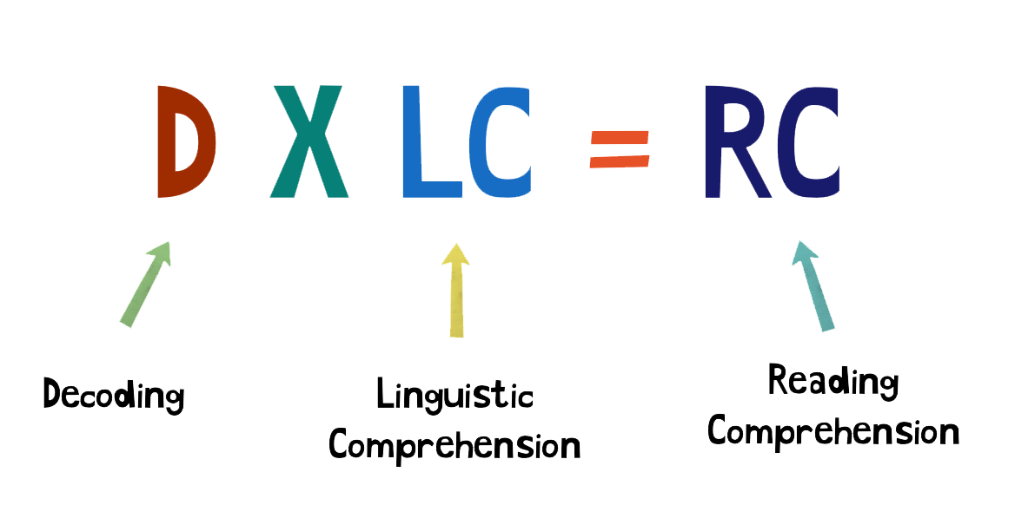
  - Is UFLI Foundations research-based? Is UFLI Foundations evidence-based?
    - UFLI Foundations is research-based. This means it was developed to align with what decades of reading research has shown to be effective. We incorporated findings from research on word reading development and effective instruction to build an explicit and systematic program for teaching children to read and spell words.
    - UFLI Foundations is also evidence-based. Before releasing the program, we spent two full years developing and piloting each component. We observed lessons, and we got feedback from teachers who were using the program. Most importantly, we assessed student progress, and we found that students who received instruction using UFLI Foundations made significant gains in phonemic awareness, decoding, and oral reading fluency.

- LETRS training 2024 – 2025 and 2025 – 2026, Read At expectation, for the professional development for all licensed teachers teaching reading
- Sonday Reading Groups
- Super Kids K-2 Reading Program (2023-2024)
- Alignment with the Science of Reading/Letrs Training
- Co-Teaching efforts with Special Ed Teachers and special ed paras
- Special Ed Para Support for small groups and individuals
- ELL Teacher supporting multilingual students, pushing into MS grades and pulling out small groups in grades K-5.
- IXL and Lexia are used as a supplemental intervention along with Adopted Bridges (math) Illustrative and My view curriciulums
- New K-8th grade ELA Currciulum “Fish Tank”
        - Page 33

We believe in students.
All students can master grade-level content, solve critical problems, and discuss complex ideas. When they receive the support they need, all students can achieve at high levels.
The Fishtank curriculum is grounded in the best practices for teaching and learning, built around rigorous objectives, and highly rated by EdReports for alignment to standards.

34
Teachers are our essential partners in fulfilling our mission, as they are in the very best position to understand the unique strengths and
needs of their students. We aim to provide them with the right balance of flexibility and support in the resources we create.
The Fishtank curriculum does not script lessons, and focuses instead on providing tools that help teachers to deeply internalize and differentiate unit and lesson content.
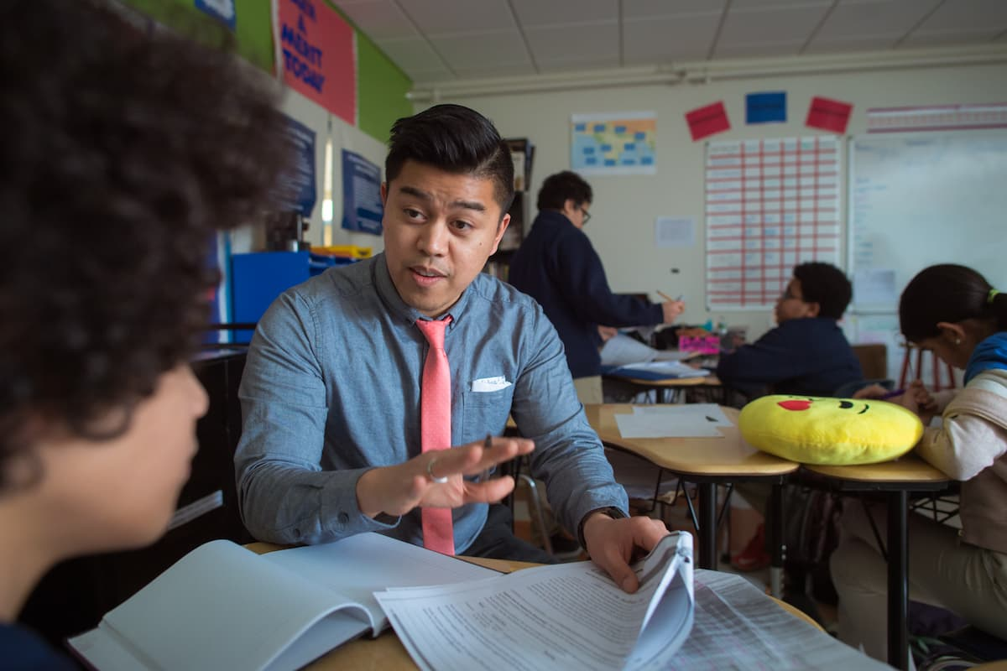
35

We strive for racial equity and social justice.Rigorous grade-level curriculum is at the heart of any anti-racist classroom. We seek to create curricular materials that center students, reflect multiple perspectives and experiences, and empower students to think critically about the world they live in.
The core Fishtank materials are available as a free Open Educational Resource
to alleviate any economic barriers to access.

36

We listen, learn, and adapt.We challenge the status quo and experiment to find new and better ways to support teachers and students. We continually improve and refine our resources by turning to the research, collaborating with partners, and actively seeking out feedback from our users.
The Fishtank curriculum team draws on their years in the classroom to craft a curriculum that meets the needs of today’s students and teachers.
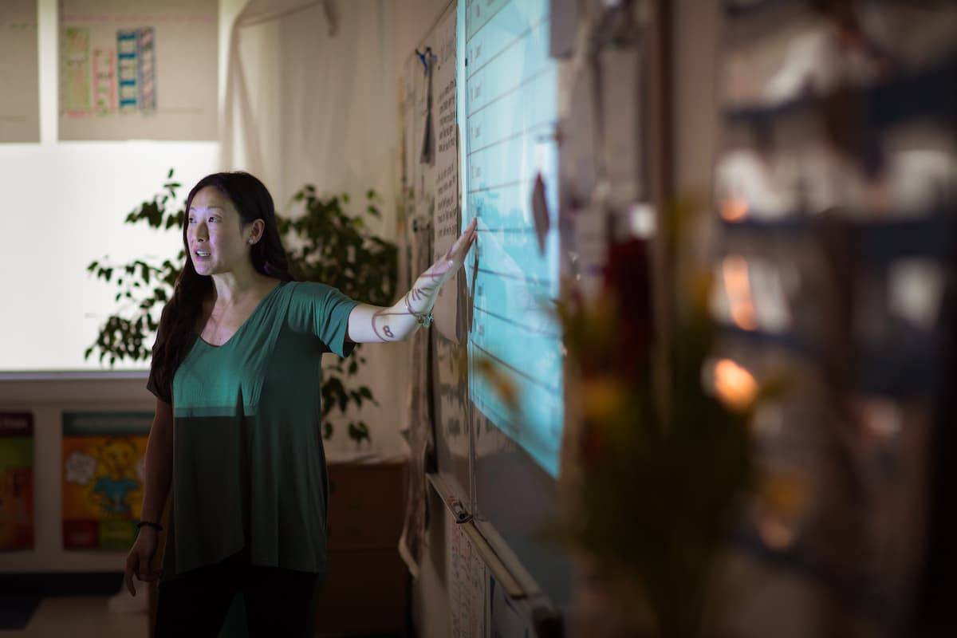

37


Mathematics

Fishtank Learning was originally founded as Match Fishtank. As a part of Match Education
, we developed the curriculum to be used in Match Charter Public School
classrooms, and began sharing the resources with teachers around the world via the Match Fishtank website in 2016. In December 2020, Fishtank Learning spun out of Match Education to create a new
38
nonprofit, fully focused on creating and sharing high quality instructional materials.
Our partnership with the teachers and instructional leaders at Match Charter Public School was invaluable as we developed the Fishtank curriculum. We are grateful to the teachers who taught the curriculum and helped us refine it over the years. The opportunity to pilot new units and receive feedback directly from classrooms has shaped the curriculum in fundamental ways.

- School Wide Title 1
- Academic: Introduced small group interventions for struggling readers and launched a new digital literacy platform.
- SEL: Staff received training in mindfulness techniques, and a school-wide "Calm Down Corner" was established in classrooms.
- Engagement: Launched a parent communication app for event reminders and feedback, and created monthly “Family Nights” to increase community involvement.

- Innovative Practices and Implementation
In Minnesota, K-8th grade charter schools often emphasize innovative practices and their implementation to provide unique educational opportunities for students. These schools, which are publicly funded but independently operated, are encouraged to experiment with different teaching methods, curriculum designs, and student engagement strategies. The goal is to improve student outcomes and offer more personalized learning experiences that may not be available in traditional district-run schools.
Here are some examples of innovative practices and their implementation at North Metro Flex Academy:

39
1. Personalized Learning
- What it is: Personalized learning tailors education to individual students' strengths, needs, and interests.
- Implementation:
  - We may use adaptive learning technology, differentiated instruction, or project-based learning.
  - Teachers might provide students with flexible learning pathways that allow for more choice in how they demonstrate mastery.
  - For example, a student might choose how they want to show their understanding of a science concept—through a video, a research paper, or a physical model.

2. Blended Learning
- What it is: Blended learning combines traditional face-to-face instruction with online learning.
- Implementation:
  - Students might work on digital lessons and assessments at their own pace, while still engaging in classroom-based activities and discussions.
  - Technology tools, such as online assessments or interactive software, are used to support the curriculum and allow for more individualized learning.

3. Project-Based Learning (PBL)
- What it is: PBL focuses on students working on a project over an extended period of time, integrating different subjects to solve real-world problems.
- Implementation:
  - A class or lesson might have students collaborate on creating a community garden, designing a model of sustainable energy, or researching historical figures to produce a class presentation.
  - PBL often emphasizes critical thinking, teamwork, and communication skills, making learning more relevant and hands-on.

4. Social-Emotional Learning (SEL)
- What it is: SEL focuses on developing students' emotional intelligence, resilience, and interpersonal skills.
- Implementation:
  - NMFA includes SEL lessons weekly from the BARR program as part of the daily schedule, using programs or curricula designed to teach self-awareness, self-management, responsible decision-making, and relationship skills.
  - Classes use mindfulness practices and restorative justice strategies to help students work through conflicts and improve emotional regulation.

6. Culturally Responsive Teaching
40
- What it is: This approach recognizes and values the diverse cultural backgrounds of students, adapting the curriculum to reflect those backgrounds and make learning more relevant.
- Implementation:
  - Teachers integrate diverse literature, historical perspectives, and cultural practices into lessons.
  - We are working towards offering bilingual education programs and focus on creating inclusive environments that celebrate different cultural traditions

7. Flexible Scheduling
- What it is: Flexible scheduling allows students to learn at times and in formats that best suit their needs.
- Implementation:
  - We are working on extended hours and offering summer programs to allow for deeper learning opportunities.
  - At times NMFA implements a block schedule that gives students more time to focus on fewer subjects in a day, rather than switching classes frequently.

9. Mindfulness and Wellness Programs
- What it is: These programs are designed to foster students' mental health and well-being.
- Implementation:
  - NMFA offers mindfulness exercises and incorporates wellness activities into the school day, such as yoga or stress-reduction techniques.
  - Wellness programs also include nutrition, physical activity, and mental health resources.

10. Family and Community Engagement
- What it is: NMFA prioritizes building strong relationships between families, students, and the wider community.
- Implementation:
  - NMFA offers meetings, surveys and family involvement in decision-making, and partnerships with local businesses and organizations, such as NSP Food Shelf, Every Meal, Polar Ridge, Kids in Need and local Fire and Student Resource Officers.
  - Hill Murray is mentorship/tutoring programs where seniors work directly to support students in academics or extracurricular activities.

41
- Improvement plans (including improving curriculum,
instruction and cultural competency) Leading to Comprehensive
Achievement and Civic Readiness
Creating an improvement plan for our school that focuses on enhancing curriculum, instruction, and cultural competency involves several key components to ensure the school meets academic standards while promoting civic readiness. Below are examples of improvement plans that focus on these areas.
We have adopted using Fastbridge Assessments for FALL, WINTER and SPRING.
We are using UFLI for foundational skills for grades K-3.
We have adopted FISH TANK Reading curriculum for grades K-8.
    - Curriculum Improvement Plan.
Objective:
To develop and implement a rigorous, standards-aligned curriculum that fosters deep learning, critical thinking, and prepares students for the 21st century.
Action Steps:
- Curriculum Mapping: Review and align curriculum with Minnesota State Standards and Common Core to ensure vertical and horizontal alignment across grade levels.
  - Develop K-8 curriculum maps that outline essential skills, key concepts, and learning objectives for each subject area.
  - Provide detailed guides for teachers on how to scaffold learning across grades to support student growth.
- Integrate Technology: Enhance digital literacy by incorporating technology-based tools to supplement instruction.
  - Provide professional development for teachers on integrating tech tools into lessons. Ensure students have access to devices and a safe, supportive digital learning environment.
- Differentiation and Personalization: Ensure that curriculum is tailored to meet the diverse needs of learners, including students with disabilities, English learners, and advanced learners.
  - Utilize Universal Design for Learning (UDL) principles in lesson planning to provide multiple pathways for students to engage with content.
42
  - Offer differentiated instruction strategies, such as tiered assignments, flexible groupings, and personalized learning goals.
- Formative Assessment Integration: Use ongoing formative assessments to inform instruction and track student progress.
  - Implement regular formative assessments (e.g., quizzes, exit tickets, observations) to identify learning gaps and adjust instruction accordingly.
  - Provide teachers with data analysis tools and professional development to improve the use of assessment data in instructional planning.
Outcome:
- Increased student engagement and academic achievement.
- Improved integration of cross-disciplinary skills such as problem-solving, collaboration, and innovation.

2. Instructional Improvement Plan
Objective:
To enhance teaching practices through evidence-based strategies, professional development, and consistent monitoring to improve student outcomes.
- Instructional Coaching: Provide ongoing instructional coaching for teachers to refine pedagogical practices. We are utilizing Kristen, the Literacy and Reading Lead Specialist Kelly, the Math Lead and Specialist, Kim from MDE Brightworks to support K-5 Math teaching, and Jen Van Horn from MDE Brightworks to support our ELL teacher and program and BARR coaches for support out BARR coordinators in planning for small block and big block meetings.
  - Pair teachers with instructional coaches to observe, model, and receive feedback on best practices in pedagogy, classroom management, and student engagement.
  - Offer coaching in differentiated instruction, culturally relevant teaching, and strategies for addressing learning gaps.
- Peer Collaboration and Professional Learning Communities (PLCs): Foster collaboration among teachers through PLCs to share best practices, review data, and develop collective goals for student success.
  - Organize regular PLC meetings (weekly or bi-weekly) to discuss student progress, analyze assessment data, and plan interventions for struggling students. Brightworks is scheduled to come on site to work with all teachers teaching math.
            - 43
- Adopt High-Impact Teaching Strategies: Implement evidence-based instructional strategies such as:
  - Project-Based Learning (PBL): Encourage hands-on, real-world projects that integrate multiple subject areas and promote critical thinking and teamwork.
  - Inquiry-Based Learning: Promote student-driven inquiry to develop research and problem-solving skills.
  - Explicit Instruction: Ensure that foundational concepts are explicitly taught, especially in subjects like reading, math, and science.
- Differentiated and Culturally Responsive Instruction: Ensure that teaching strategies are culturally responsive and support diverse learners.
  - Provide ongoing professional development on culturally relevant pedagogy to help teachers better connect with students from diverse backgrounds.
  - Train teachers to incorporate students' cultural contexts, histories, and experiences into lesson plans to make learning more relevant and engaging.
Outcome:
- Improved teacher effectiveness and student academic performance.
- Better student engagement and participation, particularly from historically marginalized groups.

3. Cultural Competency Improvement Plan
Objective:
To create an inclusive, culturally responsive school environment that embraces diversity and prepares students for civic participation in a multicultural society.
- Culturally Relevant Curriculum and Resources: Revise and expand curriculum to ensure that it reflects the diversity of students and the community.
  - Include literature, history, and case studies that represent a wide range of cultural perspectives, particularly Native American, African American, Latinx, and Asian American cultures.
  - Adopt social studies units that focus on social justice, equity, and historical contributions from diverse groups.
- Cultural Awareness Professional Development: Provide teachers and staff with ongoing training on cultural competency, bias reduction, and anti-racism.
          - 44
  - Host professional development workshops on topics like microaggressions, privilege, cultural humility, and how to foster an inclusive classroom environment.
  - Train teachers on understanding and addressing the cultural needs of English Language Learners (ELLs) and students with disabilities.
- Student Leadership and Civic Engagement: Create opportunities for students to engage in civic readiness programs.
  - Develop student leadership programs, such as student councils or community service projects, that encourage students to take active roles in the school and local community.
  - Establish partnerships with local community organizations to host civic engagement events such as town halls, debates, or volunteering.
- Family and Community Involvement: Strengthen partnerships between the school, families, and the broader community to foster an inclusive and supportive environment.
  - Establish a school-wide “Cultural Day” or regular family events to celebrate cultural diversity and foster cross-cultural understanding.
  - Form parent advisory committees that represent diverse backgrounds and provide input on school policies and programs.
- Restorative Practices: Implement restorative justice practices to foster an inclusive and respectful school climate.
  - Train staff in restorative circles, conflict resolution, and peer mediation strategies.
  - Incorporate restorative practices in discipline to emphasize community-building, accountability, and mutual respect.
Outcome:
- Improved school climate where students feel valued, respected, and supported.
- Increased student understanding of social justice and civic responsibility.
- Higher engagement from students, families, and community stakeholders.

4. Comprehensive Achievement and Civic Readiness Plan
Objective:
To prepare students academically and socially for high school, college, career, and active citizenship in a democratic society.
45
- Civic Engagement Curriculum: Integrate civic education into the K-8 curriculum, focusing on government, history, rights, and responsibilities.
  - Teach students about the U.S. Constitution, local government structures, and current events to foster a sense of civic duty.
  - Include service-learning projects that allow students to apply civic knowledge in real-world settings.
- College and Career Readiness Programs: Start building students’ understanding of career pathways and college opportunities from an early age.
  - Organize college visits, career fairs, and guest speaker events to expose students to various career options.
  - Implement career exploration activities, such as job shadowing or internships, in middle school.
- SEL and Emotional Intelligence: Integrate social-emotional learning (SEL) to support students’ mental and emotional development.
  - Teach students skills like empathy, conflict resolution, and self-regulation, which are crucial for both academic success and active citizenship.
  - Create a school-wide SEL program that is integrated across all subject areas and reinforced throughout the day.
- Data-Driven Achievement Monitoring: Use data to continuously monitor student progress toward academic and civic goals.
  - Establish systems to track academic performance (e.g., test scores, projects) and non-academic indicators of civic readiness (e.g., participation in service learning, leadership roles).
  - Use data to adjust instruction and interventions to meet individual student needs.
Outcome:
- Students demonstrate academic achievement that prepares them for future academic endeavors and professional careers.
- Increased student participation in civic-related activities and social responsibility projects.
- Enhanced sense of community engagement and social responsibility among students.

Additional Purposes Outlined in the Authorizer (NEO) Contract
In addition to the primary goals of the Annual Report, our contract outlines several key supplementary purposes designed to enhance educational outcomes and professional growth. These additional purposes are as follows:
- Increasing Learning Opportunities for All Pupils
This objective emphasizes the need to ensure that every student has access to rich, diverse, and challenging educational experiences.
Example: The implementation of numerous field trips, after-school clubs, family engagement activities and online enrichment modules have allowed students—especially those in underserved communities—to explore advanced topics beyond the standard curriculum.
- Encouraging the Use of Different and Innovative Teaching Methods
Innovation in pedagogy is a central component of the contract, aimed at improving engagement and effectiveness in the classroom.
Example: We have adopted the BARR system to support all students with social skills teaching, building relationships and keeping track of student data. We have embraced the Science of Reading and the Read Act expectations, as we have adopted UFLI for reading foundational skills teaching and FISHTANK a robust reading curriculum. We have partnered with Tickets for Kids and have found numerous grants to allow for real-world, hands on experiences with the arts, science and environmental education. Additionally, project-based learning has been introduced to promote critical thinking and real-world application of knowledge with our middle school social studies units. Brightworks, formerly Regional Centers of Excellence from MDE has supported and guided our teachers in the area of Math instruction.
- Creating New Professional Learning Opportunities for Teachers
Supporting teachers through ongoing development is essential for sustained improvement in instruction and student outcomes.
Example: The school has launched BARR, a peer-mentorship program, along with regular professional learning communities (PLCs), where educators share best practices, analyze student data, and engage in targeted workshops on instructional strategies and technology integration. All of our licensed staff have had the opportunity to participate in LETRS Training on site, which is aligned to the Science of Reading.
These additional purposes align with our commitment to continuous improvement and equity in education, ensuring both students and educators benefit from dynamic, forward-thinking approaches.

46

- Efforts to Equitable Distribute Diverse, effective, and In-Field
Teachers
Documentation of dissemination of information about school’s offering and enrollment procedures to diverse community groups. The dissemination of information must be to families that reflect the diversity of Minnesota’s population and targeted groups. The targeted groups include students of color, at risk of academic failure, and underrepresented relative to Minnesota’s population, as well as families and communities identified as low-income.
North Metro Flex Academy is committed to ensuring that information regarding offerings, enrollment procedures, and educational opportunities is accessible and inclusive to all families, particularly those from diverse backgrounds, including students of color, at-risk students, families living in poverty, and communities underrepresented relative to Minnesota's population. Below is a detailed overview of the efforts made to effectively disseminate this information:
1. Targeted Communication Strategies
- Multilingual Outreach: To reach families who speak languages other than English, the school provides materials in multiple languages (e.g., Spanish, Somali, Hmong, and other prevalent languages in the community). Bilingual staff are available for direct communication to ensure clarity and accessibility.

- Culturally Relevant Messaging: Outreach materials, including brochures, flyers, and digital communications, are designed to reflect the cultural values and needs of the community. Visual representations of the student body, success stories, and community involvement are incorporated to resonate with diverse families.

- Multiple Platforms Information is disseminated through various platforms, including the school website, social media, Smore email newsletters, local radio stations, and community centers. In-person meetings, town halls, and community events are also held to ensure direct communication.

- Partnerships with Local Organizations: The school partners with local non-profits, religious organizations, and community leaders to extend its outreach to underrepresented families. These partners play an instrumental role in ensuring that information reaches the target populations, including families with low incomes, students of color, and other groups at risk of academic failure.

47
2. Community Engagement
- Family Information Nights: The school hosts information nights/open houses for families, particularly those from targeted groups. These events are designed to provide detailed information about the school’s offerings, enrollment processes, and the educational support available for diverse learners.

- Parent and Family Support Programs Dedicated Cultural liaisons works with families from underrepresented communities to guide them through the enrollment process, answer questions, and assist with forms. This role is particularly important in supporting non-English speaking families or those unfamiliar with the educational system.

- Outreach to At-Risk and Low-Income Families: The school conducts targeted outreach efforts to connect with families who may not have easy access to information due to socioeconomic barriers. This includes phone calls, home visits, and participation in community events that address the needs of low-income families.

- Collaboration with Local School Districts: NMFA is working to collaborate with neighboring districts that have large populations of students from underrepresented communities to ensure that information about enrollment procedures and offerings is widely distributed.

3. Involvement of Students and Teachers
- Diverse Teacher Representation: The school actively recruits teachers who reflect the diversity of the student body, ensuring that students have role models from similar cultural and linguistic backgrounds. Information about available teacher positions and recruitment efforts is shared in college/community spaces and at events aimed at diverse families.

- Student Ambassadors: Current students from diverse backgrounds are invited to participate in outreach efforts, sharing their experiences and serving as ambassadors to encourage enrollment from their communities.
4. Continuous Evaluation and Improvement
- Feedback Mechanisms: Surveys and feedback from families, particularly those from targeted groups, are used to assess the effectiveness of the communication strategies. These insights help the school refine its approaches to ensure better outreach and engagement. ( Page 48)

- Data Tracking and Reporting: Enrollment data is regularly reviewed to ensure that the outreach efforts are reaching the intended communities, with particular attention to demographic representation in the student body.
By implementing these strategies, the school ensures that all families, especially those from diverse, underrepresented, or at-risk backgrounds, are informed about the opportunities available to them and have equitable access to enrollment and educational services.

- Future Plans
Action Plan for North Metro Flex Academy (2024-2026)
Vision: Re-authorization, Academic Excellence, Community Engagement, and Holistic Student Development
I. Financial Goals
- Sustain Financial Stability
  - Monitor Budgets: Regularly review and adjust the school budget to ensure financial health. Allocate resources to support key initiatives (curriculum improvement, mental health, after-school programs).
  - Increase Fundraising and Partnerships: Establish partnerships with local businesses, to secure funding for extracurricular activities, tutoring programs, and building improvements.
  - Grant Writing & Fund Access: Identify and apply for local, state, and federal grants that focus on education, community development, and mental health services.
  - Explore Revenue-Generating Opportunities: Investigate the possibility of charging nominal fees for after-school programs, extended day programs, or summer learning camps to support operational costs.
- Facility Improvement Funding
  - Secure funding through grants or partnerships for capital improvements to the school building, playground, and the creation of a welcoming, developmentally appropriate Pre-K space.
II. Academic Goals
- Curriculum Alignment with MN State Standards
49
  - Science Curriculum Revamp: Ensure alignment of the science curriculum with Minnesota State Science Standards, MCA testing requirements, and STEM (Science, Technology, Engineering, Math) initiatives.
  - Hands-on Learning & STEM Integration: Expand hands-on learning opportunities (e.g., experiments, interactive labs) in science classes. Encourage STEM projects that integrate technology, engineering, and math concepts across the curriculum.
  - Field Trips & Outdoor Education: Organize regular field trips to local science institutions such as the Science Museum and Bell Museum. Integrate these trips into classroom learning, using them as "living labs" to deepen students' understanding of scientific concepts. Partner with 3M visiting wizards program.
- STEM and Enrichment
  - Professional Development for Teachers: Invest in professional development for teachers to support STEM education and best practices in hands-on learning, inquiry-based instruction, and critical thinking.
  - STEM Club and After-School Enrichment: Expand after-school programs to include a dedicated STEM club where students can explore engineering, robotics, and coding.
- Pre-K Program Development (Long-term Plan)
  - Conduct Feasibility Study: Research the benefits and requirements of expanding the school to include a Pre-K program, with an eye on curriculum development, teacher certification, space requirements, and funding.
  - Phased Implementation: Begin with Pre-K as a pilot program if feasible by 2026, with a long-term goal of offering preschool and Pre-K services for local families.
III. Operational Goals
- Efficient Operations
  - Optimize Staffing: Ensure that staff are well-supported, with clear roles and responsibilities to meet academic, operational, and extracurricular goals.
  - Operational Data Management: Use data-driven decision-making for operations, from monitoring student attendance and performance to streamlining processes for resource allocation.
  - Facility Management: Create and implement a plan for building and grounds upkeep, focusing on accessibility, safety, and aesthetics (e.g., playground improvements). (page 50)

- Transportation & Tutoring Access
  - Access to Extended Days: Secure funding to offer extended day options for tutoring and enrichment activities.
  - Transportation Solutions: Work with local agencies and potential partners to offer transportation options for students, ensuring equitable access to after-school programs and field trips.
IV. Climate & Community Engagement Goals
- Inclusive School Culture
  - Promote Student Mental Health: Establish partnerships with local mental health organizations and increase resources for counseling services. Provide mental health education to students and staff, focusing on resilience, mindfulness, and emotional intelligence.
  - Family Support Programs: Expand family engagement through workshops, family nights, and parenting support services that promote a healthy school-home connection.
- Strengthening Community Ties
  - Community Partnerships: Continue to build and nurture relationships with local businesses, organizations, and community leaders. This could include collaborative events, local job shadowing for students, and internships.
  - Premier Bank Collaboration: Partner with Premier Bank to sponsor community events, fundraising initiatives, or financial literacy workshops for students and families.
- Increasing Community Engagement
  - Neighborhood Involvement: Engage local neighborhoods through volunteer programs, school events, and service learning projects. Use the school’s location as an opportunity for community-based learning initiatives.
  - Parent and Volunteer Involvement: Create a system to engage more parents and community members in the school through volunteer programs, especially for field trips, events, and after-school activities.
V. Mental Health and Social-Emotional Learning (SEL)
- Mental Health Supports
51
  - Access to Counseling Services: Increase the number of mental health professionals (counselors, social workers) on staff to support students and families.
  - Trauma-Informed Practices: Train all staff in trauma-informed practices to better support students who may be experiencing stress or hardship.
  - SEL Integration into Curriculum: Embed social-emotional learning into the regular curriculum to build resilience and empathy among students.
- After-School Programs & Tutoring
  - Expanded After-School Programming: Increase the range of after-school offerings, including academic tutoring, STEM clubs, arts programs, and sports leagues.
  - Targeted Academic Support: Utilize federal or state funds to expand access to tutoring programs, particularly for students who may be struggling with MCA tests or foundational academic skills.
  - Enriching Experiences: Provide opportunities for students to participate in cultural, artistic, or outdoor experiences that are not part of the regular school day.
VI. Communication & Accountability
- Regular Progress Monitoring
  - Annual Review: Implement an annual review of progress towards meeting all academic, financial, operational, and climate goals. Adjust the action plan as necessary.
  - Transparent Communication with Authorizers: Provide clear and regular updates to authorizers regarding progress toward meeting the goals outlined for reauthorization. Demonstrate how all initiatives align with the authorizer’s vision and state requirements.
  - Stakeholder Engagement: Keep all stakeholders (students, parents, staff, and community partners) informed about school goals, achievements, and ongoing efforts. Foster an open-door policy for feedback and suggestions.
- Comprehensive Assessment Strategy
  - MCA Testing & Academic Data: Use MCA and other academic assessment results to guide curricular improvements and tailor interventions for struggling students.Student Surveys & Feedback: Regularly gather feedback from students and parents to assess satisfaction with school climate, academic offerings, and extracurricular activities. page 52
VII. Timeline
- 2024-2025:
  - Revise and align science curriculum with state standards.
  - Begin building partnerships with local businesses and community organizations.
  - Secure funding for building and playground improvements.
  - Start developing the Pre-K feasibility study.
- 2025-2026:
  - Fully implement STEM curriculum and after-school STEM programs.
  - Expand mental health support and family engagement programs.
  - Begin pilot Pre-K program, if feasible, and initiate professional development for staff.
  - Organize an increased number of field trips, particularly to local science institutions.
- Post-2026 (Re-Authorization):
  - Demonstrate achievement of academic and operational goals, including financial stability, to meet reauthorization requirements.
  - Present a long-term strategic roadmap for continued growth, including the expansion of the Pre-K program and enhanced community partnerships.
By executing this comprehensive action plan, North Metro Flex Academy will be well-positioned for reauthorization in 2026, while fostering a robust academic program, strong community ties, and a supportive environment for students' social-emotional and mental health needs.

53
Table of Contents for the Strategic Plan for the Coming Year

- Introduction
.

Our Mission
We are a high-performing and innovative close-knit school that produces students capable of exemplary levels of critical thinking and achievement. In our school, we use exceptional curriculum, tools, and teaching to maximize student success in life.
Our Vision
We prepare a diverse community of elementary and middle school students to be successful in high school, post-secondary and in their chosen vocation through a flexible learning experience that develops analytical, compassionate, disciplined and self-directed learners.
Our History
North Metro Flex Academy opened in the Fall of 2016 as a K-4 school with 170 students in attendance. The school has since expanded to include 5th grade in 2017, sixth grade in 2018, seventh grade in 2019 and 8th grade in 2020. Our school is very diverse, including a rich blend of students from different cultures, ethnicities, and socio-economic backgrounds. Our staff reflects the makeup of our student population, and includes members of the Latino, East African, and African American communities. We are now in the process of forming committees, engaging stakeholders, and enriching our academic and extra-curricular activities to better serve our community of learners.

Novation Education Opportunities (NEO) our school’s authorizer.
Wendy Swanson Choi is the Executive Director and can be contacted at 612-889-2103 and executive.director.neo@gmail.com. NEO is organized under the Minnesota Nonprofit Corporation Act exclusively for a charitable and educational purpose, more specifically to oversee innovative charter schools through consistent, ongoing and robust evaluation to achieve significant and measurable student growth through the authorizing of public charter schools as defined in Minnesota Statutes 124E. To this end, NEO shall at all times be operated exclusively for charitable purposes within the meaning of Section 501(c)(3) of the Internal Revenue Code. All funds, whether income or principal, and whether acquired by gift or contribution or otherwise, shall be devoted to said purposes

54
- Goals and Benchmarks for the coming year
(Aligned to the 5 Comprehensive Achievement and Civic
Readiness goals of all children are ready for school, all racial and
economic achievement gaps between students are closed, all students
are ready for career and college, all students graduate, and all students
are prepared to be lifelong learners.
Goal #1 All Students Ready for School.

Grades K-1 earlyMath (at or above 50th%ile)
Exemplary | 30% of students in grades K-1 who test at or above the 50th percentile in the fall in earlyMath will have fall to spring growth at or above the 50th percentile. | 8
Satisfactory | 24% of students in grades K-1 who test at or above the 50th percentile in the fall in earlyMath will have fall to spring growth at or above the 50th percentile. (Actual: 2/7= 28%) | 4 | 4
Not Satisfactory | Less than 24% of students in grades K-1 who test at or above the 50th percentile in the fall in earlyMath will have fall to spring growth at or above the 50th percentile. | 0
Grades K-1 earlyMath (below 50th%ile)
Exemplary | 40% of students in grades K-1 who test below the 50th percentile in the fall in earlyMath will have fall to spring growth at or above the 50th percentile. (Actual: 8/18= 44%) | 8 | 8
Satisfactory | 34% of students in grades K-1 who test below the 50th percentile in the fall in earlyMath will have fall to spring growth at or above the 50th percentile. | 4
Not Satisfactory | Less than 34% of students in grades K-1 who test below the 50th percentile in the fall in earlyMath will have fall to spring growth at or above the 50th percentile. | 0
55
Results | Year | Fall earlyMath Scores At or Above 50th Percentile | Fall to Spring Growth At or Above the 50th Percentile | Fall earlyMath Scores Below 50th Percentile | Fall to Spring Growth At or Above the 50th Percentile
Results | 2021-2022 | NWEA | NWEA | NWEA | NWEA
Results | 2022-2023 | NWEA | NWEA | NWEA | NWEA
Results | 2023-2024 | 7 | 2 | 18 | 8
Results | 2024-2025
Results | 2025-2026
Results | 2021-2026
Analysis | The school's combined average 2023-2024 Fall-Spring growth rate is 40%.

Grades K-1 earlyReading (at or above 50th%ile)
Exemplary | 40% of students in grades K-1 who test at or above the 50th percentile in the fall in earlyReading will have fall to spring growth at or above the 50th percentile. (Actual: 3/3= 100%) | 8 | 8
Satisfactory | 34% of students in grades K-1 who test at or above the 50th percentile in the fall in earlyReading will have fall to spring growth at or above the 50th percentile. | 4
Not Satisfactory | Less than 34% of students in grades K-1 who test at or above the 50th percentile in the fall in earlyReading will have fall to spring growth at or above the 50th percentile. | 0
Page 56
Grades K-1 earlyReading (below 50th%ile)
Exemplary | 40% of students in grades K-1 who test below the 50th percentile in the fall in earlyReading will have fall to spring growth at or above the 50th percentile. | 8
Satisfactory | 34% of students in grades K-1 who test below the 50th percentile in the fall in earlyReading will have fall to spring growth at or above the 50th percentile. | 4
Not Satisfactory | Less than 34% of students in grades K-1 who test below the 50th percentile in the fall in earlyReading will have fall to spring growth at or above the 50th percentile. (Actual: 0/22= 0%) | 0 | 0

Results | Year | Fall earlyReading Scores At or Above 50th Percentile | Fall to Spring Growth At or Above the 50th Percentile | Fall earlyReading Scores Below 50th Percentile | Fall to Spring Growth At or Above the 50th Percentile
Results | 2021-2022 | NWEA | NWEA | NWEA | NWEA
Results | 2022-2023 | NWEA | NWEA | NWEA | NWEA
Results | 2023-2024 | 3 | 3 | 22 | 0
Results | 2024-2025
Results | 2025-2026
Results | 2021-2026
Analysis | The school's combined average 2023-2024 Fall-Spring growth rate is 12%.
57

Goal #2 All racial and
economic achievement gaps between students are closed
Goal:
The school's combined proficiency rate exceeds the state combined proficiency rate AND/OR the school improves its proficiency rate from the baseline year of FY 2022 by at least 10 percentage points by FY 2025.
Result:
MCA – Math FRP Focus Group – State Comparison (grades 3 – 8)
2023-2024 | Proficient  15 | Total students tested  79 | NMFA % Proficient  18.99% | State Proficient rate  28.77%
Analysis:
The school's combined proficiency rate of 14.95% is 12.43 percentage points lower than the state's combined proficiency rate of 27.38%
From the baseline year 2021-2022 rate of 11.58% the school’s proficiency increased to 18.99%, an increase of 7.41 percentage points

MCA – Reading Goals (grades 3 – 8)
FRP Focus Group – State Comparison
2023-2024 | Proficient students tested  29 | Total students tested  80 | NMFA % Proficient  36.25% | State % proficient rate  33.64%
Analysis:
The school's combined proficiency rate of 30.99% is 1.92 percentage points lower than the state's combined proficiency rate of 32.90%.
From the baseline year 2021-2022 rate of 29.17% the school’s proficiency increased to 36.25%, an increase of 7.08 percentage points.
58
MCA – Math Goals (grades 3 – 8)
FRP Focus - Resident District Comparison
The school's combined proficiency rate exceeds the resident district average.
2023-2024 | Proficient students  15 | Total students tested  79 | NMFA % proficient rate  18.99% | St. Paul Proficient rate  16.02%
2021 - 2026 | Proficient students  42 | Total Students tested 281 | NMFA % Rate  14.95% | St. Paul  Proficient  15.55%
Analysis: The school's combined proficiency rate of 14.95% is 0.60 percentage points lower than the resident district's combined proficiency rate of 15.55%.

MCA – Reading Goals (grades 3 – 8)
FRP Focus – Resident District Comparison
The school's combined proficiency rate exceeds the resident district average
2023-2024 | Proficient students  29 | Total students tested  80 | NMFA % proficient rate  36.25% | St. Paul Proficient rate  21.58%

2021-2025 | Proficient students  88 | Total students tested  284 | NMFA % proficient rate  30.99% | St. Paul Proficient rate  21.67%
Analysis: The school's combined proficiency rate of 30.99% is 9.31 percentage points higher than the resident district's combined proficiency rate of 21.67%.

59
Goal: Attain grade level proficiency – EL Focus group – state comparison
Math MCA
The school's combined proficiency rate exceeds the state combined proficiency rate AND/OR the school improves its proficiency rate from the baseline year of FY 2022 by at least 10 percentage points by FY 2025.
2023-2024 | Proficient Students  1 | Total students tested  23 | NMFA % Proficient  4.35% | State proficiency rate  14.06%
Analysis:
The school's combined proficiency rate of 6.02% is 7.81 percentage points lower than the state's combined proficiency rate of 13.83%
From the baseline year 2021-2022 rate of 7.14% the school’s proficiency decreased to 4.35%, a decrease of 2.80 percentage points.

Goal: Attain grade level proficiency – EL focus group – state comparison
Reading MCA
The school's combined proficiency rate exceeds the state combined proficiency rate AND/OR the school improves its proficiency rate from the baseline year of FY 2022 by at least 10 percentage points by FY 2025.
2023-2024 | Proficient students  4 | Total students tested  23 | NMFA % Proficient  17.39% | State Proficient rate  11.38%
 | 9 | 84 | 10.71% | 11.83%
  2021-2025
Analysis: The school's combined proficiency rate of 10.71% is 1.12 percentage points lower than the state's combined proficiency rate of 11.83%.
From the baseline year 2021-2022 rate of 7.14% the school’s proficiency increased to 17.39%, an increase of 10.25 percentage points.

60
Goal: Attain grade level proficiency – EL focus group – resident comparison
Math MCA (3 -8)
2023-2024 | Proficient Students tested  1 | Total students tested  23 | NMFA Proficient rate 4.35% | St. Paul Proficient rate  10.98%
2021-202 | 5 | 83 | 6.02% | 11.22%
The school's combined proficiency rate of 6.02% is 5.20 percentage points lower than the resident district's combined proficiency rate of 11.22%

Goal: Attain grade level proficiency – EL focus group – resident comparison
Reading MCA (3 – 8)
The school's combined proficiency rate exceeds the resident district average
2023-2024 | Proficient students  4 | Total students tested  23 | NMFA Proficient rate  17.39% | St. Paul Proficent rate  8.91%
2021-2026 | 9 | 84 | 10.71% | 9.53%
The school's combined proficiency rate of 10.71% is 1.19 percentage points lower than the resident district's combined proficiency rate of 9.53%

61
Goal: Attain Grade-level Proficiency- SPED Focus Group State Comparison
MCA Math (grades 3 – 8)
The school's combined proficiency rate exceeds the state combined proficiency rate AND/OR the school improves its proficiency rate from the baseline year of FY 2022 by at least 10 percentage points by FY 2025.
2023-2024 | Proficient Students  1 | Students tested  31 | NMFA % Proficient  3.23% | State proficient rate  26.05%
2021-2026 | 4 | 84 | 4.76% | 25.69%
Analysis: The school's combined proficiency rate of 4.76% is 20.93 percentage points lower than the state's combined proficiency rate of 25.69%
From the baseline year 2021-2022 rate of 8.70% the school’s proficiency decreased to 3.23%, a decrease of 5.47 percentage points

Goal: Attain Grade-level Proficiency- SPED Focus Group State Comparison
Reading (grades 3 – 8)
Goal: The school's combined proficiency rate exceeds the state combined proficiency rate AND/OR the school improves its proficiency rate from the baseline year of FY 2022 by at least 10 percentage points by FY 2025.

2023-2024 | Proficient Students  3 | Total students tested  31 | NMFA % Proficient  9.68% | State Proficient Rate  25.50%
2021-2025 | 6 | 84 | 7.14% | 25.70%
The school's combined proficiency rate of 7.14% is 18.56 percentage points lower than the state's combined proficiency rate of 25.70%.
From the baseline year 2021-2022 rate of 8.70% the school’s proficiency increased to 9.68%, an increase of 0.98 percentage points.
62
Goal: Attain Grade-level Proficiency- SPED Focus Group resident Comparison
Math MCA (grades 3 -8)
The school's combined proficiency rate exceeds the resident district average.
2023-2024 | Students Proficicnt  1 | Total students tested  31 | NMFA % Proficient  3.23% | St. Paul Proficient Rate  17.11%
2021-2025 | 4 | 84 | 4.76% | 16.09%
Analysis: The school's combined proficiency rate of 4.76% is 11.33 percentage points lower than the resident district's combined proficiency rate of 16.09%.

Goal: Attain Grade-level Proficiency- SPED Focus Group resident Comparison
Reading MCA (grades 3 -8)
The school's combined proficiency rate exceeds the resident district average.

2023-2024 | Students proficient  3 | Total students tested  31 | NMFA % Proficient  9.68% | St. Paul Proficient Rate  17.57%
2021-2025 | 6 | 84 | 7.14% | 17.56%

The school's combined proficiency rate of 7.14% is 10.42 percentage points lower than the resident district's combined proficiency rate of 17.56%

63

Goal #3 All students are ready for career and college.
Meet or Exceed National Growth Norms- Students Below Grade Level Making High Growth
Grades 2-5 aReading (below 50th%ile)
Exemplary | 40% of students in grades 2-5 who test below the 50th percentile in the fall in aReading will have fall to spring growth at or above the 50th percentile. (Actual: 32/52= 61%) | 8 | 8
Satisfactory | 34% of students in grades 2-5 who test below the 50th percentile in the fall in aReading will have fall to spring growth at or above the 50th percentile. | 4
Not Satisfactory | Less than 34% of students in grades 2-5 who test below the 50th percentile in the fall in aReading will have fall to spring growth at or above the 50th percentile. | 0

Results | Year | Fall aReading Scores At or Above 50th Percentile | Fall to Spring Growth At or Above the 50th Percentile | Fall aReading Scores Below 50th Percentile | Fall to Spring Growth At or Above the 50th Percentile
Results | 2021-2022 | NWEA | NWEA | NWEA | NWEA
Results | 2022-2023 | NWEA | NWEA | NWEA | NWEA
Results | 2023-2024 | 25 | 8 | 52 | 32
Results | 2024-2025
Results | 2025-2026 |  |  |  | Page 64
Results | 2021-2026
Analysis | The school's combined average 2023-2024 Fall-Spring growth rate is 52%.

Grades 2-5 aMath (below 50th%ile)
Exemplary | 40% of students in grades 2-5 who test below the 50th percentile in the fall in aMath will have fall to spring growth at or above the 50th percentile. (Actual: 23/53=44%) | 8 | 8
Satisfactory | 34% of students in grades 2-5 who test below the 50th percentile in the fall in aMath will have fall to spring growth at or above the 50th percentile. | 4
Not Satisfactory | Less than 34% of students in grades 2-5 who test below the 50th percentile in the fall in aMath will have fall to spring growth at or above the 50th percentile. | 0
Results | Year | Fall aMath Scores At or Above 50th Percentile | Fall to Spring Growth At or Above the 50th Percentile | Fall aMath Scores Below 50th Percentile | Fall to Spring Growth At or Above the 50th Percentile
Results | 2021-2022 | NWEA | NWEA | NWEA | NWEA
Results | 2022-2023 | NWEA | NWEA | NWEA | NWEA
Results | 2023-2024 | 7 | 2 | 53 | 23
Results | 2024-2025
Results | 2025-2026 |  |  |  | Page 65
Results | 2021-2026
Analysis | The school's combined average 2023-2024 Fall-Spring growth rate is 41%.

Page 66
Grades 6-8 baseline: ‘24-’25 school year aMath (below 50th%ile)
Exemplary | 40% of students in grades 6-8 who test below the 50th percentile in the fall in aMath will have fall to spring growth at or above the 50th percentile. | 8
Satisfactory | 34% of students in grades 6-8 who test below the 50th percentile in the fall in aMath will have fall to spring growth at or above the 50th percentile. | 4
Not Satisfactory | Less than 34% of students in grades 6-8 who test below the 50th percentile in the fall in aMath will have fall to spring growth at or above the 50th percentile. | 0

Results | Year | Fall aMath Scores At or Above 50th Percentile | Fall to Spring Growth At or Above the 50th Percentile | Fall aMath Scores Below 50th Percentile | Fall to Spring Growth At or Above the 50th Percentile
Results | 2021-2022 | NWEA | NWEA | NWEA | NWEA
Results | 2022-2023 | NWEA | NWEA | NWEA | NWEA
Results | 2023-2024 | NWEA | NWEA | NWEA | NWEA
Results | 2024-2025
Results | 2025-2026
Results | 2021-2026
Analysis | The school's combined average 2024-2025 Fall-Spring growth rate is

67
Grades 6-8 baseline: ‘24-’25 school year aReading (below 50th%ile)
Exemplary | 40% of students in grades 6-8 who test below the 50th percentile in the fall in aReading will have fall to spring growth at or above the 50th percentile. (Actual: 32/52= 61%) | 8 | 8
Satisfactory | 34% of students in grades 6-8 who test below the 50th percentile in the fall in aReading will have fall to spring growth at or above the 50th percentile. | 4
Not Satisfactory | Less than 34% of students in grades 6-8 who test below the 50th percentile in the fall in aReading will have fall to spring growth at or above the 50th percentile. | 0

Results | Year | Fall aReading Scores At or Above 50th Percentile | Fall to Spring Growth At or Above the 50th Percentile | Fall aReading Scores Below 50th Percentile | Fall to Spring Growth At or Above the 50th Percentile
Results | 2021-2022 | NWEA | NWEA | NWEA | NWEA
Results | 2022-2023 | NWEA | NWEA | NWEA | NWEA
Results | 2023-2024 | NWEA | NWEA | NWEA | NWEA
Results | 2024-2025
Results | 2025-2026
Results | 2021-2026
Analysis | The school's combined average 2024-2025 Fall-Spring growth rate is
68
Goal #4 All students will graduate.
NMFA is a K-8th grade school. It does not have high school graduates.

Goal #5 All students are prepared to be lifelong learners.
This will be a goal for next year.

- Process to Evaluate Progress Toward Standards
In Minnesota, charter schools are publicly funded schools that operate independently of traditional school districts, yet they are still required to meet state standards and regulations. The process to evaluate progress toward standards in Minnesota K-8th grade charter schools involves several key components, including accountability measures, assessments, and reporting requirements. Below is a breakdown of how progress is evaluated at North Metro Flex Academy:

1. State Standards and Curriculum Requirements
Minnesota's academic standards outline the expectations for student learning in core subjects such as reading, math, science, and social studies. Charter schools in Minnesota are required to follow these state standards and develop curricula that align with them. These standards are designed to ensure that students are gaining the necessary knowledge and skills at each grade level.

- Reading and Mathematics: These subjects are a major focus of evaluation, as students are expected to meet grade-level expectations in literacy and numeracy. The Minnesota Academic Standards specify learning goals for each subject area and grade level.

- Science and Social Studies: Schools are also expected to meet standards in science and social studies, although these are sometimes less heavily emphasized in state assessments than reading and math.

69
2. Standardized Testing and Assessments
Minnesota charter schools participate in statewide standardized testing to assess student performance against the state’s standards. The key assessments used are:

- Minnesota Comprehensive Assessments (MCAs): The MCAs are the state’s primary testing tool to measure student proficiency in math, reading, and science. Students in grades 3-8 take the MCAs annually to assess whether they meet the state’s grade-level standards.
  - Reading (Grades 3-8)
  - Mathematics (Grades 3-8)
  - Science (Grades 5 and 8)

- ACCESS for ELLs: This test assesses English language proficiency for students who are English learners (ELs).
These standardized tests are used to evaluate whether students are progressing toward meeting the state standards in key subject areas.

3. School-Defined Assessments
In addition to state-mandated assessments, many charter schools in Minnesota use other assessments to evaluate student progress, such as:

- Benchmark Assessments: These are typically administered several times throughout the school year to monitor student growth and identify areas where students may need additional support. NMFA is using FASTBRIDGE assessments during the FALL, WINTER and SPRING.

- Formative Assessments: Teachers frequently use quizzes, assignments, and classroom activities to assess student understanding on a day-to-day basis.

- Interim Assessments: These assessments are often used to monitor student progress at specific intervals throughout the year.

\4. Accountability and Reporting Requirements
Charter schools in Minnesota are held accountable for their performance based on academic achievement, financial health, and organizational effectiveness. The process for evaluating progress involves reporting on key performance indicators (KPIs), such as:
- Academic Achievement: This includes data from MCAs, internal assessments, and graduation rates (for middle school students moving to high school).
70
- Student Growth: Charter schools are also assessed on the academic growth of students, which is tracked using value-added measures or growth percentiles, particularly in subjects like reading and mathematics.
- School Climate and Environment: Schools may report on indicators like student attendance, behavior, and engagement.

- Teacher Quality: Schools report on the qualifications and effectiveness of teachers, including ongoing professional development and retention rates.
Charter schools are required to submit an annual report to their authorizer, which includes data on these performance indicators. The report must detail the school’s progress toward meeting the goals set in its charter contract.

5. Authorizer Oversight
Each charter school in Minnesota is authorized by a designated authorizer (a nonprofit organization, school district, higher education institution, or a state agency), which provides oversight to ensure that the school meets its academic, financial, and operational goals. The authorizer monitors the school’s progress through:

- Annual Performance Reviews: These reviews assess academic progress, student outcomes, financial health, and adherence to the terms of the charter.

- Renewal Process: Charter contracts are typically renewed every five years. To receive renewal, the school must demonstrate satisfactory performance across a variety of areas, including student achievement, financial stability, and compliance with state laws and charter goals.
If a charter school fails to meet the expectations outlined in its contract, the authorizer can take corrective actions, which may include providing technical assistance, revising the school’s charter, or even revoking the charter.

6. Data Use and Continuous Improvement
Data collected through assessments, surveys, and other means are used by schools to drive instructional decisions and support continuous improvement efforts. Charter schools are encouraged to use data to:

- Identify Trends and Gaps: Schools analyze student performance data to identify areas where students may be struggling and adjust instruction accordingly.

- Set Improvement Goals: Schools may set academic growth targets or implement new programs to address specific needs.
71
- Engage Stakeholders: Schools may share progress reports with parents, students, and the community to foster collaboration in addressing challenges.

7. Parent and Community Involvement
Charter schools in Minnesota are required to involve parents and the community in the educational process. Schools often use parent-teacher conferences, newsletters, and school events to keep families informed about student progress. Additionally, charter schools may seek feedback from families and community members through surveys or advisory councils to ensure that the school is meeting the needs of its students.

- Process to Identify Students for Gifted/Talented Programs and
Accelerate their learning

Process to Identify Students for Gifted/Talented Programs and Accelerate Their Learning at North Metro Flex Academy Charter School
The process of identifying students for gifted and talented (GT) programs, as well as accelerating their learning, is a multifaceted process that incorporates both formal and informal assessments, as well as a focus on individual student needs and strengths. The goal is to ensure that students who demonstrate advanced intellectual, creative, or artistic abilities receive the appropriate educational opportunities to foster their growth.
Here's a suggested framework for developing a process to identify and accelerate learning for gifted and talented students in a Minnesota K-8 charter school
Referral Process for Gifted and Talented Identification

- Teacher Referral: Teachers are often the first to recognize students with advanced abilities. Teachers should have a clear process to refer students who demonstrate signs of giftedness, such as:
  - Accelerated learning pace in one or more subjects.
  - Exceptional creativity, problem-solving, or leadership skills.
  - Intense curiosity or focus on topics outside the typical grade-level curriculum.

- Parent Referral: Parents may also notice signs of giftedness outside the school environment. Schools can provide a formalized system for parents to refer their child for evaluation.
72
- Student Self-Referral: In some cases, students may express an interest in being identified or participating in GT programs. This self-referral can prompt further evaluation.
2.Data Collection and Initial Screening
- Standardized Testing: Administer state or district-approved assessments (such as the NWEA MAP, CogAT, or other IQ tests) to gauge academic achievement and cognitive abilitiess.

- Classroom Observations: Teachers should collect qualitative data on students' classroom behaviors, such as problem-solving, leadership, and independent learning.

- Portfolio Assessment: Collect samples of student work that demonstrate creative, critical thinking, and problem-solving abilities.

- Multiple Measures: Use a combination of tests, teacher assessments, parent input, and peer assessments to ensure a well-rounded view of the student's abilities.

3. Screening Criteria and Rubrics
Develop a rubric or set of criteria to assess giftedness based on:

- Intellectual Ability: High reasoning skills, problem-solving, and abstract thinking.

- Academic Achievement: Consistent above-grade-level performance in subjects like math, reading, and science.

- Creativity: Innovative thinking, original ideas, and the ability to think outside the box.

- Motivation and Persistence: Strong intrinsic motivation, perseverance, and passion for learning.

- Social-Emotional Development: Emotional intensity, sensitivity, and leadership qualities that may distinguish gifted students.
73

2. Identification and Program Placement

- Multi-Stage Evaluation: After initial screening, students who meet certain criteria should undergo a deeper assessment. This could include more specialized tests or evaluations by a team of professionals (e.g., gifted education coordinators, school psychologists).
- Individualized Consideration: Take into account the student's academic strengths and weaknesses. A student may be gifted in one area (e.g., math) but not others (e.g., reading or social studies).

- Parental and Student Involvement: Share the results with the student’s parents and discuss potential placement in a gifted program. It's important to ensure families are informed and actively involved in the decision-making process.

5. Gifted and Talented Program Options and Acceleration
Once students are identified as gifted, a variety of options for acceleration and enrichment should be available, including:

- Subject-Specific Acceleration: Students can be placed in higher-level courses for subjects they excel in (e.g., 3rd grade student placed in 5th-grade math or language arts).

- Cluster Grouping: Group gifted students together in a heterogeneous classroom, so they can work with peers who have similar abilities while still participating in the broader classroom community.

- Differentiated Instruction: Teachers provide tailored instruction within the general education curriculum that allows students to work at their own pace, go deeper into content, and tackle more complex concepts.

- Independent Study or Research Projects: Allow students to explore topics of interest through independent or guided research, creating opportunities for creativity and deeper learning.

- Mentorship Programs: Pair gifted students with mentors in their areas of interest (e.g., local professionals or university students).

- Enrichment Activities: Provide opportunities outside the classroom, such as field trips, competitions (e.g., science fairs, math contests), or special workshops.
74
6. Ongoing Monitoring and Adjustment
- Progress Monitoring: Regularly assess the student's academic progress, social-emotional well-being, and engagement in the program. Use data from classroom assessments, portfolios, and teacher feedback

- Adaptation and Flexibility: Gifted students may need new challenges over time, so it's important to be flexible in adjusting their learning opportunities. If students are no longer engaged or seem to have outgrown the program, reevaluation should take place to provide appropriate next steps.

- Parent and Student Feedback: Continually involve parents and students in the process, asking for feedback on the program’s effectiveness and the child’s satisfaction with the level of challenge they are experiencing.

7. Social-Emotional Support
Gifted students often face unique social-emotional challenges, including perfectionism, underachievement due to boredom, or difficulty finding peers with similar interests. Schools should provide:

- Social-Emotional Learning (SEL): Incorporate SEL strategies to help students build resilience, self-awareness, and relationship-building skills.

- Counseling Services: Provide access to counseling for gifted students to help them manage stress, perfectionism, and feelings of isolation.

- Peer Groups: Create opportunities for gifted students to socialize and work with like-minded peers, building a sense of community and shared experience.

8. Professional Development for Staff
- Teacher Training: Provide ongoing professional development for all teachers to recognize and support gifted students. Training should cover topics like differentiation, using data to modify instruction, and how to recognize giftedness in different domains (e.g., creative or artistic abilities).
- Collaboration with Gifted Education Specialists: Teachers should have regular opportunities to collaborate with gifted education coordinators or specialists to share strategies, resources, and insights on how to best support gifted students.

75

9. Equity and Inclusion in Gifted Education

- Ensuring Access for All: Work to eliminate biases in the identification process, ensuring that all students, regardless of background or socioeconomic status, have equitable access to gifted education programs.

- Outreach to Underrepresented Groups: Make intentional efforts to identify and support students from underrepresented groups (e.g., students of color, students with disabilities, or low-income students).

- Process to Adopt Early Admission Procedures
In Minnesota, K-8 charter schools that wish to adopt early admission procedures must comply with both state regulations and the specific provisions laid out for charter schools. The process for adopting early admission procedures typically involves several key steps, including public notification, board approval, and adherence to state educational guidelines. Here's an outline of the general process:

1. Review Legal and Regulatory Framework
Charter schools in Minnesota must comply with state laws governing education, which include policies related to student admissions, especially regarding early admission. The Minnesota Department of Education (MDE) provides guidelines on age requirements and early admission practices.

- According to Minnesota Statutes, students must generally be 5 years old on or before September 1st to enter kindergarten, and 6 years old for first grade. However, there is some flexibility with early admission procedures.

- Charter schools may choose to implement early admission policies for kindergarten or other grade levels, allowing students who are younger than the usual cutoff age to enter school if certain criteria are met.

2. Develop and Adopt a Formal Early Admission Policy
Charter schools need to develop a clear policy on early admission. This policy should address:
76
- Eligibility Criteria: Criteria might include developmental assessments, academic readiness, and/or recommendations from early childhood education programs.

- Process for Application: Steps for parents to apply for early admission, including necessary documentation or assessments.

- Assessment Procedures: How the school will evaluate whether a student is ready for early admission. This could involve cognitive and social-emotional readiness assessments.

- Decision-Making Process: Who within the school (e.g., a committee or the board) will make the final decision about whether to grant early admission.

3. Board Approval
The charter school board must approve the early admission policy before it can be implemented. The board will typically:

- Review the proposed policy for compliance with state regulations.
- Ensure that the policy is in line with the school’s mission and educational goals.
- Hold a public meeting where the policy is presented for discussion.

4. Public Notification and Community Input
Charter schools are encouraged to notify the public about the adoption of early admission procedures and allow for community input. This might include:
- Posting the draft policy on the school’s website.
- Holding public meetings or forums for parents and community members to ask questions or provide feedback.
- Sending notifications to families regarding the availability of early admission options and the process to apply.

5. Compliance with State Guidelines
It is important for the school to ensure that its early admission policy is in compliance with state laws and the charter school’s authorizer's guidelines. This includes:

- Ensuring that the school meets the age requirements outlined in Minnesota Statutes, especially for students entering kindergarten or first grade.
77
- Confirming that the early admission policy aligns with the school’s charter and the educational outcomes it aims to achieve.

6. Application and Review Process
Once the policy is in place, the school will accept applications for early admission. The review process typically involves:
- Gathering necessary documentation from parents or guardians, including any assessments or recommendations that support the request for early admission.
- A review committee or administrative team will evaluate whether the child meets the criteria for early admission based on readiness, developmental milestones, and any other relevant factors.
- The school will notify families of the decision, and if the request is granted, they will be provided with instructions on next steps (e.g., enrollment).

7. Implementation and Monitoring
Once a student is admitted early, the school should monitor their progress to ensure that they are thriving in the academic environment. This could include:
- Regular check-ins with teachers, parents, and support staff.
- Academic and social assessments to gauge the student’s readiness and success in the classroom.

- Making adjustments if necessary to support the child’s development.
8. Reporting to Authorizer and the MDE
Charter schools in Minnesota are accountable to their authorizers and the MDE. The school may be required to report on the number of early admissions and demonstrate how the process aligns with educational goals and student outcomes.
By following these steps, charter schools in Minnesota can create a transparent, fair, and legally compliant process for admitting younger students who are ready to start school before the typical age cutoff.

- System to Review the Effectiveness of Instruction and Curriculum
In Minnesota, K-8th grade charter schools are subject to various state laws and accountability standards that guide the effectiveness of instruction and curriculum. A system to review the effectiveness of instruction and curriculum is essential to ensure that students are meeting academic standards and that the charter schools are fulfilling their missions. Below is an outline of what such a system typically entails:

    - State and Local Accountability Requirements
78
Minnesota charter schools are required to meet specific state standards for student achievement, which are typically assessed through statewide standardized tests. Schools are held accountable for student performance in core areas such as reading, math, and science, and the effectiveness of their curriculum and instruction is evaluated based on student outcomes.

2. Internal Assessment and Data Collection
A system for reviewing instruction and curriculum effectiveness generally includes robust internal assessments. These may include:

- Formative assessments: Regular checks for understanding (e.g., quizzes, written reflections, class discussions).

- Summative assessments: End-of-unit tests or final projects that evaluate mastery of content.

- Diagnostic assessments: Initial assessments to determine students’ starting points and guide instructional planning.

- Benchmark assessments: Periodic tests that measure progress toward academic goals.
Data from these assessments helps schools identify areas where students are excelling or struggling and inform instructional decisions.

3. Curriculum Mapping and Alignment
Effective curriculum design ensures that the instructional materials and activities align with Minnesota's state standards (such as the Minnesota Academic Standards). Charter schools often implement:

- Curriculum mapping: Aligning the content, skills, and learning objectives with state standards.

- Vertical and horizontal alignment: Ensuring consistency in instruction across grade levels (vertical) and within a grade level (horizontal).

- Adapting curriculum: Using data to modify or enhance the curriculum to meet the needs of diverse learners, including students with disabilities and English language learners.
79
4. Use of Data to Inform Instruction
Charter schools often implement systems to analyze data from a variety of sources:

- Standardized testing: Minnesota Comprehensive Assessments (MCAs) and other state-required assessments provide data on student performance relative to state standards.

- Student work samples: Teachers review student work to assess the depth of understanding and identify patterns of achievement or areas needing improvement.

- Teacher assessments: Teacher-developed assessments and student portfolios can give insight into how well the curriculum is being internalized by students.
These data points help schools adjust instruction, providing additional resources or interventions where needed.

5. Professional Development and Teacher Feedback
An important part of reviewing instructional effectiveness is providing teachers with ongoing professional development based on identified needs. Schools often implement:

- Collaborative review: Teachers meet in grade-level teams or subject-area groups to review student performance data and instructional strategies.

- Coaching: Experienced educators or instructional coaches work with teachers to refine their practices.

- Peer observations and feedback: Teachers observe each other’s classrooms to provide constructive feedback on teaching practices and strategies.
Professional development efforts should be targeted to improve instruction and better meet students' academic needs.

6. Parent and Community Involvement
Charter schools may involve parents and community members in reviewing the effectiveness of instruction. This might include:

- Surveys: Gathering feedback from parents, students, and community members about the quality of the instructional experience and curriculum.
80
- School Advisory Councils: These councils often include parents, teachers, and community stakeholders who help review school performance and suggest improvements.

- Communication: Regular updates on student progress, curriculum changes, and upcoming assessments ensure transparency and engagement.

7. Student Support Services

A system for reviewing the effectiveness of instruction and curriculum should also take into account how well students are supported through additional services. This includes:

- Special Education programs: Monitoring how well students with disabilities are served by the curriculum and instruction.

- Interventions: Identifying struggling students and providing additional support (e.g., small-group instruction, tutoring).

- Language support: Assessing how well English Language Learners (ELLs) are integrated into the curriculum and ensuring they are receiving appropriate language support.

8. Annual Performance Reports
Charter schools are often required to provide an annual report that evaluates the performance of their students, teachers, and curriculum. These reports are submitted to authorizers, the state, and sometimes the public. Key performance indicators might include:

- Academic growth: How much progress students have made over the year, measured by standardized tests or other indicators.

- Attendance rates: High attendance is often correlated with better academic performance.

- Graduation rates: For schools with a K-8 focus, this may involve tracking long-term academic success and preparation for high school.
81
9. Continuous Improvement and Program Evaluation
Effective systems for reviewing instruction and curriculum should be designed to evolve over time. This might involve:

- Curriculum review cycles: Regular reviews of the curriculum, with input from teachers, students, and parents

- Adoption of new programs or methodologies: Based on feedback and data, charter schools might adopt new instructional practices, technology tools, or curricula that better support student achievement.

- Evaluation of external programs: Charter schools might collaborate with external evaluators or researchers to assess the effectiveness of specific programs or strategies.

10. External Evaluation and Accreditation
Charter schools in Minnesota may also undergo external evaluations by their authorizers. This process helps to ensure that the schools are fulfilling their charter agreements and providing a quality educational experience. External evaluations might assess:

- School performance against charter goals.
- Compliance with state and federal regulations.
- Satisfaction of students and parents.

- System to Provide Student Access to Effective Teachers Who Reflect the
Diversity of Enrolled Students
In Minnesota, as well as in many other states, charter schools, including those serving K-8th grade students, are encouraged—and often required—to develop systems to provide student access to effective teachers who reflect the diversity of the student population. This focus is part of broader efforts to promote equity in education and ensure that all students have access to high-quality teaching that is culturally responsive and inclusive.
Here are key elements and strategies that Minnesota K-8th grade charter schools may use to address this issue:

82
1. Recruitment and Retention of Diverse Teachers
Charter schools can adopt strategies to recruit and retain a diverse teaching staff that mirrors the racial, ethnic, and cultural makeup of the student body. This could include:

- Targeted recruitment efforts to attract teachers from underrepresented communities, including job fairs, partnerships with universities, and outreach to minority-serving institutions.

- Providing scholarships and loan forgiveness programs for diverse teacher candidates, particularly those who agree to teach in high-needs schools or subjects.
- Hiring practices that prioritize diversity and cultural competence in the recruitment process.

2. Professional Development in Cultural Competency
Charter schools may implement ongoing professional development opportunities to help all teachers improve their ability to teach diverse student populations. This could include:

- Training in culturally responsive teaching methods, where teachers learn to understand and integrate students' cultural backgrounds into their curriculum and teaching practices.
- Ongoing equity workshops focusing on racial justice, implicit bias, and strategies for creating inclusive classrooms.

3. Mentorship and Support for Diverse Teachers
Charter schools can provide mentorship and support systems for teachers from diverse backgrounds, helping them navigate the challenges of teaching in a sometimes underserved or underrepresented environment. This might involve:

- Peer mentorship programs where more experienced educators can guide newer, diverse teachers.
- Networking opportunities with other diverse educators to foster community and support.

- Support for new teachers of color through induction programs specifically designed to address their unique challenges.

83
4. Student-Centered and Culturally Relevant Curriculum
While not directly about teacher diversity, having a curriculum that is relevant to the students' cultural backgrounds helps create a more inclusive and effective learning environment. Charter schools in Minnesota might:

- Integrate diverse authors, historical perspectives, and cultural practices into the curriculum, ensuring students see their identities and experiences reflected in their education.

- Engage in curriculum development processes that include input from a variety of community stakeholders, ensuring it aligns with the needs of the student population.

5. Teacher Diversity Data and Accountability
Schools and charter networks may track data on the diversity of their teaching staff and student outcomes to ensure equitable access to effective educators. This might involve:
- Reporting on teacher diversity to ensure transparency and accountability.
- Using data to identify disparities in teacher effectiveness and develop strategies to address them.

- Equity audits to monitor progress in hiring practices and teacher diversity.

6. Community Engagement

In Minnesota, charter schools often collaborate with the local community to address the diverse needs of students. Involving parents and families in the hiring process can help ensure that teachers reflect the values and needs of the community. Schools may:

- Hold community forums to gather input on what qualities they seek in teachers.

- Partner with local organizations, cultural centers, and universities to support the professional development of teachers who reflect the community’s diversity.

7. Incentives for Teacher Diversity
Some charter schools might offer specific incentives to teachers of color or those from diverse backgrounds. These could include:
84
- Bonuses or salary incentives for teachers who meet diversity goals

- Professional growth opportunities, such as advanced degrees or certifications, that are focused on leadership in diverse classrooms.

- Workplace flexibility and other policies that promote teacher retention, particularly for teachers from underrepresented groups.

8. Equity and Inclusion Committees

Charter schools often have advisory committees or task forces that are focused on diversity, equity, and inclusion (DEI). These committees might:

- Monitor the school’s progress toward ensuring that all students have access to teachers who are culturally competent and effecve.

- Help guide policy decisions related to teacher hiring and professional development.
Legal and Policy Framework
In Minnesota, charter schools must comply with state and federal regulations that promote educational equity, such as the Minnesota Human Rights Act, Title VI of the Civil Rights Act, and various mandates under the Every Student Succeeds Act (ESSA). These laws emphasize ensuring equitable access to qualified teachers, with a focus on reducing disparities between teacher quality for different student groups.
By implementing these strategies, Minnesota charter schools can help ensure that students have access to teachers who are not only effective but also reflect the diversity of the student body. This can lead to improved educational outcomes, greater student engagement, and a more inclusive school culture overall.

85

Strategies for Improving the English Language Development of
Multilingual Learners (English Language Learners)
In Minnesota, as in other states, charter schools serving K-8th grade students face the challenge of ensuring effective English language development (ELD) for multilingual learners (MLs), often referred to as English Language Learners (ELLs). Strategies for improving ELD typically focus on language acquisition, academic content mastery, and cultural responsiveness. Below are some effective strategies for improving the English language development of multilingual learners in Minnesota charter schools:

1. Bilingual/Multilingual Education Programs
- Dual Language Programs: These programs support students in both their home language and English, promoting bilingualism and biliteracy. Minnesota charter schools could implement dual-language programs where instruction is provided in both the students' native language and English. Research shows that dual language programs not only boost language proficiency but also support academic achievement in other subjects.

- Transitional Bilingual Education (TBE): For multilingual learners, TBE programs initially offer instruction in the student’s home language with a gradual transition to English-only instruction. This approach allows students to build academic vocabulary and content knowledge in their native language before fully transitioning to English.

2. Sheltered Instruction and SIOP Model
The Sheltered Instruction Observation Protocol (SIOP) model is a well-established method for teaching English language learners that integrates language development with academic content instruction. Some key features of the SIOP model include:
Lesson planning with clear language objectives alongside content objectives.
Use of visual aids such as charts, graphs, and pictures to support understanding.
Scaffolding techniques like modifying speech, repeating key points, and providing sentence frames to encourage student participation and language practice.
86

- Interactive and cooperative learning activities that promote language use in authentic, meaningful contexts.

3. Comprehensive and Culturally Responsive Curriculum
- Culturally Relevant Content: Charter schools can integrate culturally responsive teaching by ensuring the curriculum reflects the diverse cultural backgrounds of students. This promotes student engagement and fosters a sense of belonging.

- Content-Based Language Instruction: This strategy combines language instruction with content learning. For example, teaching science or social studies while focusing on language skills can help students acquire vocabulary and grammar in context.

4. Intensive English Language Support (Pull-Out/Push-In Models)
- Pull-Out Services: Students may receive additional, targeted English language instruction outside the general classroom. These sessions focus on language development through targeted activities such as vocabulary building, grammar lessons, and reading comprehension.

- Push-In Services: English language development is provided by specialized teachers or language support staff who "push in" to the general education classroom to provide language support while the students engage in content learning.

5. Formative Assessment and Data-Driven Instruction
- Charter schools can use formative assessments to track the progress of multilingual learners. Regular assessments can help teachers understand where students are in their language development and adjust instruction accordingly.

- Language Proficiency Assessments: Minnesota uses the ACCESS for ELLs test to assess English proficiency. Teachers can use the results of this test to guide their instructional decisions and ensure that students receive targeted support where needed.

- Student Progress Monitoring: Regular checks on student language development progress (e.g., using rubrics, portfolios, or digital tracking systems) allow educators to tailor instruction and interventions.
87
6. Professional Development for Educators
- Teachers need ongoing professional development to become skilled at working with multilingual learners. Training should focus on second language acquisition, culturally responsive pedagogy, and differentiation techniques.
- Collaborative Learning Communities: Teachers can work together in professional learning communities (PLCs) to share strategies and resources for improving ELD. This collaboration enhances the consistency and effectiveness of language support across the school.

7. Family and Community Engagement
- Engaging multilingual families is critical in supporting the language development of students. Charter schools can offer language classes for parents and host community events that celebrate linguistic diversity.

- Bilingual Support Staff: Having bilingual staff or interpreters who can communicate with families in their native language can help build strong relationships and encourage parental involvement in students' education.

8. Leveraging Technology for Language Development

- Language Learning Apps: Educational technology can play a significant role in supporting English language development. Programs like Duolingo, Rosetta Stone, or Language Live! can offer additional practice outside the classroom.

- Interactive Platforms: Online platforms like Raz-Kids or Reading A-Z offer leveled reading materials, which can be a powerful tool for scaffolding reading development for multilingual learners at various stages of proficiency.

9. Extended Learning Opportunities
- Summer Language Camps or After-School Programs: Charter schools can offer extended learning opportunities outside of regular school hours. These programs provide additional practice in both language development and content areas and may be especially beneficial for multilingual learners who need extra support.
88
- Peer Mentoring and Buddy Programs: Pairing multilingual learners with more advanced English speakers in informal settings can promote natural language use and help students feel more integrated into the school community.

10. Addressing Social and Emotional Needs
- Language development goes beyond academics; supporting the social and emotional well-being of multilingual learners is critical. Schools can create safe, inclusive spaces where students can express themselves, build friendships, and develop the confidence needed to communicate in English.

11. Use of Scaffolded Language Support

- Visual Aids and Graphic Organizers: To facilitate comprehension, teachers can use tools such as word walls, picture dictionaries, and sentence frames to support language development.

- Language Scaffolding: For example, teachers may use gestures, modeling, and repetition to help students understand new language concepts or instructions. By breaking tasks into smaller, more manageable steps, teachers ensure that students feel successful and confident.

12. Collaboration with ESL Specialists
- In many cases, charter schools can collaborate with ESL (English as a Second Language) specialists or TESOL (Teaching English to Speakers of Other Languages) experts to provide targeted support. Specialists can work with general education teachers to tailor lesson plans and adapt materials to the needs of multilingual learners.

89

- Practices that Integrate High Quality Instruction, Rigorous
Curriculum, Technology, and a Collaborative Professional Culture
In Minnesota, K-8th grade public charter schools have increasingly integrated high-quality instruction, rigorous curriculum, technology, and a collaborative professional culture to improve student outcomes. These practices aim to create an environment where both students and educators are empowered to succeed. Here's an overview of some of the key strategies used in these schools:

1. High-Quality Instruction
High-quality instruction is centered on practices that engage students, foster critical thinking, and support diverse learning styles. Common strategies include:

- Differentiated Instruction: Teachers tailor their lessons to accommodate various learning needs, ensuring that all students can access the curriculum. This includes providing different content, process, or product options based on students' abilities and interests.

- Data-Driven Instruction: Teachers use formative assessments and data analysis to continuously monitor student progress and adjust instruction accordingly. Tools like MAP (Measures of Academic Progress) and formative quizzes are often used.
- Engagement and Active Learning: High-quality instruction focuses on interactive and hands-on learning experiences. Teachers often incorporate project-based learning (PBL), inquiry-based activities, and real-world problem-solving scenarios.

- High Expectations and Rigor: Teachers set high expectations for all students, focusing on both academic and behavioral growth. This includes using rigorous texts, complex problem-solving tasks, and pushing students to think critically and analytically
2. Rigorous Curriculum
The curriculum in Minnesota charter schools is designed to be challenging, aligned with state standards, and responsive to the needs of diverse learners. Key features of rigorous curriculum integration include:
Alignment with Minnesota State Standards: Charter schools adopt and adapt curricula that meet or exceed the state's academic standards in core subjects like math, reading, science, and social studies.
Core Subject Mastery: Students are expected to demonstrate deep mastery of subjects, especially in literacy and numeracy, which are foundational to academic success. Schools may use a mix of traditional and innovative curricula, like the
90
Common Core, Next Generation Science Standards, or curriculum models like Open Up Resources for math.

- Integrated Learning: Subjects such as STEM (Science, Technology, Engineering, and Math) are often integrated with arts and humanities to create cross-disciplinary learning experiences that are more relevant to real-world applications.

- Social-Emotional Learning (SEL): Alongside academic rigor, SEL is often woven into the curriculum to ensure that students develop skills in self-awareness, relationship-building, and resilience, which are key for academic success and overall well-being.

3. Technology Integration
Charter schools in Minnesota increasingly leverage technology as a tool for both instruction and operational efficiency. Examples include:

- 1:1 Device Programs: Many schools provide students with individual devices (e.g., Chromebooks, tablets) to support personalized learning. This allows students to access digital resources, submit assignments, and engage with interactive content.

- Blended Learning Models: Blended learning combines face-to-face instruction with online learning, allowing students to work at their own pace and receive immediate feedback. This can help students master material more effectively and efficiently.

- EdTech Tools: Schools use a variety of digital tools such as Google Classroom, Khan Academy, and adaptive learning platforms like DreamBox or i-Ready to personalize instruction, provide additional practice, and track student progress.

- Flipped Classrooms: Some charter schools employ the flipped classroom model, where students learn new content at home (via videos or digital resources) and use class time for deeper discussion, problem-solving, and collaborative activities.
4. Collaborative Professional Culture
Creating a strong, supportive, and collaborative professional culture is critical for fostering high-quality teaching and continuous improvement. Key aspects of this culture include:
- Professional Learning Communities (PLCs): Teachers regularly collaborate in PLCs to share best practices, review student data, and align instructional strategies.
- These communities often work together to solve problems, develop interdisciplinary units, and reflect on instructional practices. 91

- Ongoing Professional Development: Charter schools invest in continuous professional development (PD) to ensure that educators are up-to-date with the latest pedagogical strategies, technology tools, and content knowledge. PD might include workshops, conferences, peer observations, and coaching.

- Teacher Autonomy and Leadership: Many charter schools provide teachers with greater autonomy over their classrooms, while also fostering leadership opportunities for staff. Teachers may serve on leadership teams, participate in decision-making, and influence school policies.

- Mentorship and Peer Observation: New teachers are often paired with experienced mentors who guide them through instructional challenges, classroom management, and curriculum implementation. Peer observations are also common to support professional growth.

- School Culture of Collaboration: Beyond individual classrooms, schools promote a culture where staff collaborate across grade levels and disciplines. This helps ensure consistency in curriculum implementation and fosters a shared sense of mission and values.

- Community and Parent Engagement

- Active Parent Involvement: Charter schools often emphasize strong family and community engagement. They may offer regular parent-teacher conferences, volunteer opportunities, and events designed to build strong relationships between home and school.

- Community Partnerships: Some charter schools partner with local businesses, organizations, and higher education institutions to enhance students' learning experiences, offer mentorship opportunities, and provide real-world learning contexts.

Assessment and Accountability
Charter schools typically use a variety of assessments to monitor and support student progress, including:

- Formative and Summative Assessments: Schools use both types of assessments to gauge student learning and inform instructional decisions. (page 92)

- Standardized Testing: Charter schools participate in state-mandated assessments (such as the MCA—Minnesota Comprehensive Assessments) to measure academic performance and meet accountability requirements.

- Student Portfolios: In some cases, students maintain portfolios that track their academic progress and reflect on their learning journey.

7. Innovative Educational Models
Charter schools in Minnesota are often at the forefront of implementing new educational models that integrate the above elements in unique ways. Some examples include:

- Expeditionary Learning: A model that emphasizes learning through fieldwork, community projects, and a focus on deeper, inquiry-driven exploration.

By combining rigorous curriculum, high-quality instruction, technology, and a supportive, collaborative culture, North Metro Flex Academy aims to provide students with the tools and opportunities they need to succeed academically and thrive in a rapidly changing world. These integrated practices help create a dynamic learning environment that promotes not just academic achievement, but also personal growth and lifelong learning.

- Annual Budget for Implementing the Long-Term Strategic Plan

- Finances
The school’s financial packet and supplemental transaction data are reviewed monthly at the Board’s Finance Committee. At this committee, members review and inspect the financials, receiving clarifications and answers to questions on line items that may be outside the expected numbers as compared to the budget. The Board Treasurer and Finance Manager provide a monthly update at each regularly scheduled board meeting providing full transparency to the board, staff and community.
93
Schools typically receive most of their funding through state sources, derived from legislation passed by the Minnesota legislature. In FY2024, North Metro Flex received funds from local sources, federal and state funding. The breakdown is represented in the graph below:

North Metro Flex Academy continues to focus on investing most of its dollars directly into instructional activities to keep the funds as close to the students as possible. Spending funds in the classroom helps to ensure that our money is where our focus is, with our students. Instructional expenses make up over 70% of all spending at North Metro Flex Academy as represented below.
94
Audited financial statements for North Metro Flex Academy showed a loss of $77,896 for FY2024. This results in a fund balance of 673,760 or 17.5% when considering all fund balances. When considering only unrestricted fund balances, the school finished the year at 15.47%. This is represented in the balance sheet and income statements provided below.

95

96

97

