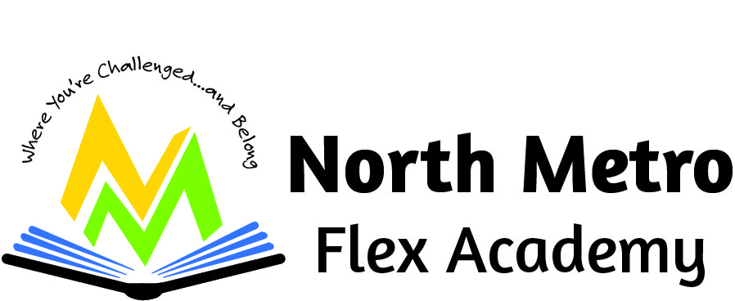

Strategic Plan

Table of Contents
for the Strategic Plan for the Coming Year

- Introduction page 54
School mission, vision, how the school is meeting the primary and
additional purposes for which it was chartered, and name of
school authorizer.

- Goals and Benchmarks for the coming year page 55
(Aligned to the 5 Comprehensive Achievement and Civic
Readiness goals of all children are ready for school, all racial and
economic achievement gaps between students are closed, all students
are ready for career and college, all students graduate, and all students
are prepared to be lifelong learners.

- Process to Evaluate Progress Toward Standards page 69

- Process to Identify Students for Gifted/Talented Programs and
Accelerate their learning page 72

- Process to Adopt Early Admission Procedures page 76

- System to Review the Effectiveness of Instruction and Curriculum page 78

- System to Provide Student Access to Effective Teachers Who Reflect the
Diversity of Enrolled Students page 82

- Strategies for Improving the Englis Language Development of
Multilingual Learners (English Language Learners) page 86

- Practices that Integrate High Quality Instruction, Rigorous
- Curriculum,
Technology, and a Collaborative Prfessional Culture page 90

- Annual Budget for Implementing the Long-Term Strategic Plan page 93

Table of Contents for the Strategic Plan for the Coming Year

- Introduction
.

Our Mission
We are a high-performing and innovative close-knit school that produces students capable of exemplary levels of critical thinking and achievement. In our school, we use exceptional curriculum, tools, and teaching to maximize student success in life.
Our Vision
We prepare a diverse community of elementary and middle school students to be successful in high school, post-secondary and in their chosen vocation through a flexible learning experience that develops analytical, compassionate, disciplined and self-directed learners.
Our History
North Metro Flex Academy opened in the Fall of 2016 as a K-4 school with 170 students in attendance. The school has since expanded to include 5th grade in 2017, sixth grade in 2018, seventh grade in 2019 and 8th grade in 2020. Our school is very diverse, including a rich blend of students from different cultures, ethnicities, and socio-economic backgrounds. Our staff reflects the makeup of our student population, and includes members of the Latino, East African, and African American communities. We are now in the process of forming committees, engaging stakeholders, and enriching our academic and extra-curricular activities to better serve our community of learners.

Novation Education Opportunities (NEO) our school’s authorizer.
Wendy Swanson Choi is the Executive Director and can be contacted at 612-889-2103 and executive.director.neo@gmail.com. NEO is organized under the Minnesota Nonprofit Corporation Act exclusively for a charitable and educational purpose, more specifically to oversee innovative charter schools through consistent, ongoing and robust evaluation to achieve significant and measurable student growth through the authorizing of public charter schools as defined in Minnesota Statutes 124E. To this end, NEO shall at all times be operated exclusively for charitable purposes within the meaning of Section 501(c)(3) of the Internal Revenue Code. All funds, whether income or principal, and whether acquired by gift or contribution or otherwise, shall be devoted to said purposes

54
- Goals and Benchmarks for the coming year
(Aligned to the 5 Comprehensive Achievement and Civic
Readiness goals of all children are ready for school, all racial and
economic achievement gaps between students are closed, all students
are ready for career and college, all students graduate, and all students
are prepared to be lifelong learners.
Goal #1 All Students Ready for School.

Grades K-1 earlyMath (at or above 50th%ile)
Exemplary | 30% of students in grades K-1 who test at or above the 50th percentile in the fall in earlyMath will have fall to spring growth at or above the 50th percentile. | 8
Satisfactory | 24% of students in grades K-1 who test at or above the 50th percentile in the fall in earlyMath will have fall to spring growth at or above the 50th percentile. (Actual: 2/7= 28%) | 4 | 4
Not Satisfactory | Less than 24% of students in grades K-1 who test at or above the 50th percentile in the fall in earlyMath will have fall to spring growth at or above the 50th percentile. | 0
Grades K-1 earlyMath (below 50th%ile)
Exemplary | 40% of students in grades K-1 who test below the 50th percentile in the fall in earlyMath will have fall to spring growth at or above the 50th percentile. (Actual: 8/18= 44%) | 8 | 8
Satisfactory | 34% of students in grades K-1 who test below the 50th percentile in the fall in earlyMath will have fall to spring growth at or above the 50th percentile. | 4
Not Satisfactory | Less than 34% of students in grades K-1 who test below the 50th percentile in the fall in earlyMath will have fall to spring growth at or above the 50th percentile. | 0
55
Results | Year | Fall earlyMath Scores At or Above 50th Percentile | Fall to Spring Growth At or Above the 50th Percentile | Fall earlyMath Scores Below 50th Percentile | Fall to Spring Growth At or Above the 50th Percentile
Results | 2021-2022 | NWEA | NWEA | NWEA | NWEA
Results | 2022-2023 | NWEA | NWEA | NWEA | NWEA
Results | 2023-2024 | 7 | 2 | 18 | 8
Results | 2024-2025
Results | 2025-2026
Results | 2021-2026
Analysis | The school's combined average 2023-2024 Fall-Spring growth rate is 40%.

Grades K-1 earlyReading (at or above 50th%ile)
Exemplary | 40% of students in grades K-1 who test at or above the 50th percentile in the fall in earlyReading will have fall to spring growth at or above the 50th percentile. (Actual: 3/3= 100%) | 8 | 8
Satisfactory | 34% of students in grades K-1 who test at or above the 50th percentile in the fall in earlyReading will have fall to spring growth at or above the 50th percentile. | 4
Not Satisfactory | Less than 34% of students in grades K-1 who test at or above the 50th percentile in the fall in earlyReading will have fall to spring growth at or above the 50th percentile. | 0
Page 56
Grades K-1 earlyReading (below 50th%ile)
Exemplary | 40% of students in grades K-1 who test below the 50th percentile in the fall in earlyReading will have fall to spring growth at or above the 50th percentile. | 8
Satisfactory | 34% of students in grades K-1 who test below the 50th percentile in the fall in earlyReading will have fall to spring growth at or above the 50th percentile. | 4
Not Satisfactory | Less than 34% of students in grades K-1 who test below the 50th percentile in the fall in earlyReading will have fall to spring growth at or above the 50th percentile. (Actual: 0/22= 0%) | 0 | 0

Results | Year | Fall earlyReading Scores At or Above 50th Percentile | Fall to Spring Growth At or Above the 50th Percentile | Fall earlyReading Scores Below 50th Percentile | Fall to Spring Growth At or Above the 50th Percentile
Results | 2021-2022 | NWEA | NWEA | NWEA | NWEA
Results | 2022-2023 | NWEA | NWEA | NWEA | NWEA
Results | 2023-2024 | 3 | 3 | 22 | 0
Results | 2024-2025
Results | 2025-2026
Results | 2021-2026
Analysis | The school's combined average 2023-2024 Fall-Spring growth rate is 12%.
57

Goal #2 All racial and
economic achievement gaps between students are closed
Goal:
The school's combined proficiency rate exceeds the state combined proficiency rate AND/OR the school improves its proficiency rate from the baseline year of FY 2022 by at least 10 percentage points by FY 2025.
Result:
MCA – Math FRP Focus Group – State Comparison (grades 3 – 8)
2023-2024 | Proficient  15 | Total students tested  79 | NMFA % Proficient  18.99% | State Proficient rate  28.77%
Analysis:
The school's combined proficiency rate of 14.95% is 12.43 percentage points lower than the state's combined proficiency rate of 27.38%
From the baseline year 2021-2022 rate of 11.58% the school’s proficiency increased to 18.99%, an increase of 7.41 percentage points

MCA – Reading Goals (grades 3 – 8)
FRP Focus Group – State Comparison
2023-2024 | Proficient students tested  29 | Total students tested  80 | NMFA % Proficient  36.25% | State % proficient rate  33.64%
Analysis:
The school's combined proficiency rate of 30.99% is 1.92 percentage points lower than the state's combined proficiency rate of 32.90%.
From the baseline year 2021-2022 rate of 29.17% the school’s proficiency increased to 36.25%, an increase of 7.08 percentage points.
58
MCA – Math Goals (grades 3 – 8)
FRP Focus - Resident District Comparison
The school's combined proficiency rate exceeds the resident district average.
2023-2024 | Proficient students  15 | Total students tested  79 | NMFA % proficient rate  18.99% | St. Paul Proficient rate  16.02%
2021 - 2026 | Proficient students  42 | Total Students tested 281 | NMFA % Rate  14.95% | St. Paul  Proficient  15.55%
Analysis: The school's combined proficiency rate of 14.95% is 0.60 percentage points lower than the resident district's combined proficiency rate of 15.55%.

MCA – Reading Goals (grades 3 – 8)
FRP Focus – Resident District Comparison
The school's combined proficiency rate exceeds the resident district average
2023-2024 | Proficient students  29 | Total students tested  80 | NMFA % proficient rate  36.25% | St. Paul Proficient rate  21.58%

2021-2025 | Proficient students  88 | Total students tested  284 | NMFA % proficient rate  30.99% | St. Paul Proficient rate  21.67%
Analysis: The school's combined proficiency rate of 30.99% is 9.31 percentage points higher than the resident district's combined proficiency rate of 21.67%.

59
Goal: Attain grade level proficiency – EL Focus group – state comparison
Math MCA
The school's combined proficiency rate exceeds the state combined proficiency rate AND/OR the school improves its proficiency rate from the baseline year of FY 2022 by at least 10 percentage points by FY 2025.
2023-2024 | Proficient Students  1 | Total students tested  23 | NMFA % Proficient  4.35% | State proficiency rate  14.06%
Analysis:
The school's combined proficiency rate of 6.02% is 7.81 percentage points lower than the state's combined proficiency rate of 13.83%
From the baseline year 2021-2022 rate of 7.14% the school’s proficiency decreased to 4.35%, a decrease of 2.80 percentage points.

Goal: Attain grade level proficiency – EL focus group – state comparison
Reading MCA
The school's combined proficiency rate exceeds the state combined proficiency rate AND/OR the school improves its proficiency rate from the baseline year of FY 2022 by at least 10 percentage points by FY 2025.
2023-2024 | Proficient students  4 | Total students tested  23 | NMFA % Proficient  17.39% | State Proficient rate  11.38%
 | 9 | 84 | 10.71% | 11.83%
  2021-2025
Analysis: The school's combined proficiency rate of 10.71% is 1.12 percentage points lower than the state's combined proficiency rate of 11.83%.
From the baseline year 2021-2022 rate of 7.14% the school’s proficiency increased to 17.39%, an increase of 10.25 percentage points.

60
Goal: Attain grade level proficiency – EL focus group – resident comparison
Math MCA (3 -8)
2023-2024 | Proficient Students tested  1 | Total students tested  23 | NMFA Proficient rate 4.35% | St. Paul Proficient rate  10.98%
2021-202 | 5 | 83 | 6.02% | 11.22%
The school's combined proficiency rate of 6.02% is 5.20 percentage points lower than the resident district's combined proficiency rate of 11.22%

Goal: Attain grade level proficiency – EL focus group – resident comparison
Reading MCA (3 – 8)
The school's combined proficiency rate exceeds the resident district average
2023-2024 | Proficient students  4 | Total students tested  23 | NMFA Proficient rate  17.39% | St. Paul Proficent rate  8.91%
2021-2026 | 9 | 84 | 10.71% | 9.53%
The school's combined proficiency rate of 10.71% is 1.19 percentage points lower than the resident district's combined proficiency rate of 9.53%

61
Goal: Attain Grade-level Proficiency- SPED Focus Group State Comparison
MCA Math (grades 3 – 8)
The school's combined proficiency rate exceeds the state combined proficiency rate AND/OR the school improves its proficiency rate from the baseline year of FY 2022 by at least 10 percentage points by FY 2025.
2023-2024 | Proficient Students  1 | Students tested  31 | NMFA % Proficient  3.23% | State proficient rate  26.05%
2021-2026 | 4 | 84 | 4.76% | 25.69%
Analysis: The school's combined proficiency rate of 4.76% is 20.93 percentage points lower than the state's combined proficiency rate of 25.69%
From the baseline year 2021-2022 rate of 8.70% the school’s proficiency decreased to 3.23%, a decrease of 5.47 percentage points

Goal: Attain Grade-level Proficiency- SPED Focus Group State Comparison
Reading (grades 3 – 8)
Goal: The school's combined proficiency rate exceeds the state combined proficiency rate AND/OR the school improves its proficiency rate from the baseline year of FY 2022 by at least 10 percentage points by FY 2025.

2023-2024 | Proficient Students  3 | Total students tested  31 | NMFA % Proficient  9.68% | State Proficient Rate  25.50%
2021-2025 | 6 | 84 | 7.14% | 25.70%
The school's combined proficiency rate of 7.14% is 18.56 percentage points lower than the state's combined proficiency rate of 25.70%.
From the baseline year 2021-2022 rate of 8.70% the school’s proficiency increased to 9.68%, an increase of 0.98 percentage points.
62
Goal: Attain Grade-level Proficiency- SPED Focus Group resident Comparison
Math MCA (grades 3 -8)
The school's combined proficiency rate exceeds the resident district average.
2023-2024 | Students Proficicnt  1 | Total students tested  31 | NMFA % Proficient  3.23% | St. Paul Proficient Rate  17.11%
2021-2025 | 4 | 84 | 4.76% | 16.09%
Analysis: The school's combined proficiency rate of 4.76% is 11.33 percentage points lower than the resident district's combined proficiency rate of 16.09%.

Goal: Attain Grade-level Proficiency- SPED Focus Group resident Comparison
Reading MCA (grades 3 -8)
The school's combined proficiency rate exceeds the resident district average.

2023-2024 | Students proficient  3 | Total students tested  31 | NMFA % Proficient  9.68% | St. Paul Proficient Rate  17.57%
2021-2025 | 6 | 84 | 7.14% | 17.56%

The school's combined proficiency rate of 7.14% is 10.42 percentage points lower than the resident district's combined proficiency rate of 17.56%

63

Goal #3 All students are ready for career and college.
Meet or Exceed National Growth Norms- Students Below Grade Level Making High Growth
Grades 2-5 aReading (below 50th%ile)
Exemplary | 40% of students in grades 2-5 who test below the 50th percentile in the fall in aReading will have fall to spring growth at or above the 50th percentile. (Actual: 32/52= 61%) | 8 | 8
Satisfactory | 34% of students in grades 2-5 who test below the 50th percentile in the fall in aReading will have fall to spring growth at or above the 50th percentile. | 4
Not Satisfactory | Less than 34% of students in grades 2-5 who test below the 50th percentile in the fall in aReading will have fall to spring growth at or above the 50th percentile. | 0

Results | Year | Fall aReading Scores At or Above 50th Percentile | Fall to Spring Growth At or Above the 50th Percentile | Fall aReading Scores Below 50th Percentile | Fall to Spring Growth At or Above the 50th Percentile
Results | 2021-2022 | NWEA | NWEA | NWEA | NWEA
Results | 2022-2023 | NWEA | NWEA | NWEA | NWEA
Results | 2023-2024 | 25 | 8 | 52 | 32
Results | 2024-2025
Results | 2025-2026 |  |  |  | Page 64
Results | 2021-2026
Analysis | The school's combined average 2023-2024 Fall-Spring growth rate is 52%.

Grades 2-5 aMath (below 50th%ile)
Exemplary | 40% of students in grades 2-5 who test below the 50th percentile in the fall in aMath will have fall to spring growth at or above the 50th percentile. (Actual: 23/53=44%) | 8 | 8
Satisfactory | 34% of students in grades 2-5 who test below the 50th percentile in the fall in aMath will have fall to spring growth at or above the 50th percentile. | 4
Not Satisfactory | Less than 34% of students in grades 2-5 who test below the 50th percentile in the fall in aMath will have fall to spring growth at or above the 50th percentile. | 0
Results | Year | Fall aMath Scores At or Above 50th Percentile | Fall to Spring Growth At or Above the 50th Percentile | Fall aMath Scores Below 50th Percentile | Fall to Spring Growth At or Above the 50th Percentile
Results | 2021-2022 | NWEA | NWEA | NWEA | NWEA
Results | 2022-2023 | NWEA | NWEA | NWEA | NWEA
Results | 2023-2024 | 7 | 2 | 53 | 23
Results | 2024-2025
Results | 2025-2026 |  |  |  | Page 65
Results | 2021-2026
Analysis | The school's combined average 2023-2024 Fall-Spring growth rate is 41%.

Page 66
Grades 6-8 baseline: ‘24-’25 school year aMath (below 50th%ile)
Exemplary | 40% of students in grades 6-8 who test below the 50th percentile in the fall in aMath will have fall to spring growth at or above the 50th percentile. | 8
Satisfactory | 34% of students in grades 6-8 who test below the 50th percentile in the fall in aMath will have fall to spring growth at or above the 50th percentile. | 4
Not Satisfactory | Less than 34% of students in grades 6-8 who test below the 50th percentile in the fall in aMath will have fall to spring growth at or above the 50th percentile. | 0

Results | Year | Fall aMath Scores At or Above 50th Percentile | Fall to Spring Growth At or Above the 50th Percentile | Fall aMath Scores Below 50th Percentile | Fall to Spring Growth At or Above the 50th Percentile
Results | 2021-2022 | NWEA | NWEA | NWEA | NWEA
Results | 2022-2023 | NWEA | NWEA | NWEA | NWEA
Results | 2023-2024 | NWEA | NWEA | NWEA | NWEA
Results | 2024-2025
Results | 2025-2026
Results | 2021-2026
Analysis | The school's combined average 2024-2025 Fall-Spring growth rate is

67
Grades 6-8 baseline: ‘24-’25 school year aReading (below 50th%ile)
Exemplary | 40% of students in grades 6-8 who test below the 50th percentile in the fall in aReading will have fall to spring growth at or above the 50th percentile. (Actual: 32/52= 61%) | 8 | 8
Satisfactory | 34% of students in grades 6-8 who test below the 50th percentile in the fall in aReading will have fall to spring growth at or above the 50th percentile. | 4
Not Satisfactory | Less than 34% of students in grades 6-8 who test below the 50th percentile in the fall in aReading will have fall to spring growth at or above the 50th percentile. | 0

Results | Year | Fall aReading Scores At or Above 50th Percentile | Fall to Spring Growth At or Above the 50th Percentile | Fall aReading Scores Below 50th Percentile | Fall to Spring Growth At or Above the 50th Percentile
Results | 2021-2022 | NWEA | NWEA | NWEA | NWEA
Results | 2022-2023 | NWEA | NWEA | NWEA | NWEA
Results | 2023-2024 | NWEA | NWEA | NWEA | NWEA
Results | 2024-2025
Results | 2025-2026
Results | 2021-2026
Analysis | The school's combined average 2024-2025 Fall-Spring growth rate is
68
Goal #4 All students will graduate.
NMFA is a K-8th grade school. It does not have high school graduates.

Goal #5 All students are prepared to be lifelong learners.
This will be a goal for next year.

- Process to Evaluate Progress Toward Standards
In Minnesota, charter schools are publicly funded schools that operate independently of traditional school districts, yet they are still required to meet state standards and regulations. The process to evaluate progress toward standards in Minnesota K-8th grade charter schools involves several key components, including accountability measures, assessments, and reporting requirements. Below is a breakdown of how progress is evaluated at North Metro Flex Academy:

1. State Standards and Curriculum Requirements
Minnesota's academic standards outline the expectations for student learning in core subjects such as reading, math, science, and social studies. Charter schools in Minnesota are required to follow these state standards and develop curricula that align with them. These standards are designed to ensure that students are gaining the necessary knowledge and skills at each grade level.

- Reading and Mathematics: These subjects are a major focus of evaluation, as students are expected to meet grade-level expectations in literacy and numeracy. The Minnesota Academic Standards specify learning goals for each subject area and grade level.

- Science and Social Studies: Schools are also expected to meet standards in science and social studies, although these are sometimes less heavily emphasized in state assessments than reading and math.

69
2. Standardized Testing and Assessments
Minnesota charter schools participate in statewide standardized testing to assess student performance against the state’s standards. The key assessments used are:

- Minnesota Comprehensive Assessments (MCAs): The MCAs are the state’s primary testing tool to measure student proficiency in math, reading, and science. Students in grades 3-8 take the MCAs annually to assess whether they meet the state’s grade-level standards.
  - Reading (Grades 3-8)
  - Mathematics (Grades 3-8)
  - Science (Grades 5 and 8)

- ACCESS for ELLs: This test assesses English language proficiency for students who are English learners (ELs).
These standardized tests are used to evaluate whether students are progressing toward meeting the state standards in key subject areas.

3. School-Defined Assessments
In addition to state-mandated assessments, many charter schools in Minnesota use other assessments to evaluate student progress, such as:

- Benchmark Assessments: These are typically administered several times throughout the school year to monitor student growth and identify areas where students may need additional support. NMFA is using FASTBRIDGE assessments during the FALL, WINTER and SPRING.

- Formative Assessments: Teachers frequently use quizzes, assignments, and classroom activities to assess student understanding on a day-to-day basis.

- Interim Assessments: These assessments are often used to monitor student progress at specific intervals throughout the year.

\4. Accountability and Reporting Requirements
Charter schools in Minnesota are held accountable for their performance based on academic achievement, financial health, and organizational effectiveness. The process for evaluating progress involves reporting on key performance indicators (KPIs), such as:
- Academic Achievement: This includes data from MCAs, internal assessments, and graduation rates (for middle school students moving to high school).
70
- Student Growth: Charter schools are also assessed on the academic growth of students, which is tracked using value-added measures or growth percentiles, particularly in subjects like reading and mathematics.
- School Climate and Environment: Schools may report on indicators like student attendance, behavior, and engagement.

- Teacher Quality: Schools report on the qualifications and effectiveness of teachers, including ongoing professional development and retention rates.
Charter schools are required to submit an annual report to their authorizer, which includes data on these performance indicators. The report must detail the school’s progress toward meeting the goals set in its charter contract.

5. Authorizer Oversight
Each charter school in Minnesota is authorized by a designated authorizer (a nonprofit organization, school district, higher education institution, or a state agency), which provides oversight to ensure that the school meets its academic, financial, and operational goals. The authorizer monitors the school’s progress through:

- Annual Performance Reviews: These reviews assess academic progress, student outcomes, financial health, and adherence to the terms of the charter.

- Renewal Process: Charter contracts are typically renewed every five years. To receive renewal, the school must demonstrate satisfactory performance across a variety of areas, including student achievement, financial stability, and compliance with state laws and charter goals.
If a charter school fails to meet the expectations outlined in its contract, the authorizer can take corrective actions, which may include providing technical assistance, revising the school’s charter, or even revoking the charter.

6. Data Use and Continuous Improvement
Data collected through assessments, surveys, and other means are used by schools to drive instructional decisions and support continuous improvement efforts. Charter schools are encouraged to use data to:

- Identify Trends and Gaps: Schools analyze student performance data to identify areas where students may be struggling and adjust instruction accordingly.

- Set Improvement Goals: Schools may set academic growth targets or implement new programs to address specific needs.
71
- Engage Stakeholders: Schools may share progress reports with parents, students, and the community to foster collaboration in addressing challenges.

7. Parent and Community Involvement
Charter schools in Minnesota are required to involve parents and the community in the educational process. Schools often use parent-teacher conferences, newsletters, and school events to keep families informed about student progress. Additionally, charter schools may seek feedback from families and community members through surveys or advisory councils to ensure that the school is meeting the needs of its students.

- Process to Identify Students for Gifted/Talented Programs and
Accelerate their learning

Process to Identify Students for Gifted/Talented Programs and Accelerate Their Learning at North Metro Flex Academy Charter School
The process of identifying students for gifted and talented (GT) programs, as well as accelerating their learning, is a multifaceted process that incorporates both formal and informal assessments, as well as a focus on individual student needs and strengths. The goal is to ensure that students who demonstrate advanced intellectual, creative, or artistic abilities receive the appropriate educational opportunities to foster their growth.
Here's a suggested framework for developing a process to identify and accelerate learning for gifted and talented students in a Minnesota K-8 charter school
Referral Process for Gifted and Talented Identification

- Teacher Referral: Teachers are often the first to recognize students with advanced abilities. Teachers should have a clear process to refer students who demonstrate signs of giftedness, such as:
  - Accelerated learning pace in one or more subjects.
  - Exceptional creativity, problem-solving, or leadership skills.
  - Intense curiosity or focus on topics outside the typical grade-level curriculum.

- Parent Referral: Parents may also notice signs of giftedness outside the school environment. Schools can provide a formalized system for parents to refer their child for evaluation.
72
- Student Self-Referral: In some cases, students may express an interest in being identified or participating in GT programs. This self-referral can prompt further evaluation.
2.Data Collection and Initial Screening
- Standardized Testing: Administer state or district-approved assessments (such as the NWEA MAP, CogAT, or other IQ tests) to gauge academic achievement and cognitive abilitiess.

- Classroom Observations: Teachers should collect qualitative data on students' classroom behaviors, such as problem-solving, leadership, and independent learning.

- Portfolio Assessment: Collect samples of student work that demonstrate creative, critical thinking, and problem-solving abilities.

- Multiple Measures: Use a combination of tests, teacher assessments, parent input, and peer assessments to ensure a well-rounded view of the student's abilities.

3. Screening Criteria and Rubrics
Develop a rubric or set of criteria to assess giftedness based on:

- Intellectual Ability: High reasoning skills, problem-solving, and abstract thinking.

- Academic Achievement: Consistent above-grade-level performance in subjects like math, reading, and science.

- Creativity: Innovative thinking, original ideas, and the ability to think outside the box.

- Motivation and Persistence: Strong intrinsic motivation, perseverance, and passion for learning.

- Social-Emotional Development: Emotional intensity, sensitivity, and leadership qualities that may distinguish gifted students.
73

2. Identification and Program Placement

- Multi-Stage Evaluation: After initial screening, students who meet certain criteria should undergo a deeper assessment. This could include more specialized tests or evaluations by a team of professionals (e.g., gifted education coordinators, school psychologists).
- Individualized Consideration: Take into account the student's academic strengths and weaknesses. A student may be gifted in one area (e.g., math) but not others (e.g., reading or social studies).

- Parental and Student Involvement: Share the results with the student’s parents and discuss potential placement in a gifted program. It's important to ensure families are informed and actively involved in the decision-making process.

5. Gifted and Talented Program Options and Acceleration
Once students are identified as gifted, a variety of options for acceleration and enrichment should be available, including:

- Subject-Specific Acceleration: Students can be placed in higher-level courses for subjects they excel in (e.g., 3rd grade student placed in 5th-grade math or language arts).

- Cluster Grouping: Group gifted students together in a heterogeneous classroom, so they can work with peers who have similar abilities while still participating in the broader classroom community.

- Differentiated Instruction: Teachers provide tailored instruction within the general education curriculum that allows students to work at their own pace, go deeper into content, and tackle more complex concepts.

- Independent Study or Research Projects: Allow students to explore topics of interest through independent or guided research, creating opportunities for creativity and deeper learning.

- Mentorship Programs: Pair gifted students with mentors in their areas of interest (e.g., local professionals or university students).

- Enrichment Activities: Provide opportunities outside the classroom, such as field trips, competitions (e.g., science fairs, math contests), or special workshops.
74
6. Ongoing Monitoring and Adjustment
- Progress Monitoring: Regularly assess the student's academic progress, social-emotional well-being, and engagement in the program. Use data from classroom assessments, portfolios, and teacher feedback

- Adaptation and Flexibility: Gifted students may need new challenges over time, so it's important to be flexible in adjusting their learning opportunities. If students are no longer engaged or seem to have outgrown the program, reevaluation should take place to provide appropriate next steps.

- Parent and Student Feedback: Continually involve parents and students in the process, asking for feedback on the program’s effectiveness and the child’s satisfaction with the level of challenge they are experiencing.

7. Social-Emotional Support
Gifted students often face unique social-emotional challenges, including perfectionism, underachievement due to boredom, or difficulty finding peers with similar interests. Schools should provide:

- Social-Emotional Learning (SEL): Incorporate SEL strategies to help students build resilience, self-awareness, and relationship-building skills.

- Counseling Services: Provide access to counseling for gifted students to help them manage stress, perfectionism, and feelings of isolation.

- Peer Groups: Create opportunities for gifted students to socialize and work with like-minded peers, building a sense of community and shared experience.

8. Professional Development for Staff
- Teacher Training: Provide ongoing professional development for all teachers to recognize and support gifted students. Training should cover topics like differentiation, using data to modify instruction, and how to recognize giftedness in different domains (e.g., creative or artistic abilities).
- Collaboration with Gifted Education Specialists: Teachers should have regular opportunities to collaborate with gifted education coordinators or specialists to share strategies, resources, and insights on how to best support gifted students.

75

9. Equity and Inclusion in Gifted Education

- Ensuring Access for All: Work to eliminate biases in the identification process, ensuring that all students, regardless of background or socioeconomic status, have equitable access to gifted education programs.

- Outreach to Underrepresented Groups: Make intentional efforts to identify and support students from underrepresented groups (e.g., students of color, students with disabilities, or low-income students).

- Process to Adopt Early Admission Procedures
In Minnesota, K-8 charter schools that wish to adopt early admission procedures must comply with both state regulations and the specific provisions laid out for charter schools. The process for adopting early admission procedures typically involves several key steps, including public notification, board approval, and adherence to state educational guidelines. Here's an outline of the general process:

1. Review Legal and Regulatory Framework
Charter schools in Minnesota must comply with state laws governing education, which include policies related to student admissions, especially regarding early admission. The Minnesota Department of Education (MDE) provides guidelines on age requirements and early admission practices.

- According to Minnesota Statutes, students must generally be 5 years old on or before September 1st to enter kindergarten, and 6 years old for first grade. However, there is some flexibility with early admission procedures.

- Charter schools may choose to implement early admission policies for kindergarten or other grade levels, allowing students who are younger than the usual cutoff age to enter school if certain criteria are met.

2. Develop and Adopt a Formal Early Admission Policy
Charter schools need to develop a clear policy on early admission. This policy should address:
76
- Eligibility Criteria: Criteria might include developmental assessments, academic readiness, and/or recommendations from early childhood education programs.

- Process for Application: Steps for parents to apply for early admission, including necessary documentation or assessments.

- Assessment Procedures: How the school will evaluate whether a student is ready for early admission. This could involve cognitive and social-emotional readiness assessments.

- Decision-Making Process: Who within the school (e.g., a committee or the board) will make the final decision about whether to grant early admission.

3. Board Approval
The charter school board must approve the early admission policy before it can be implemented. The board will typically:

- Review the proposed policy for compliance with state regulations.
- Ensure that the policy is in line with the school’s mission and educational goals.
- Hold a public meeting where the policy is presented for discussion.

4. Public Notification and Community Input
Charter schools are encouraged to notify the public about the adoption of early admission procedures and allow for community input. This might include:
- Posting the draft policy on the school’s website.
- Holding public meetings or forums for parents and community members to ask questions or provide feedback.
- Sending notifications to families regarding the availability of early admission options and the process to apply.

5. Compliance with State Guidelines
It is important for the school to ensure that its early admission policy is in compliance with state laws and the charter school’s authorizer's guidelines. This includes:

- Ensuring that the school meets the age requirements outlined in Minnesota Statutes, especially for students entering kindergarten or first grade.
77
- Confirming that the early admission policy aligns with the school’s charter and the educational outcomes it aims to achieve.

6. Application and Review Process
Once the policy is in place, the school will accept applications for early admission. The review process typically involves:
- Gathering necessary documentation from parents or guardians, including any assessments or recommendations that support the request for early admission.
- A review committee or administrative team will evaluate whether the child meets the criteria for early admission based on readiness, developmental milestones, and any other relevant factors.
- The school will notify families of the decision, and if the request is granted, they will be provided with instructions on next steps (e.g., enrollment).

7. Implementation and Monitoring
Once a student is admitted early, the school should monitor their progress to ensure that they are thriving in the academic environment. This could include:
- Regular check-ins with teachers, parents, and support staff.
- Academic and social assessments to gauge the student’s readiness and success in the classroom.

- Making adjustments if necessary to support the child’s development.
8. Reporting to Authorizer and the MDE
Charter schools in Minnesota are accountable to their authorizers and the MDE. The school may be required to report on the number of early admissions and demonstrate how the process aligns with educational goals and student outcomes.
By following these steps, charter schools in Minnesota can create a transparent, fair, and legally compliant process for admitting younger students who are ready to start school before the typical age cutoff.

- System to Review the Effectiveness of Instruction and Curriculum
In Minnesota, K-8th grade charter schools are subject to various state laws and accountability standards that guide the effectiveness of instruction and curriculum. A system to review the effectiveness of instruction and curriculum is essential to ensure that students are meeting academic standards and that the charter schools are fulfilling their missions. Below is an outline of what such a system typically entails:

    - State and Local Accountability Requirements
78
Minnesota charter schools are required to meet specific state standards for student achievement, which are typically assessed through statewide standardized tests. Schools are held accountable for student performance in core areas such as reading, math, and science, and the effectiveness of their curriculum and instruction is evaluated based on student outcomes.

2. Internal Assessment and Data Collection
A system for reviewing instruction and curriculum effectiveness generally includes robust internal assessments. These may include:

- Formative assessments: Regular checks for understanding (e.g., quizzes, written reflections, class discussions).

- Summative assessments: End-of-unit tests or final projects that evaluate mastery of content.

- Diagnostic assessments: Initial assessments to determine students’ starting points and guide instructional planning.

- Benchmark assessments: Periodic tests that measure progress toward academic goals.
Data from these assessments helps schools identify areas where students are excelling or struggling and inform instructional decisions.

3. Curriculum Mapping and Alignment
Effective curriculum design ensures that the instructional materials and activities align with Minnesota's state standards (such as the Minnesota Academic Standards). Charter schools often implement:

- Curriculum mapping: Aligning the content, skills, and learning objectives with state standards.

- Vertical and horizontal alignment: Ensuring consistency in instruction across grade levels (vertical) and within a grade level (horizontal).

- Adapting curriculum: Using data to modify or enhance the curriculum to meet the needs of diverse learners, including students with disabilities and English language learners.
79
4. Use of Data to Inform Instruction
Charter schools often implement systems to analyze data from a variety of sources:

- Standardized testing: Minnesota Comprehensive Assessments (MCAs) and other state-required assessments provide data on student performance relative to state standards.

- Student work samples: Teachers review student work to assess the depth of understanding and identify patterns of achievement or areas needing improvement.

- Teacher assessments: Teacher-developed assessments and student portfolios can give insight into how well the curriculum is being internalized by students.
These data points help schools adjust instruction, providing additional resources or interventions where needed.

5. Professional Development and Teacher Feedback
An important part of reviewing instructional effectiveness is providing teachers with ongoing professional development based on identified needs. Schools often implement:

- Collaborative review: Teachers meet in grade-level teams or subject-area groups to review student performance data and instructional strategies.

- Coaching: Experienced educators or instructional coaches work with teachers to refine their practices.

- Peer observations and feedback: Teachers observe each other’s classrooms to provide constructive feedback on teaching practices and strategies.
Professional development efforts should be targeted to improve instruction and better meet students' academic needs.

6. Parent and Community Involvement
Charter schools may involve parents and community members in reviewing the effectiveness of instruction. This might include:

- Surveys: Gathering feedback from parents, students, and community members about the quality of the instructional experience and curriculum.
80
- School Advisory Councils: These councils often include parents, teachers, and community stakeholders who help review school performance and suggest improvements.

- Communication: Regular updates on student progress, curriculum changes, and upcoming assessments ensure transparency and engagement.

7. Student Support Services

A system for reviewing the effectiveness of instruction and curriculum should also take into account how well students are supported through additional services. This includes:

- Special Education programs: Monitoring how well students with disabilities are served by the curriculum and instruction.

- Interventions: Identifying struggling students and providing additional support (e.g., small-group instruction, tutoring).

- Language support: Assessing how well English Language Learners (ELLs) are integrated into the curriculum and ensuring they are receiving appropriate language support.

8. Annual Performance Reports
Charter schools are often required to provide an annual report that evaluates the performance of their students, teachers, and curriculum. These reports are submitted to authorizers, the state, and sometimes the public. Key performance indicators might include:

- Academic growth: How much progress students have made over the year, measured by standardized tests or other indicators.

- Attendance rates: High attendance is often correlated with better academic performance.

- Graduation rates: For schools with a K-8 focus, this may involve tracking long-term academic success and preparation for high school.
81
9. Continuous Improvement and Program Evaluation
Effective systems for reviewing instruction and curriculum should be designed to evolve over time. This might involve:

- Curriculum review cycles: Regular reviews of the curriculum, with input from teachers, students, and parents

- Adoption of new programs or methodologies: Based on feedback and data, charter schools might adopt new instructional practices, technology tools, or curricula that better support student achievement.

- Evaluation of external programs: Charter schools might collaborate with external evaluators or researchers to assess the effectiveness of specific programs or strategies.

10. External Evaluation and Accreditation
Charter schools in Minnesota may also undergo external evaluations by their authorizers. This process helps to ensure that the schools are fulfilling their charter agreements and providing a quality educational experience. External evaluations might assess:

- School performance against charter goals.
- Compliance with state and federal regulations.
- Satisfaction of students and parents.

- System to Provide Student Access to Effective Teachers Who Reflect the
Diversity of Enrolled Students
In Minnesota, as well as in many other states, charter schools, including those serving K-8th grade students, are encouraged—and often required—to develop systems to provide student access to effective teachers who reflect the diversity of the student population. This focus is part of broader efforts to promote equity in education and ensure that all students have access to high-quality teaching that is culturally responsive and inclusive.
Here are key elements and strategies that Minnesota K-8th grade charter schools may use to address this issue:

82
1. Recruitment and Retention of Diverse Teachers
Charter schools can adopt strategies to recruit and retain a diverse teaching staff that mirrors the racial, ethnic, and cultural makeup of the student body. This could include:

- Targeted recruitment efforts to attract teachers from underrepresented communities, including job fairs, partnerships with universities, and outreach to minority-serving institutions.

- Providing scholarships and loan forgiveness programs for diverse teacher candidates, particularly those who agree to teach in high-needs schools or subjects.
- Hiring practices that prioritize diversity and cultural competence in the recruitment process.

2. Professional Development in Cultural Competency
Charter schools may implement ongoing professional development opportunities to help all teachers improve their ability to teach diverse student populations. This could include:

- Training in culturally responsive teaching methods, where teachers learn to understand and integrate students' cultural backgrounds into their curriculum and teaching practices.
- Ongoing equity workshops focusing on racial justice, implicit bias, and strategies for creating inclusive classrooms.

3. Mentorship and Support for Diverse Teachers
Charter schools can provide mentorship and support systems for teachers from diverse backgrounds, helping them navigate the challenges of teaching in a sometimes underserved or underrepresented environment. This might involve:

- Peer mentorship programs where more experienced educators can guide newer, diverse teachers.
- Networking opportunities with other diverse educators to foster community and support.

- Support for new teachers of color through induction programs specifically designed to address their unique challenges.

83
4. Student-Centered and Culturally Relevant Curriculum
While not directly about teacher diversity, having a curriculum that is relevant to the students' cultural backgrounds helps create a more inclusive and effective learning environment. Charter schools in Minnesota might:

- Integrate diverse authors, historical perspectives, and cultural practices into the curriculum, ensuring students see their identities and experiences reflected in their education.

- Engage in curriculum development processes that include input from a variety of community stakeholders, ensuring it aligns with the needs of the student population.

5. Teacher Diversity Data and Accountability
Schools and charter networks may track data on the diversity of their teaching staff and student outcomes to ensure equitable access to effective educators. This might involve:
- Reporting on teacher diversity to ensure transparency and accountability.
- Using data to identify disparities in teacher effectiveness and develop strategies to address them.

- Equity audits to monitor progress in hiring practices and teacher diversity.

6. Community Engagement

In Minnesota, charter schools often collaborate with the local community to address the diverse needs of students. Involving parents and families in the hiring process can help ensure that teachers reflect the values and needs of the community. Schools may:

- Hold community forums to gather input on what qualities they seek in teachers.

- Partner with local organizations, cultural centers, and universities to support the professional development of teachers who reflect the community’s diversity.

7. Incentives for Teacher Diversity
Some charter schools might offer specific incentives to teachers of color or those from diverse backgrounds. These could include:
84
- Bonuses or salary incentives for teachers who meet diversity goals

- Professional growth opportunities, such as advanced degrees or certifications, that are focused on leadership in diverse classrooms.

- Workplace flexibility and other policies that promote teacher retention, particularly for teachers from underrepresented groups.

8. Equity and Inclusion Committees

Charter schools often have advisory committees or task forces that are focused on diversity, equity, and inclusion (DEI). These committees might:

- Monitor the school’s progress toward ensuring that all students have access to teachers who are culturally competent and effecve.

- Help guide policy decisions related to teacher hiring and professional development.
Legal and Policy Framework
In Minnesota, charter schools must comply with state and federal regulations that promote educational equity, such as the Minnesota Human Rights Act, Title VI of the Civil Rights Act, and various mandates under the Every Student Succeeds Act (ESSA). These laws emphasize ensuring equitable access to qualified teachers, with a focus on reducing disparities between teacher quality for different student groups.
By implementing these strategies, Minnesota charter schools can help ensure that students have access to teachers who are not only effective but also reflect the diversity of the student body. This can lead to improved educational outcomes, greater student engagement, and a more inclusive school culture overall.

85

Strategies for Improving the English Language Development of
Multilingual Learners (English Language Learners)
In Minnesota, as in other states, charter schools serving K-8th grade students face the challenge of ensuring effective English language development (ELD) for multilingual learners (MLs), often referred to as English Language Learners (ELLs). Strategies for improving ELD typically focus on language acquisition, academic content mastery, and cultural responsiveness. Below are some effective strategies for improving the English language development of multilingual learners in Minnesota charter schools:

1. Bilingual/Multilingual Education Programs
- Dual Language Programs: These programs support students in both their home language and English, promoting bilingualism and biliteracy. Minnesota charter schools could implement dual-language programs where instruction is provided in both the students' native language and English. Research shows that dual language programs not only boost language proficiency but also support academic achievement in other subjects.

- Transitional Bilingual Education (TBE): For multilingual learners, TBE programs initially offer instruction in the student’s home language with a gradual transition to English-only instruction. This approach allows students to build academic vocabulary and content knowledge in their native language before fully transitioning to English.

2. Sheltered Instruction and SIOP Model
The Sheltered Instruction Observation Protocol (SIOP) model is a well-established method for teaching English language learners that integrates language development with academic content instruction. Some key features of the SIOP model include:
Lesson planning with clear language objectives alongside content objectives.
Use of visual aids such as charts, graphs, and pictures to support understanding.
Scaffolding techniques like modifying speech, repeating key points, and providing sentence frames to encourage student participation and language practice.
86

- Interactive and cooperative learning activities that promote language use in authentic, meaningful contexts.

3. Comprehensive and Culturally Responsive Curriculum
- Culturally Relevant Content: Charter schools can integrate culturally responsive teaching by ensuring the curriculum reflects the diverse cultural backgrounds of students. This promotes student engagement and fosters a sense of belonging.

- Content-Based Language Instruction: This strategy combines language instruction with content learning. For example, teaching science or social studies while focusing on language skills can help students acquire vocabulary and grammar in context.

4. Intensive English Language Support (Pull-Out/Push-In Models)
- Pull-Out Services: Students may receive additional, targeted English language instruction outside the general classroom. These sessions focus on language development through targeted activities such as vocabulary building, grammar lessons, and reading comprehension.

- Push-In Services: English language development is provided by specialized teachers or language support staff who "push in" to the general education classroom to provide language support while the students engage in content learning.

5. Formative Assessment and Data-Driven Instruction
- Charter schools can use formative assessments to track the progress of multilingual learners. Regular assessments can help teachers understand where students are in their language development and adjust instruction accordingly.

- Language Proficiency Assessments: Minnesota uses the ACCESS for ELLs test to assess English proficiency. Teachers can use the results of this test to guide their instructional decisions and ensure that students receive targeted support where needed.

- Student Progress Monitoring: Regular checks on student language development progress (e.g., using rubrics, portfolios, or digital tracking systems) allow educators to tailor instruction and interventions.
87
6. Professional Development for Educators
- Teachers need ongoing professional development to become skilled at working with multilingual learners. Training should focus on second language acquisition, culturally responsive pedagogy, and differentiation techniques.
- Collaborative Learning Communities: Teachers can work together in professional learning communities (PLCs) to share strategies and resources for improving ELD. This collaboration enhances the consistency and effectiveness of language support across the school.

7. Family and Community Engagement
- Engaging multilingual families is critical in supporting the language development of students. Charter schools can offer language classes for parents and host community events that celebrate linguistic diversity.

- Bilingual Support Staff: Having bilingual staff or interpreters who can communicate with families in their native language can help build strong relationships and encourage parental involvement in students' education.

8. Leveraging Technology for Language Development

- Language Learning Apps: Educational technology can play a significant role in supporting English language development. Programs like Duolingo, Rosetta Stone, or Language Live! can offer additional practice outside the classroom.

- Interactive Platforms: Online platforms like Raz-Kids or Reading A-Z offer leveled reading materials, which can be a powerful tool for scaffolding reading development for multilingual learners at various stages of proficiency.

9. Extended Learning Opportunities
- Summer Language Camps or After-School Programs: Charter schools can offer extended learning opportunities outside of regular school hours. These programs provide additional practice in both language development and content areas and may be especially beneficial for multilingual learners who need extra support.
88
- Peer Mentoring and Buddy Programs: Pairing multilingual learners with more advanced English speakers in informal settings can promote natural language use and help students feel more integrated into the school community.

10. Addressing Social and Emotional Needs
- Language development goes beyond academics; supporting the social and emotional well-being of multilingual learners is critical. Schools can create safe, inclusive spaces where students can express themselves, build friendships, and develop the confidence needed to communicate in English.

11. Use of Scaffolded Language Support

- Visual Aids and Graphic Organizers: To facilitate comprehension, teachers can use tools such as word walls, picture dictionaries, and sentence frames to support language development.

- Language Scaffolding: For example, teachers may use gestures, modeling, and repetition to help students understand new language concepts or instructions. By breaking tasks into smaller, more manageable steps, teachers ensure that students feel successful and confident.

12. Collaboration with ESL Specialists
- In many cases, charter schools can collaborate with ESL (English as a Second Language) specialists or TESOL (Teaching English to Speakers of Other Languages) experts to provide targeted support. Specialists can work with general education teachers to tailor lesson plans and adapt materials to the needs of multilingual learners.

89

- Practices that Integrate High Quality Instruction, Rigorous
Curriculum, Technology, and a Collaborative Professional Culture
In Minnesota, K-8th grade public charter schools have increasingly integrated high-quality instruction, rigorous curriculum, technology, and a collaborative professional culture to improve student outcomes. These practices aim to create an environment where both students and educators are empowered to succeed. Here's an overview of some of the key strategies used in these schools:

1. High-Quality Instruction
High-quality instruction is centered on practices that engage students, foster critical thinking, and support diverse learning styles. Common strategies include:

- Differentiated Instruction: Teachers tailor their lessons to accommodate various learning needs, ensuring that all students can access the curriculum. This includes providing different content, process, or product options based on students' abilities and interests.

- Data-Driven Instruction: Teachers use formative assessments and data analysis to continuously monitor student progress and adjust instruction accordingly. Tools like MAP (Measures of Academic Progress) and formative quizzes are often used.
- Engagement and Active Learning: High-quality instruction focuses on interactive and hands-on learning experiences. Teachers often incorporate project-based learning (PBL), inquiry-based activities, and real-world problem-solving scenarios.

- High Expectations and Rigor: Teachers set high expectations for all students, focusing on both academic and behavioral growth. This includes using rigorous texts, complex problem-solving tasks, and pushing students to think critically and analytically
2. Rigorous Curriculum
The curriculum in Minnesota charter schools is designed to be challenging, aligned with state standards, and responsive to the needs of diverse learners. Key features of rigorous curriculum integration include:
Alignment with Minnesota State Standards: Charter schools adopt and adapt curricula that meet or exceed the state's academic standards in core subjects like math, reading, science, and social studies.
Core Subject Mastery: Students are expected to demonstrate deep mastery of subjects, especially in literacy and numeracy, which are foundational to academic success. Schools may use a mix of traditional and innovative curricula, like the
90
Common Core, Next Generation Science Standards, or curriculum models like Open Up Resources for math.

- Integrated Learning: Subjects such as STEM (Science, Technology, Engineering, and Math) are often integrated with arts and humanities to create cross-disciplinary learning experiences that are more relevant to real-world applications.

- Social-Emotional Learning (SEL): Alongside academic rigor, SEL is often woven into the curriculum to ensure that students develop skills in self-awareness, relationship-building, and resilience, which are key for academic success and overall well-being.

3. Technology Integration
Charter schools in Minnesota increasingly leverage technology as a tool for both instruction and operational efficiency. Examples include:

- 1:1 Device Programs: Many schools provide students with individual devices (e.g., Chromebooks, tablets) to support personalized learning. This allows students to access digital resources, submit assignments, and engage with interactive content.

- Blended Learning Models: Blended learning combines face-to-face instruction with online learning, allowing students to work at their own pace and receive immediate feedback. This can help students master material more effectively and efficiently.

- EdTech Tools: Schools use a variety of digital tools such as Google Classroom, Khan Academy, and adaptive learning platforms like DreamBox or i-Ready to personalize instruction, provide additional practice, and track student progress.

- Flipped Classrooms: Some charter schools employ the flipped classroom model, where students learn new content at home (via videos or digital resources) and use class time for deeper discussion, problem-solving, and collaborative activities.
4. Collaborative Professional Culture
Creating a strong, supportive, and collaborative professional culture is critical for fostering high-quality teaching and continuous improvement. Key aspects of this culture include:
- Professional Learning Communities (PLCs): Teachers regularly collaborate in PLCs to share best practices, review student data, and align instructional strategies.
- These communities often work together to solve problems, develop interdisciplinary units, and reflect on instructional practices. 91

- Ongoing Professional Development: Charter schools invest in continuous professional development (PD) to ensure that educators are up-to-date with the latest pedagogical strategies, technology tools, and content knowledge. PD might include workshops, conferences, peer observations, and coaching.

- Teacher Autonomy and Leadership: Many charter schools provide teachers with greater autonomy over their classrooms, while also fostering leadership opportunities for staff. Teachers may serve on leadership teams, participate in decision-making, and influence school policies.

- Mentorship and Peer Observation: New teachers are often paired with experienced mentors who guide them through instructional challenges, classroom management, and curriculum implementation. Peer observations are also common to support professional growth.

- School Culture of Collaboration: Beyond individual classrooms, schools promote a culture where staff collaborate across grade levels and disciplines. This helps ensure consistency in curriculum implementation and fosters a shared sense of mission and values.

- Community and Parent Engagement

- Active Parent Involvement: Charter schools often emphasize strong family and community engagement. They may offer regular parent-teacher conferences, volunteer opportunities, and events designed to build strong relationships between home and school.

- Community Partnerships: Some charter schools partner with local businesses, organizations, and higher education institutions to enhance students' learning experiences, offer mentorship opportunities, and provide real-world learning contexts.

Assessment and Accountability
Charter schools typically use a variety of assessments to monitor and support student progress, including:

- Formative and Summative Assessments: Schools use both types of assessments to gauge student learning and inform instructional decisions. (page 92)

- Standardized Testing: Charter schools participate in state-mandated assessments (such as the MCA—Minnesota Comprehensive Assessments) to measure academic performance and meet accountability requirements.

- Student Portfolios: In some cases, students maintain portfolios that track their academic progress and reflect on their learning journey.

7. Innovative Educational Models
Charter schools in Minnesota are often at the forefront of implementing new educational models that integrate the above elements in unique ways. Some examples include:

- Expeditionary Learning: A model that emphasizes learning through fieldwork, community projects, and a focus on deeper, inquiry-driven exploration.

By combining rigorous curriculum, high-quality instruction, technology, and a supportive, collaborative culture, North Metro Flex Academy aims to provide students with the tools and opportunities they need to succeed academically and thrive in a rapidly changing world. These integrated practices help create a dynamic learning environment that promotes not just academic achievement, but also personal growth and lifelong learning.

- Annual Budget for Implementing the Long-Term Strategic Plan

- Finances
The school’s financial packet and supplemental transaction data are reviewed monthly at the Board’s Finance Committee. At this committee, members review and inspect the financials, receiving clarifications and answers to questions on line items that may be outside the expected numbers as compared to the budget. The Board Treasurer and Finance Manager provide a monthly update at each regularly scheduled board meeting providing full transparency to the board, staff and community.
93
Schools typically receive most of their funding through state sources, derived from legislation passed by the Minnesota legislature. In FY2024, North Metro Flex received funds from local sources, federal and state funding. The breakdown is represented in the graph below:
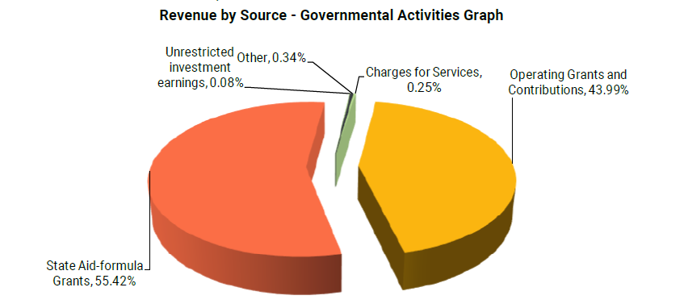

North Metro Flex Academy continues to focus on investing most of its dollars directly into instructional activities to keep the funds as close to the students as possible. Spending funds in the classroom helps to ensure that our money is where our focus is, with our students. Instructional expenses make up over 70% of all spending at North Metro Flex Academy as represented below.
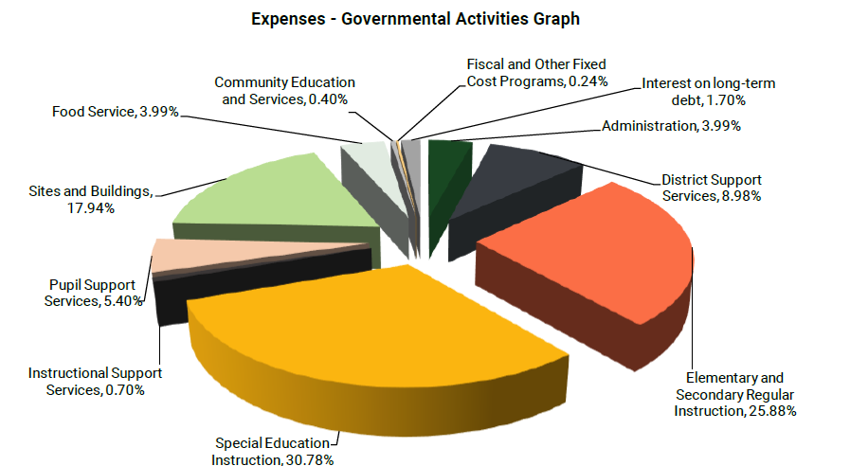
94
Audited financial statements for North Metro Flex Academy showed a loss of $77,896 for FY2024. This results in a fund balance of 673,760 or 17.5% when considering all fund balances. When considering only unrestricted fund balances, the school finished the year at 15.47%. This is represented in the balance sheet and income statements provided below.

95
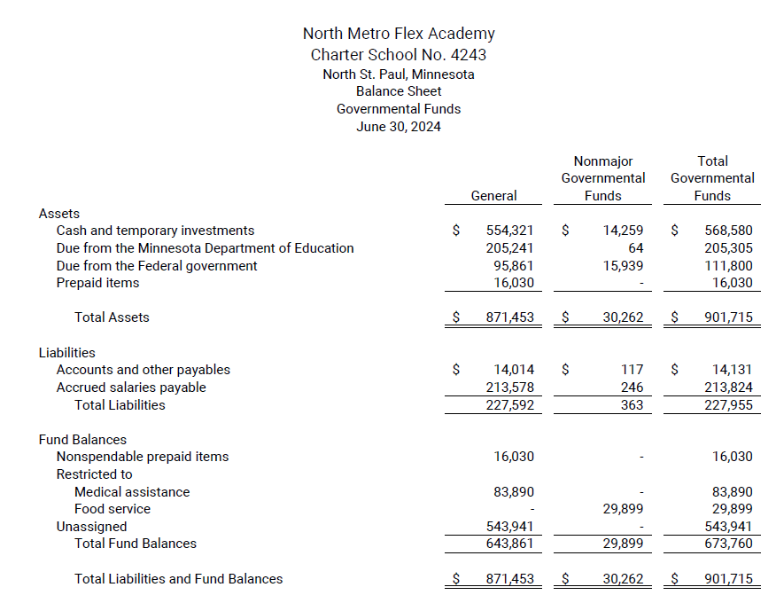

96

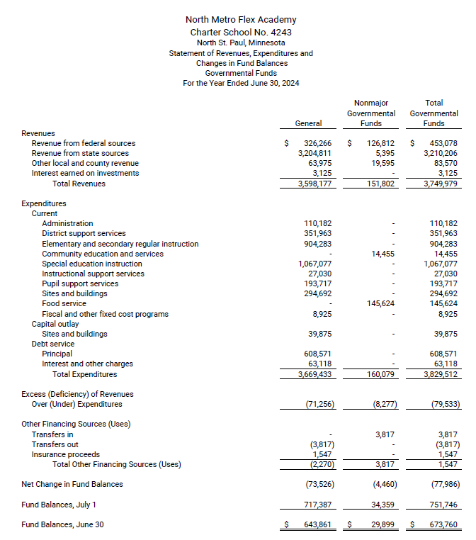

97

